GRADE SIX (6)
Time: 1 Hour 20 min.

MATHEMATICS

M. E. ASSESSMENT TERM TWO
M TWO

- Mr. Otaro had 34689 animals on his farm. What is the place value of digit 4 as shown in the total numbers of animals on the farm?
- Thousandths B. Tens C. Thousands D. Tens of thousands
- A tea factory harvested 34865 bags of tea leaves in a year. What’s the total value of 8 in the number of bags.
- 800 B. 80 C. 8 D. 8000
- The government delivered seven thousand six hundred and thirty nine books in a school. What is the number of book delivered in symbol.
- 76309 B. 7639 C. 7000639 D. 76309
- Rose arranged the numbers shown in an ascending order. Which one is the correct order.
4689, 6489, 9864, 8946, 6894

- 4689, 9864, 6489, 6894,8946
- 8946, 6894, 6489, 4689, 9864
- 6489, 4689, 8946, 6894, 9864
- 4689, 6498, 6894, 8946, 9864
- Round off 29368 to the nearest Thousands.
- 29300 B. 29000 C. 30000 D. 29360
- What’s the square of 49
- 7 B. 2401 C. 98 D. 13
- What’s √169?
- 23 B. 31 C. 13 D. 14
- A tree nursery had 5100 mango seedlings and 256 orange seedlings. What’s the total number of seedlings in the nursery?
- 5356 B. 5350 C. 5536 D. 5300
- A business man transported 2793 oranges for sale,109 oranges got spoiled. How many mangoes remained for sale?
- 2902 B. 2992 C. 2674 D. 2684
- Work out 2146 x 5 =?
- 10730 B. 21510 C. 105230 D. 10630
- A soap making company packed 2400 bars of soap in 20 boxes equally. How many bars of soap were in each box?
- 1200 B. 102 C. 120 D. 12
- Work out 24 $÷$4 x 3 + 12 - 5
- 18 B. 14 C. 30 D. 28
- Work out 40 x 2 + 50 - 20
- 10 B. 110 C. 80 D. 90
- Work out 16 ÷ 2 x 3 + 8 - 3
- 29 B. 30 C. 28 D. 40
- Find the least number that is divisible by 18, 15 and 12
- 3 B. 36 C. 12 D. 180
- What is the shortest possible length of a rope from which equal pieces of ropes measuring 12cm, 18cm and 20cm can be cut.
- 18cm B. 1800cm C. 180cm D. 108cm
- Work out the G.C.D OF 6, 12, and 18.
- 3 B. 9 C. 6 D. 4
- The side of a square plot measures 64m. Find the area.
- 128M² B. 4096M² C. 256M² D. 128CM²
- What is the value of $8 \frac{5}{6} - 2 \frac{1}{3}$?
- $6\frac{3}{6}$ B. $6\frac{4}{9}$ C. $6\frac{4}{8}$ D. $6\frac{2}{4}$
- Find the value of $\frac{1}{3} + \frac{2}{10} + \frac{1}{5}$
- $\frac{4}{18}$ B. $\frac{11}{30}$ C. $\frac{19}{30}$ D. $\frac{22}{30}$
- The teacher drew the following shapes on the Blackboard
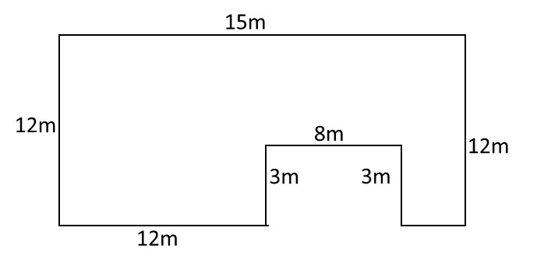

What is the perimeter of the shape
- 60m B. 63m C. 65m D. 58

- Grade six learners arranged bricks as shown in the diagram below.
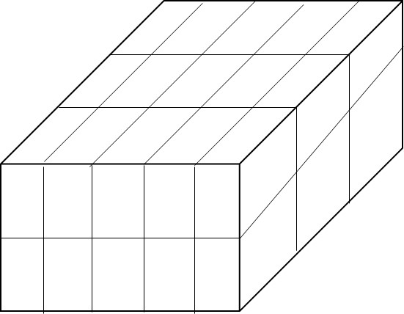

How many bricks did they use to make the stack?
- 20 B. 25 C. 15 D. 30
- Omollo a grade 5 learners drew the shape below.
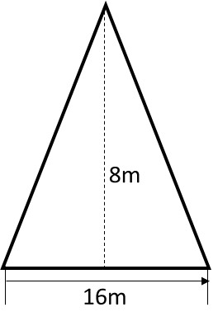

What is the area of the shape drawn?
- 48m² B. 96m² C. 24m² D. 48m²
- What is the next numbers in the series below.
2, 6, 10, 14, _____________
- 16 B. 14 C. 24 D. 18
- While walking in the school compound Joseph picked the following 3D object.
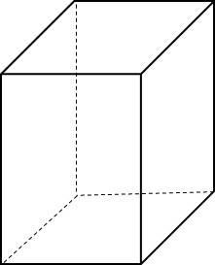

How many edges does the objects have.
- 12 B. 9 C. 8 D. 6

- How many years are there in 70 months?
- 4 years 6 months
- 10 years
- 5 years 10 months
- 6 years 6 months
- Which of the following lines are perpendicular
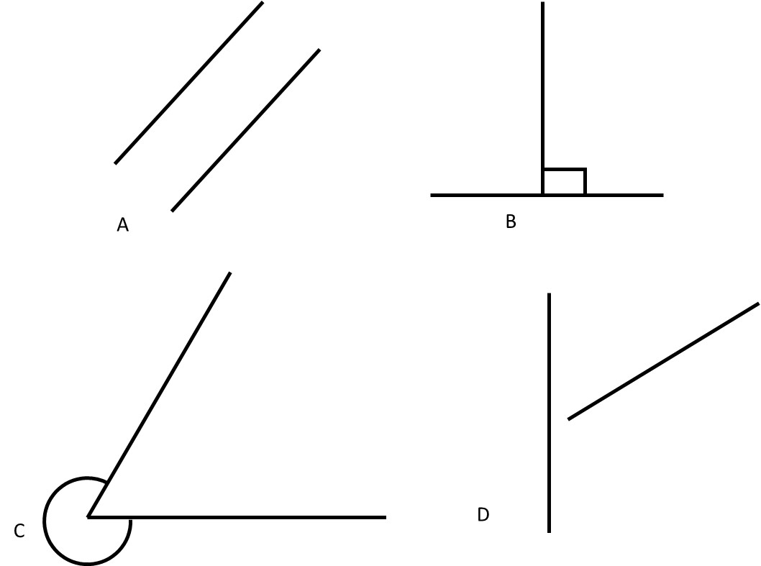

- Convert 3 metres 50cm into centimetres
- 305cm B. 350cm C. 3500cm D. 35cm
- The table below shows the number of pupils in a certain school
Grade | 1 | 2 | 3 | 4 | 5 | 6 | 7 | 8
Number | 103 | 72 | 60 | 40 | 90 | 52 | 44 | 49
What is the total number of pupils in grade two and six?
- 80 B. 20 C. 124 D. 122
- What is the next shape in the pattern below?

¿

