M.E. ASSESSMENT TERM TWO
GRADE SIX (6)
INTEGRATED SCIENCE TIME: 1 HOUR 40 MIN.

SCIENCE AND TECHNOLOGY
- Grade 5 learners in Makunga Primary school were asked to name useful fungi. Who gave the wrong answer?
- John – Yeast B. Peter – Toadstool C. Andrew- Mushroom D. James – Penicillium

- The diagrams below were drawn by learners to represent two types of roots.
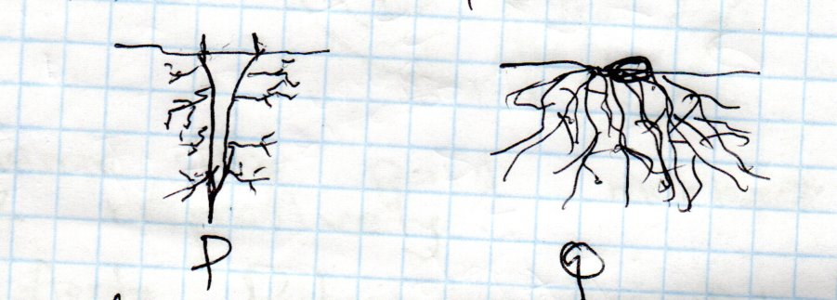
Q
P

Which one of the following pairs of plants is matched correctly to its root system.
 | P | Q
A | Onions | Beans
B | Sisal | Maize
C | Napier grass | Mango
D | Beans | Sugarcane
- During a nature walk learners came across an invertebrate which had the following characteristics
i). Three body parts
ii). Have antennae
iii).Have wings
iv). Three pairs of legs.
The invertebrate was likely to be
- Centipede B. Slug C. Cockroach D. Tick
- The diagram below represents some parts of human heart.

Name the part marked W,Y,X and Z respectively.
- Aorta, Pulmonary vein, Pulmonary Artery, Venacava
- Venacava, Pulmonary Artery, Aorta, Pulmonary vein
- Venacava, Pulmonary vein, Aorta, Pulmonary Artery
- Pulmonary artery, Venacava, Aorta, Pulmonary vein

- Which is the best method of managing solid plastic waste containers at home?
- Burning B. Recycling C. Reducing D. Reusing
- Which of the following is a change in both boys and girls during adolescence.
- Hips broaden
- Shoulder broaden
- Increase in height and weight
- Voice deepens
- Which one of the following animals is an example of Amphibians.
A. Frog B. Snake C. Tortoise D. Gecko
- Which of the following describes cumulus clouds.
- Dark grey in colour
- Appear high in the sky
- Indicate heavy rainfall
- Appear low in the sky
- What happens when metals are heated. They …………………………
A. Shrink B. Expand C. Cool D. Contract

- Mercy and Carren observed a mango fruit falling from a mango tree. Mercy told Carren that the mango fell because of
- Its high motion
- High temperature
- Its small mass
- Force of gravity.
- Below are characteristics of a certain state of matter.
i). Do not flow
ii). Have a fixed shape
iii). Have a fixed volume.
The state of matter described above is
- Air B. Solids C. Gases D. Liquids

- Water used for cleaning fruits can be used again to water crops. This way of water conversation is __
A. Recycling B. Reducing C. Reusing D. Mulching

- Which one of the following is NOT a waterborne disease?
A. Dysentery B. Cholera C. Malaria D. Typhoid
- Which statement best describes convection.
- Transfer of heat in liquid and gases
- Transfer of heat in liquids only
- Transfer of heat in liquids only
- Transfer of heat in solids.
- We wear _____ when touching poisonous plants in our environment.
A. Clothes B. Goggle C. Gumboots D. Gloves.

AGRICULTURE

- Grade 4 learners were investigating the ability of soil to allow water to pass through it. Which of the types of soil allowed water to pass through it fastest?
- Sand soil B. Clay soil
C. Silt soil D. Loam soil
- Which of the following materials is not needed when making a scare crow?
- Sticks B. Nails
C. Iron sheets D. Grass
- Mrs. Indangasi a grade 4 Agriculture teacher asked leaners to bring the following materials during an Agriculture lesson.
i). Top soil
ii). Ash
iii). Farm yard manure
iv). Dry grass.
Which of the above materials helps in adding extra – nutrients in a compost heap?
- Top soil B. Ash
- Farmyard manure D. Dry grass
- The following are methods of water conservation in farming. Which one is not?
- Mulching B. Cover cropping
C. Shading crops D. Thinning crops
- The following are uses of a domestic animal
i). Used for transport
ii). Provide milk
iii). Provides Meat
iv). Used for payment of dowry by Somali community.
Which domestic animal is it?
- Dog B. Pig
C. Camel D. Goat
- The following are examples of indigenous food crops. Which one is not?
- Maize
- Sweet potatoes
- Black nightshade
- Sorghum
- The act of replacing seedlings that have dried up after transplanting is called?
- Pruning B. Irrigation
C. Gapping D. Weeding
- During a nature walk grade 6 learners of Khaimba comprehensive school observed the following after it had rained.
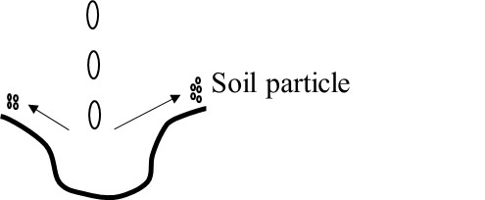

Which type of soil erosion did they observe?
- Sheet erosion B. Gully erosion
C. Rill erosion D. Splash erosion
- A grade six learner at Petros Comprehensive school found a trapped wild animal in the school farm. What is the best practice to be carried out to the wild animal?
- Beat the animal to death
- Burn the animal to ashes
- Return the animal to the forest
- Eat the animal
- A grade five Agriculture teacher asked learners to bring the following materials.
i). A sack
ii). Soil
iii). Manure
iv). Seedlings
v). Shovel
Which of the following practices were they going to carry out?
- Soil recovery
- Water conservation
- Innovative gardening
- Making manure
NUTRITION
- Marion is a grade 6 girl undergoing some changes that do take place in boys during adolescence.
Which one of the following changes is occurring in her?
- Experiencing wet dreams
- Breaking and deepening of the voice
- Hair growing on the chin
- Developing breasts.

- Pre-adolescence occurs between ______
- 9 and 12 years
- 6 and 7 years
- 2 and 5 years
- 19 and 35 years
- Elimu primary school invited a guest speaker from Jamaa health centre who talked about non-communicable diseases.
Which one of the following is a non-communicable disease.
- Malaria
B. Asthma
C. Corona virus disease 2019(covid-19)
D. Tuberculosis
- Cosmetics are _______________
- Accessories
- Items you wear other than clothes
- Items that a person applies on their face or body
- Items that a person carries.
- What is the importance of making a budget?
- It enables a person to spend wisely
- It encourages impulse buying
- It enables a person to spend more money
- It helps a person to buy items they cannot afford.

- A grade 6 boy was asked to plan a meal for the family. In the planning he was asked to include a cereal. Which one did he include?
A. Sweet potatoes B. Carrots C. Green banana D. Rice

- Sherry likes stewed food. Which of the following foods can be stewed?
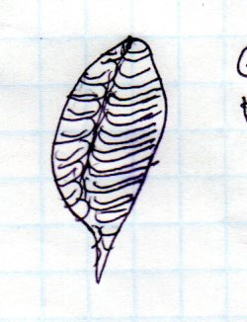
A. Chapati B. Green maize C. Meat D. Groundnuts
- Grade 6 learners made a table cloth using the following stitch.

Which stitch is this?
- Backstitch B. Chain stitch C. Loop stitch D. Satin stitch

- Care labels are attached to clothes to indicate the fibre content and laundering instructions.
The care label below indicates ______________


- Drip dry B. Do not dry clean C. Chloride bleach allowed D. Do not bleach

- _................................................._ is a man made fibric
- Polyester B. Wool C. Cotton D. Silk

PHYSICAL EDUCATION
- During the sub-county Athletics competition, a 200m athlete was seen in the below position for the Bunch start. The athlete was in the _______position.
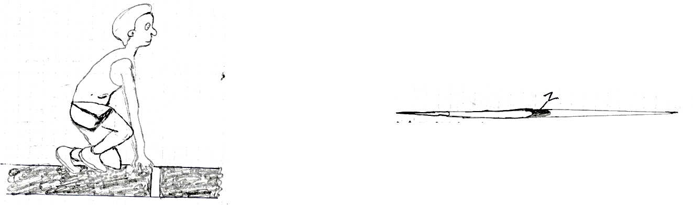

- Go B. Get Ready C. Set D. On your marks

- Mr. Matendechere from Makunga primary school took the grade 6 learners to the field for a out-door P.E practical lesson. He was carrying the below Javelin implement. The part marked Z is known as _
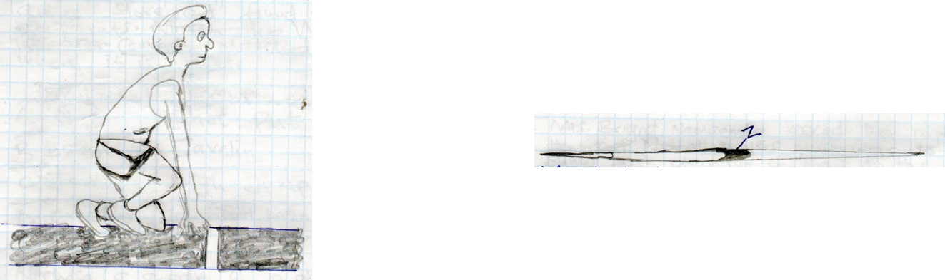

- Tail B. Shaft C. Metal head D. Cord
- Isongo primary grade 6 girls had a soccer friendly match with Mwitoti primary grade 6 girls, how many players were in the field playing when the game was going on.
- 11 B. 22 C. 15 D. 27
- A grade 6 pupil of Shitoto primary school went into a sports and games store and found the following equipments. Which equipment is correctly matched to the event where it is used.

 | EQUIPMENT | EVENT
 | Shot | Shot put
 | Baton | Javelin
 | Javelin | High jump
 | Crossbar | Non-visual baton exchange race
- Nechesa, a grade 6 pupil told her classmates during a P.E group discussion that the Handball goals are painted in two contrasting colours i.e Black/White or Red/White. Is it True or False:

- TRUE B. FALSE C. NOT-TRUE D. NOT SURE
- Mrs. Namaemba asked her pupils what the Netball players Must wear to clearly show the playing positions on the Netball court. Which pupil gave the correct answer.
- ROONEY- Jerseys B. SWEENEY- Shorts
C. WHITNEY- Bibs D. DAISY- Scurfs
- Grade 6 pupils were seen during a P.E lesson in the school field playing a game that involved touching opened and successfully escaping back to one’s half of the court without being restricted. The game they were playing was likely to be _____
- Soft ball B. Kabaddi C. Athletics D. Football
- Mr. Mamboleo explained to his grade 6 pupils that in Frisbee, a pancake catch is said to be well executed when the disc is flying between the chin height and the ________
- Hand B. Head C. Elbow D. Waist
- A teacher asked her grade 6 learners to improvise a soccer ball. Which of the following materials were not needed.
- Strings B. Old newspapers
C. Stones D. Soft nylon papers
- During a P.E lesson, a learner got injured and the school had no bandage. From which of the following materials can the teacher improvise a bandage:-

- Old timber B. Piece of clothe C. Wire D. Iron sheet.
- During the Inter-class competition at Muroni primary school, the above field was marked by a games teacher. The teacher asked the grade 6 pupils to jump field below. Which pupil gave the correct answer.
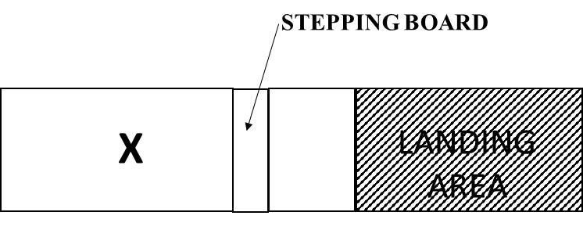

- JESCA - Straight area B. PETER - Jumping area
C. ANN - Runway D. JOHN -Landing area
- During a P.E practical lesson in the school field grade 6 pupils learned and practiced ways of trapping a soccer ball by a player. Which of the following was not learned and practiced as a way of trapping a soccer ball.
- Trapping using the sole B. Trapping using the chest
C. Trapping using the Elbow D. Trapping using the thigh
- John a grade 6 pupil asked his teacher to state a type of pass used in volleyball where a player uses one hand to receive or pass the ball in a situation where the player cannot reach the ball with both hands. What was the correct answer the teacher gave to John?
- Over arm Serve pass B. Single hand dig pass
C. Triangular pass D. Double hand pass.
- Appolo was seen holding a netball ball in the position shown in the picture during a netball competition. Which of these passes was she likely to apply?
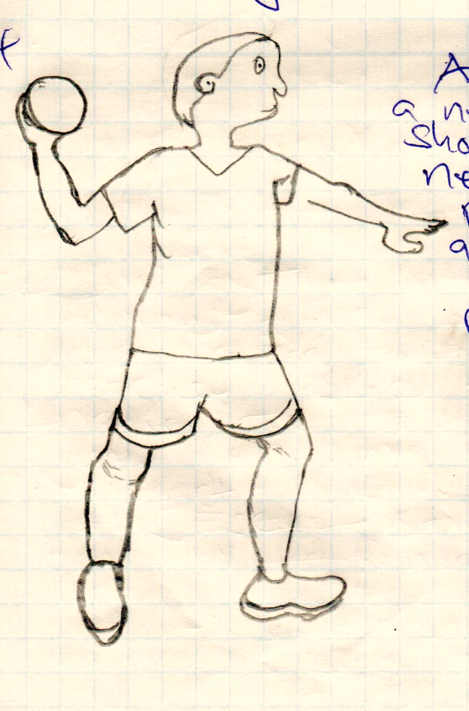

- Loop pass B. Head pass C. High pass D. Shoulder pass

- Mrs. Nyarotso took grade 6 learners to the field for a P.E lesson. Unfortunately, one learner got injured. What was she supposed to do?
- Take the pupil to the head teacher’s office
- Take the pupil to hospital
- Give first Aid to the pupil
- Call the pupil’s parents to come and take the pupil.

