Candidate’s Name: ………………………………………………………… Assessment Number: …………………………………………
School Name: ……………………………………………………………………. School Code: …………………………………………………………
Candidate’s Signature: ………………………………..…………….Date: …………………………………………………….…………….
COMPETENCE BASED EDUCATION
KENYA JUNIOR SCHOOL EDUCATION ASSESSMENT
912/1 PRE-TECHNICAL STUDIES THEORY
JUNE 2025
Time: 1 hour 40 minutes
INSTRUCTIONS TO CANDIDATES
- Write your name and assessment number in the spaces provided above.
- Write the name and code of your school in the spaces provided above.
- Sign and write the date of the assessment in the spaces provided above.
- This paper consists of two sections: A and B.
- Section A comprises Multiple Choice Questions.
- Section B comprises Short Structured questions.
- Answer ALL the questions in section A on the separate ANSWER SHEET provided.
- Answer ALL the questions in section B in the spaces provided in this question paper.
- Do not remove any page from this question paper.
- Answer all questions in English.
For official use only
Section | Task | Question Range | Max Score (Task) | Candidate's Score (Task)
B | Task 1 | 31-39 | 25
 | Task 2 | 40-44 | 12
 | Task 3 | 45-50 | 13
 |  | Total | 50
This paper consists of 12 printed pages. Candidates should check the question paper to ascertain that all the pages are printed as indicated and that no questions are missing.
© 2025, The Competence Based Assessment Turn over 1

SECTION A (30 marks) Read the instructions carefully.
- You have been given this question paper and a separate answer sheet.
- Answer ALL questions in this section on the ANSWER SHEET provided, NOT in the question paper.
- Do all the necessary rough work in the question paper.
HOW TO USE THE ANSWER SHEET
4. Use an ordinary HB pencil. 5. Confirm that the answer sheet you have been provided with has the following:
YOUR ASSESSMENT NUMBER
YOUR NAME
NAME OF YOUR SCHOOL
NAME OF THE SUBJECT
- Keep the answer sheet clean, dry and DO NOT fold it.
- For each of the questions 1 – 30, four options are given. The options are lettered A, B, C and D. In each case, only ONE of the four options is correct. Choose the correct answer from the options.
- On the answer sheet, the correct answer is to be shown by drawing a dark line inside the box in which the letter you have chosen is written.
Example In the Question Booklet:
  - Which one of the following drawing instruments is used to draw circles?
A. Set square B. Ruler C. Compass D. Protractor
The correct answer is ‘C’.
On the answer sheet, in the set of boxes given for number 18, draw a dark line inside the box with the letter C printed in it as indicated below.
18 [A] [B] [C] [D]
- Your dark line MUST be inside the box.
- For each question, ONLY ONE box is to be marked in each set of four boxes.

SECTION A (30 marks)
Answer ALL questions in this section on the answer sheets provided.

- Pre-Technical Studies integrates knowledge from different areas. Which one of the following combinations correctly represents the components of Pre-Technical Studies? A. Technical, Agriculture, and Business Studies. B. Technical, Entrepreneurship, and Computer Studies. C. Technical, Home Science, and Computer Studies. D. Technical, Art and Design, and Business Studies.

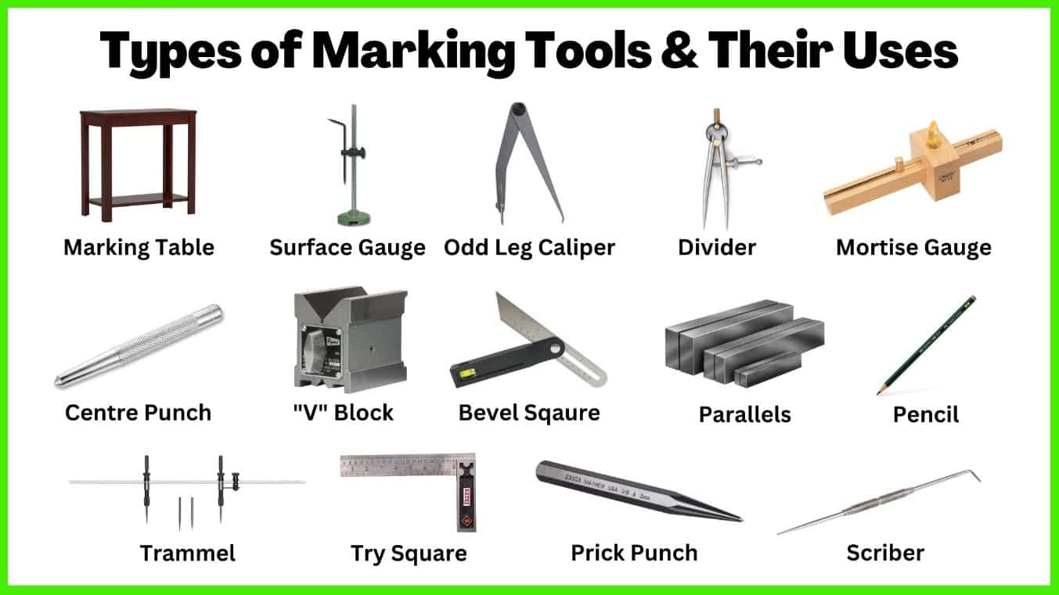
- Which one of the following tools is known as the sliding bevel?

A B C D

- Which one of the following drawing lines is used to indicate hidden edges or contours in a technical drawing? A. Continuous thick line B. Thin chain line C. Thin short dashes D. Continuous thin line
- A learner wants to draw a circle with a specific radius in technical drawing. Which tool is most suitable for this task? A. Tee square B. Set square C. Divider D. Compass
- Which one of the following is a common material used for making water pipes in construction? A. Timber B. Steel C. PVC (Polyvinyl Chloride) D. Glass
- A workshop tool used for driving nails into wood is a: A. Mallet B. Screwdriver C. Claw hammer D. Pliers
- Which one of the following safety rules should be observed when using hand tools in a workshop? A. Use tools with blunt edges. B. Leave tools lying on the floor. C. Use the right tool for the right job. D. Carry sharp tools in your pockets.
- Which one of the following is a synthetic material? A. Cotton B. Wool C. Plastic D. Leather

- When planning a simple construction project like a birdhouse, the first step should typically be: A. Gathering materials B. Drawing a plan C. Cutting the wood D. Assembling the parts
- A joint commonly used to connect two pieces of wood at a right angle is the: A. Butt joint B. Lap joint C. Mortise and tenon joint D. Dovetail joint
- Which one of the following is a primary source of business ideas? A. Reading biographies of entrepreneurs B. Identifying problems or needs in the community C. Copying successful businesses D. Attending business seminars
- The simplest form of business ownership where one person owns and runs the business is called a: A. Partnership B. Company C. Co-operative society D. Sole proprietorship
- Which one of the following is a factor to consider when choosing a location for a retail business? A. Availability of raw materials B. Proximity to competitors C. Access to customers D. Cost of production
- What is the purpose of marketing in a business? A. To pay taxes B. To promote and sell products C. To hire employees D. To keep financial records
- The amount of money a business owner has invested in the business is called: A. Revenue B. Expense C. Profit D. Capital
- Which one of the following is a source of passive income? A. Salary from a job B. Profit from selling goods C. Rent received from property D. Wages for services rendered
- What is budgeting in personal finance? A. Spending money without planning B. Tracking where money comes from and goes C. Borrowing money from friends D. Investing money in stocks
- What does 'saving' mean in financial terms? A. Spending money immediately B. Setting aside money for future use C. Buying goods on credit D. Donating money to charity
- Which one of the following activities is part of record keeping in a small business? A. Hiring staff B. Advertising products C. Recording daily sales D. Setting prices
- Which one of the following is an input device for a computer? A. Monitor B. Keyboard C. Printer D. Speaker
- Which type of computer is designed for use by one person at a time, typically on a desk? A. Supercomputer B. Mainframe computer C. Desktop computer D. Minicomputer
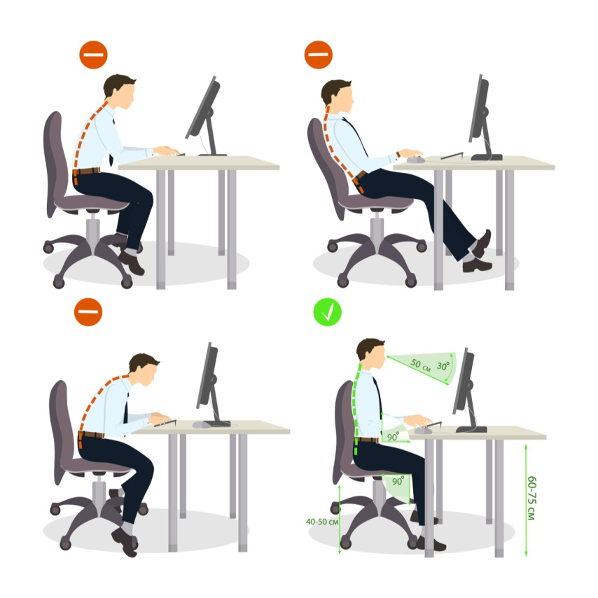
- Kalama was using his computer to draw 3D shapes. Which one of the following is the right posture while using the computer?

A B

C D
- Which one of the following is a safety precaution when using a computer? A. Eating and drinking near the computer B. Working in a dark room C. Sitting with proper posture D. Staring at the screen for long periods
- What is the main function of an operating system? A. To type documents B. To draw pictures C. To manage computer hardware and software D. To browse the internet

- Which one of the following software applications is used for creating and editing text documents? A. Spreadsheet software B. Presentation software C. Word processing software D. Database software
- In a spreadsheet, what is the formula to add the values in cells A1 and A2? A. SUM(A1+A2) B. ADD(A1, A2) C. A1+A2 D. =A1+A2
- Which one of the following is an example of application software? A. Windows B. Linux C. macOS D. Microsoft Word
- What is the primary purpose of using a password to access a computer or online account? A. To speed up the computer B. To protect information from unauthorized access C. To install new software D. To change the computer's settings
- Which one of the following is an example of an online threat? A. Saving a document B. Printing a file C. Phishing attacks D. Using a search engine
- What is the term for buying and selling goods or services using mobile devices? A. E-commerce B. M-commerce C. Social media marketing D. Online banking

SECTION B (50 marks)
Answer ALL the questions in this section in the spaces provided.
Task 1 (25 Marks)
- State two characteristics of a good technical drawing line. (2 marks)
________________________________________________________________________
_______________________________________________________________________
- The diagram below shows a common tool used in the workshop.
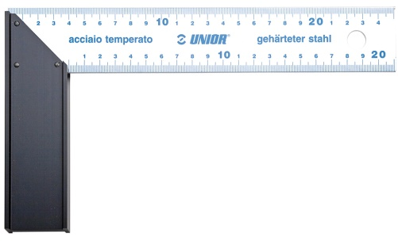
(a) Identify the tool shown above. (1 mark)
_______________________________________________________________________
(b) State two uses of this tool in woodworking. (2 marks)
________________________________________________________________________
_______________________________________________________________________
- Differentiate between Orthographic projection and Oblique projection as used in technical drawing. (2 marks)
_______________________________________________________________________
_______________________________________________________________________
_______________________________________________________________________

- Make a free hand sketch of a cylindrical tin in pictorial view. (3 marks)

- State three advantages of using plastic materials in making furniture compared to wood. (3 marks)
________________________________________________________________________
________________________________________________________________________
________________________________________________________________________
- Mention two raised platforms. (2 marks)
________________________________________________________________________
________________________________________________________________________
- Explain two ways in which recycling of materials benefits the environment. (2 marks)
_______________________________________________________________________
_______________________________________________________________________
______________________________________________________________________
- Name two cutting tools used for cutting sheet metal in a workshop. (2 marks)
________________________________________________________________________
________________________________________________________________________
- State three general safety rules that should be observed in any school workshop. (3 marks)
________________________________________________________________________
________________________________________________________________________
________________________________________________________________________
- Draw a complete electric circuit. (3 marks)
________________________________________________________________________
________________________________________________________________________
________________________________________________________________________
Task 2 (12 Marks)
- State two factors to consider when selecting a business site. (2 marks)
________________________________________________________________________
________________________________________________________________________
- Outline two benefits of preparing a simple business plan before starting a business. (2 marks)
________________________________________________________________________
________________________________________________________________________
- State two ways in which a small business can promote its products or services to attract customers. (2 marks)
________________________________________________________________________
________________________________________________________________________
- State two features of a fifty shilling currency note. (2 marks)
________________________________________________________________________
_______________________________________________________________________
________________________________________________________________________
- Jane started a small business selling fruits. In her first week, she bought fruits for Ksh 8000 and sold them for Ksh 12000. Her operating expenses were Ksh 1500.
(a) Calculate her revenue for the week. (1 mark)

(b) Calculate her profit for the week. (2 marks)

- State one ethical practice a business should follow when advertising its products. (1 mark)
________________________________________________________________________
_______________________________________________________________________
Task 3 (13 Marks)
- Differentiate between system software and application software, giving one example of each. (3 marks)
________________________________________________________________________
_______________________________________________________________________
________________________________________________________________________
- Eunice was learning about the C.P.U.
Name two components of the C.P.U. (2 marks)
________________________________________________________________________
________________________________________________________________________
- Outline two safety precautions a learner should take to protect their personal information when using the internet. (2 marks)
________________________________________________________________________
________________________________________________________________________
- State one advantage and one disadvantage of using online communication platforms for businesses. (2 marks)
Advantage:
____________________________________________________________________
Disadvantage:
____________________________________________________________________

- A learner used the following output hardware component in the school. What is the name of the hardware component? (1 mark)

___________________________________________.
- Give two examples of common file extensions used for text documents and images. (2 marks)
Text document: ______________________________________________________________
Image: ____________________________________________________________________
- Explain why it is important to back up your computer files regularly. (1 mark)
________________________________________________________________________
________________________________________________________________________

THIS IS THE LAST PRINTED PAGE.

MARKING SCHEME
SECTION A (30 marks)
- B. Technical, Entrepreneurship, and Computer Studies.
- C (Sliding Bevel - the image labelled C)
- C. Thin short dashes
- D. Compass
- C. PVC (Polyvinyl Chloride)
- C. Claw hammer
- C. Use the right tool for the right job.
- C. Plastic
- B. Drawing a plan
- A. Butt joint
- B. Identifying problems or needs in the community
- D. Sole proprietorship
- C. Access to customers
- B. To promote and sell products
- D. Capital
- C. Rent received from property
- B. Tracking where money comes from and goes
- B. Setting aside money for future use
- C. Recording daily sales
- B. Keyboard
- C. Desktop computer
- D (Sitting with proper posture)
- C. Sitting with proper posture
- C. To manage computer hardware and software
- C. Word processing software
- D. =A1+A2
- D. Microsoft Word
- B. To protect information from unauthorized access
- C. Phishing attacks
- B. M-commerce
SECTION B (50 marks) Task 1 (25 Marks) 31. * Uniform thickness * Consistent darkness
- (a) Try square
(b) * Marking right angles
* Checking for squareness

  - Orthographic projection: Shows different views of an object (front, top, side) with parallel projection lines perpendicular to the projection plane.
  - Oblique projection: Shows a pictorial view of an object with parallel projection lines drawn at an angle (not 90 degrees) to the projection plane.
- (Freehand sketch of a cylindrical tin in pictorial view)
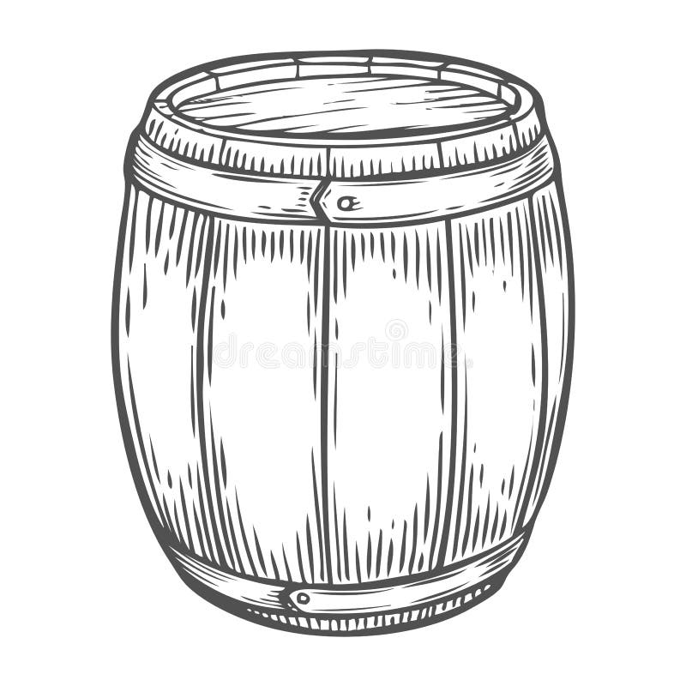

  - Resistant to moisture and rot
  - Lightweight
  - Easy to clean

  - Podium
  - Stage

  - Reduces the amount of waste sent to landfills.
  - Conserves natural resources by reducing the need for raw materials.

  - Tin snips
  - Guillotine shear

  - Wear appropriate personal protective equipment (PPE).
  - Use the right tool for the job.
  - Keep the workshop clean and tidy.
- (Drawing of a complete electric circuit including a power source, switch, bulb, and connecting wires)
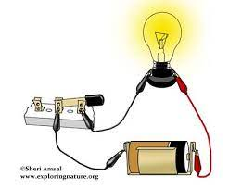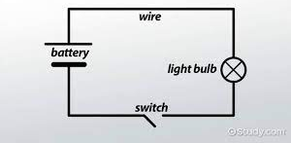
Task 2 (12 Marks)
41. * Accessibility to customers
* Visibility of the business
Security of the area

  - Helps to identify potential problems and challenges.
  - Provides a roadmap for the business operations and goals.

  - Using social media platforms
  - Offering discounts or promotions

  - It is rectangular in shape.
  - It has the portrait of the first president, Jomo Kenyatta.
  - It is predominantly green in colour.
- (a) Revenue = Ksh 12000 (b) Profit = Revenue - (Cost of goods sold + Operating expenses) = Ksh 12000 - (Ksh 8000 + Ksh 1500) = Ksh 12000 - Ksh 9500 = Ksh 2500

  - Avoid making false or misleading claims about the product.
Task 3 (13 Marks)
47. * System software: Software that manages and controls computer hardware and provides a platform for application software to run. Example: Operating System (e.g., Windows, Linux).
* Application software: Software designed to perform specific tasks for the user. Example: Word processor (e.g., Microsoft Word), Web browser (e.g., Chrome).

  - Arithmetic Logic Unit (ALU)
  - Control Unit (CU)

  - Use strong and unique passwords.
  - Be cautious about sharing personal information online.
- Advantage: Facilitates quick and easy communication with customers and partners. Disadvantage: Security risks such as hacking or data breaches.
- printer
- Text document: .txt, .docx Image: .jpg, .png
- To prevent data loss due to hardware failure, software errors, viruses, or accidental deletion.

