Candidate’s Name: ………………………………………………………… Assessment Number: …………………………………………
School Name: ……………………………………………………………………. School Code: …………………………………………………………
Candidate’s Signature: ………………………………..…………….Date: …………………………………………………….…………….
COMPETENCE BASED EDUCATION
KENYA JUNIOR SCHOOL EDUCATION ASSESSMENT
812/1 PRE-TECHNICAL STUDIES (Theory)
June, 2025 Time: 1 hour 40 minutes
INSTRUCTIONS TO CANDIDATES
- Write the required details required in the spaces provided above.
- This paper consists of two sections: A and B.
- Section A comprises Multiple Choice Questions.
- Section B comprises Short Structured questions.
- Answer ALL the questions in section A on the separate ANSWER SHEET provided.
- Answer ALL the questions in section B in the spaces provided in this question paper.
- Do not remove any page from this question paper.
- Answer all questions in English.
For official use only
SECTION B
Task | Question Range | Max Score per Task | Candidate’s Score per Question | Candidate’s Score per Task
Task 1 | 31-38 | 25
Task 2 | 39-44 | 12
Task 3 | 45-50 | 13
Total |  | 50

This paper consists of 13 printed pages. Candidates should check the question paper to ascertain that all the pages are printed as indicated and that no questions are missing.

© 2025, The Competence Based Curriculum Turn over 1

SECTION A (30 marks) Read the instructions carefully.
- You have been given this question paper and a separate answer sheet.
- Answer ALL questions in this section on the ANSWER SHEET provided, NOT in the question paper.
- Do all the necessary rough work in the question paper.
HOW TO USE THE ANSWER SHEET 4. Use an ordinary HB pencil. 5. Confirm that the answer sheet you have been provided with has the following:
YOUR ASSESSMENT NUMBER
YOUR NAME
NAME OF YOUR SCHOOL
NAME OF THE SUBJECT
- Keep the answer sheet clean, dry and DO NOT fold it.
- For each of the questions 1 – 30, four options are given. The options are lettered A, B, C and D. In each case, only ONE of the four options is correct. Choose the correct answer from the options.
- On the answer sheet, the correct answer is to be shown by drawing a dark line inside the box in which the letter you have chosen is written.
Example In the Question Booklet:
  - Which one of the following tools is used for measuring length? A. Hammer B. Ruler C. Saw D. Chisel
The correct answer is ‘B’.
On the answer sheet, in the set of boxes given for number 15, draw a dark line inside the box with the letter B printed in it as indicated below.
15) [A] [B] [C] [D]
- Your dark line MUST be inside the box.
- For each question, ONLY ONE box is to be marked in each set of four boxes.

SECTION A (30 marks)
Answer ALL questions in this section on the answer sheets provided.

- Which one of the following is a safety hazard in a workshop? A. Wearing safety goggles B. Tools left lying on the floor C. Good lighting D. Proper ventilation
- A tool used for marking straight lines on wood or metal is a: A. Marking gauge B. Centre punch C. Scriber D. Dividers
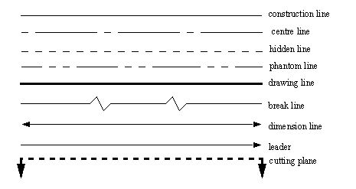
- Which type of line in technical drawing represents cutting plane?
A.
B.
C.
D.

- Which one of the following materials is obtained from trees? A. Steel B. Concrete C. Plastic D. Timber

- Angela drew a certaing symbol on the chalkboard. What does in mean?

A. Right hand B. Diameter C. Square D. Centre line

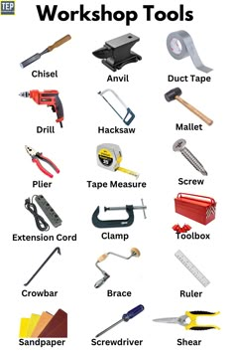
- Which one of the following is a cutting tool?
A.

B.

C.

D.
- What does the acronym PPE stand for in the context of workshop safety? A. Personal Protection Equipment B. Public Property Entry C. Project Planning and Evaluation D. Practical Performance Exercise
- Which one of the following is not a property of free hand sketching? A. erasing and correction B. texture C. Transparency D. Observation
- Ceramics are made from non-metallic materials, usually fired at high temperatures. Which one of the following is a common ceramic material? A. Rubber B. Tiles C. printers D. Cement
- A simple construction project involves joining two pieces of wood. Which one of the following is a common fastener used for this purpose? A. Bolt B. Rivet C. Nail D. Screw

- Who is an entrepreneur? A. Someone who works for wages B. Someone who starts and runs a business, taking on financial risks C. Someone who manages a company D. Someone who invests in the stock market
- Which one of the following is a source of business ideas? A. Saving money B. Identifying problems or unmet needs C. Paying taxes D. Hiring staff
- The resources needed to start and operate a business are classified into different types. Which one of the following is an example of a financial resource? A. Equipment B. Employees C. Capital D. Raw materials
- Keeping track of money coming into and going out of a business is called: A. Marketing B. Planning C. Record keeping D. Advertising
- What is the main purpose of a simple cash book in a business? A. To record customer details B. To track daily cash receipts and payments C. To list all the assets of the business D. To advertise products
- Which one of the following is a source of personal income? A. Spending money B. Saving money C. Budgeting D. Salary
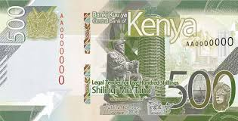
- Which one of the following is a theme in the following Kenyan currency note?

- Tourism
- Agriculture
- Social service
- Governance
- Which one of the following is a benefit of saving money? A. You can spend more money immediately B. You have funds for future needs or emergencies C. It increases your expenses D. It makes you poor
- Which one of the following is an unethical practice by a seller towards a consumer? A. Providing accurate product information B. Selling goods at a fair price C. Selling expired goods D. Offering discounts
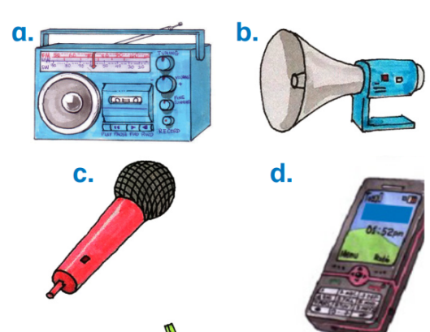
- Which one of the following ICT tool can be used in video conferencing?

- Which one of the following is a hardware component of a computer? A. Microsoft Word B. Operating System C. Keyboard D. Internet Browser
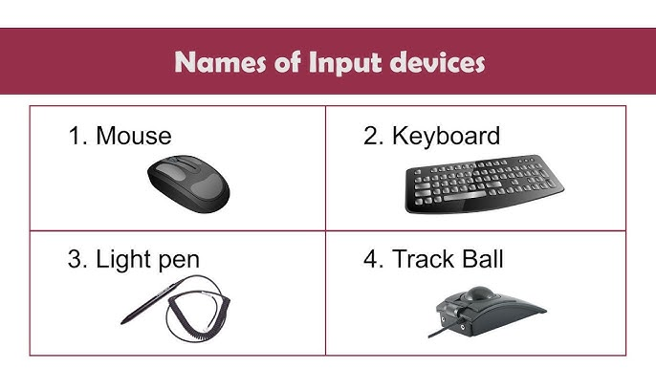
- Which device is used to input data into a computer by typing?

A. B.

C. D.

- What is the main function of the Central Processing Unit (CPU)? A. To display images B. To store data permanently C. To perform calculations and execute instructions D. To print documents
- Which one of the following is an example of storage hardware? A. Speakers B. Microphone C. Hard disk drive D. Projector
- Which one of the following is an example of system software? A. Paint program B. Spreadsheet application C. Web browser D. Operating System
- What is the primary function of the operating system? A. To create presentations B. To manage computer resources and provide a user interface C. To send emails D. To play games
- Which one of the following is a basic function performed in a word processing application? A. Performing complex calculations B. Creating video animations C. Typing and editing text D. Managing databases
- What is meant by 'cyberbullying'? A. Using the internet to research B. Using digital technology to harass or bully someone C. Sharing information online D. Playing online games
- Which one of the following is a measure to protect your privacy online? A. Sharing your password with friends B. Accepting friend requests from strangers C. Being careful about what information you share online D. Clicking on all links you receive
- What is an email address used for? A. To browse websites B. To send and receive electronic messages C. To store files online D. To make phone calls over the internet

SECTION B (50 marks)
Answer ALL the questions in this section in the spaces provided.
Task 1 (25 Marks)
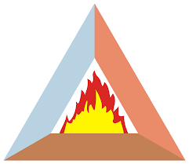
- During a fire safety lesson, learners drew a fire triangle.

Mention two components of a fire triangle. (2 marks)
________________________________________________________________________
________________________________________________________________________
- Name the following drawing symbols: (2 marks)
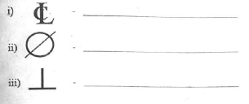
- ________________________________.

- ________________________________.

- State two reasons why workshop tools should be cleaned after use. (2 marks)
____________________________________________________________________.
____________________________________________________________________.
- During a workshop visit, learners were asked to identify the following measuring tools. What are their names? (3 marks)

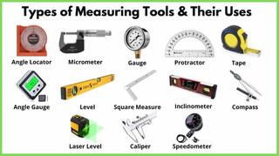

A)___________________ B)__________________ C)___________________
- Make a freehand sketch of a caricature. (3 marks)

- State three common materials used in construction of buildings. (3 marks)
________________________________________________________________________
_______________________________________________________________________
______________________________________________________________________
- Explain one two causes of fire at the workplace. (2 marks)
______________________________________________________________________
______________________________________________________________________
- State three characteristics of metallic materials. (3 marks)
_____________________________________________________________________
____________________________________________________________________
____________________________________________________________________
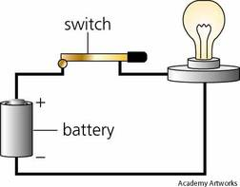
- Grade 8 learners were testing electrical conductivity of metals. Name two examples of metals when paced at part x will make the bulb ligt? (2 marks)
x

  - _______________________________________________.

  - _______________________________________________.
- Describe two ways in which recycling waste materials helps the environment. (3 marks)
________________________________________________________________________
________________________________________________________________________
________________________________________________________________________
Task 2 (12 Marks)
- State two characteristics of a good entrepreneur. (2 marks)
_______________________________________________________________________
_______________________________________________________________________
- Name two types of resources needed to start a small business. (2 marks)
______________________________________________________________________
______________________________________________________________________
- John started a small business selling mandazi. His total sales for the first day were Ksh 1500. The cost of ingredients was Ksh 600, and he paid transport of Ksh 100. Calculate his profit for the day. (3 marks)

- State two reasons why record keeping is important for a small business. (2 marks)
________________________________________________________________________
________________________________________________________________________
- Outline three features of the currency note below. (3 marks)
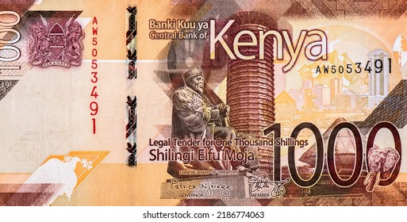
________________________________________________________________________
________________________________________________________________________
________________________________________________________________________

Task 3 (13 Marks)
- Name two common input devices for a computer. (2 marks)
________________________________________________________________________
________________________________________________________________________
- State two functions of a monitor. (2 marks)
_______________________________________________________________________
______________________________________________________________________
- Explain the difference between hardware and software, giving one example of each. (3 marks)
________________________________________________________________________
________________________________________________________________________
________________________________________________________________________

- Below is a spreadsheet application.

State one basic function of a spreadsheet application. (1 mark)
______________________________________________________________________
- State two potential dangers of sharing too much personal information on social media. (2 marks)
________________________________________________________________________
________________________________________________________________________
- Explain why strong passwords are important for online security. (1 mark)
________________________________________________________________________
________________________________________________________________________
- Name one popular search engine used to find information on the internet. (1 mark)
______________________________________________________________________

- Name one ICT tool used in communication. (1 mark)
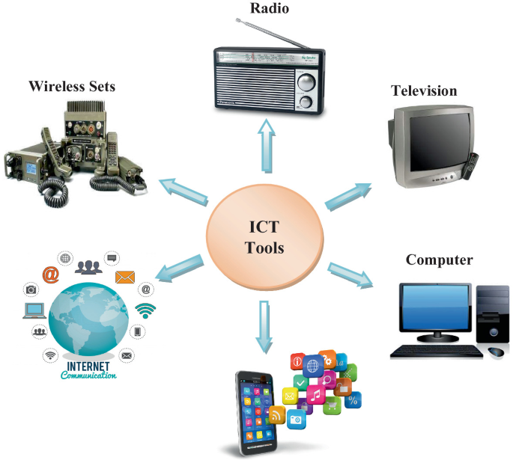

_________________________

THIS IS THE LAST PRINTED PAGE.

Answers
SECTION A (30 marks)
- B.
- C.
- D.
- D.
- D.
- A.
- A.
- C.
- B.
- C. Nail
- B. Someone who starts and runs a business, taking on financial risks
- B. Identifying problems or unmet needs
- C. Capital
- C. Record keeping
- B. To track daily cash receipts and payments
- D. Salary
- B. Agriculture
- B. You have funds for future needs or emergencies
- C. Selling expired goods
- D. Webcam in the mobile phone
- C. Keyboard
- B.
- C. To perform calculations and execute instructions
- C. Hard disk drive
- D. Operating System
- B. To manage computer resources and provide a user interface
- C. Typing and editing text
- B. Using digital technology to harass or bully someone
- C. Being careful about what information you share online
- B. To send and receive electronic messages
SECTION B (50 marks)
Task 1 (25 Marks)
- Two components of a fire triangle are:
  - Fuel
  - Heat
  - Oxygen
- Name the following drawing symbols: A. Diameter B. Perpendicularity
- Two reasons why workshop tools should be cleaned after use:
  - To prevent rust and corrosion.
  - To ensure they are ready for the next use and in good working condition.
- The names of the following measuring tools are: A) Tape measure B) Try square C) spirit level/bubble level
- (A freehand sketch of a caricature should be drawn here. A caricature is an exaggerated drawing of a person or thing.)



- Three common materials used in the construction of buildings:
  - Concrete
  - Bricks/Blocks
  - Timber
  - etc
- One cause of fire at the workplace:
  - Electrical faults due to faulty wiring or overloaded sockets.
  - Flammable materials not stored properly near sources of heat.
  - Arson
  - Human error
  - Overloading socket
  - Electrical short circuit
  - etc
- Three characteristics of metallic materials:
  - They are usually hard and strong.
  - They are good conductors of heat and electricity.
  - They often have a shiny appearance (lustrous).
- Two examples of metals that, when placed at part X, will make the bulb light: a. Copper b. Aluminum any other electrical metal conductor
- Two ways in which recycling waste materials helps the environment:
  - It reduces the amount of waste sent to landfills, conserving land and reducing pollution.
  - It conserves natural resources by reducing the need to extract raw materials.
  - It saves energy compared to manufacturing products from new raw materials.
Task 2 (12 Marks)
- Two characteristics of a good entrepreneur:
  - Risk-taker
  - Innovative/Creative
  - Persistent/Determined
  - Good communicator
- Two types of resources needed to start a small business:
  - Financial resources (capital/money)
  - Human resources (labor/employees)
  - Physical resources (equipment/materials)
- Profit calculation:
Total sales = Ksh 1500
Cost of ingredients = Ksh 600
Transport cost = Ksh 100
Total expenses = Cost of ingredients + Transport cost
= Ksh 600 + Ksh 100 = Ksh 700
Profit = Total sales - Total expenses = Ksh 1500 - Ksh 700 = Ksh 800 John's profit for the day was Ksh 800.
- Two reasons why record keeping is important for a small business:
  - To track income and expenses, helping to determine profitability.
  - To make informed decisions about the business, such as pricing and budgeting.
  - To comply with legal and tax requirements.
- Three features of the currency note below (assuming it's a Kenyan currency note, for example, a 50 shilling note):
  - It features a portrait of a prominent Kenyan figure (e.g., Jomo Kenyatta).
  - It displays the Coat of Arms of Kenya.
  - It has security features to prevent counterfeiting (e.g., a security thread, watermark).
  - It shows a specific theme related to Kenya (e.g., agriculture, tourism, governance).
Task 3 (13 Marks)
- Two common input devices for a computer:
  - Keyboard
  - Mouse
- Two functions of a monitor:
  - To display visual output from the computer.
  - To allow the user to interact with the computer interface.
- Hardware refers to the physical components of a computer that you can touch, such as the keyboard or the monitor. Software, on the other hand, is a set of instructions or programs that tell the hardware what to do. An example of hardware is a mouse, and an example of software is a web browser.
- One basic function of a spreadsheet application:
  - Performing calculations using formulas.
  - Organizing data in rows and columns.
  - Creating charts and graphs to visualize data.
- Two potential dangers of sharing too much personal information on social media:
  - Risk of identity theft.
  - Potential for cyber bullying or harassment.
  - Information could be used for unwanted marketing or spam.
  - Information could be used against you in the future (e.g., by potential employers).
- Strong passwords are important for online security because they make it difficult for unauthorized individuals to guess or crack your passwords and gain access to your accounts and personal information.
- One popular search engine used to find information on the internet:
  - Google
  - Bing
  - DuckDuckGo
- One ICT tool used in communication:
  - Mobile phone
  - Email
  - Social media platform
  - Video conferencing software (e.g., Zoom, Google Meet)
  - Any other in the picture

