Candidate’s Name: ………………………………………………………… Assessment Number: …………………………………………
School Name: ……………………………………………………………………. School Code: …………………………………………………………
Candidate’s Signature: ………………………………..…………….Date: …………………………………………………….…………….
COMPETENCE BASED EDUCATION
KENYA JUNIOR SCHOOL EDUCATION ASSESSMENT
707: SOCIAL STUDIES
JUNE 2025 Time: 1 Hour 30 Minutes
INSTRUCTIONS TO CANDIDATES
- Write your details required in the spaces as indicated above.
- This paper consists of two sections: A and B.
- Section A comprises Multiple choice Questions.
- Section B comprises structured questions and essay questions.
- Answer ALL the questions in Section A on the separate ANSWER SHEET provided.
- Answer ALL the questions in Section B in the spaces provided on this question paper.
- Do NOT remove any page from this question paper.
- Answer the questions in English.
For official use only
Task | Question | Candidate’s score | Maximum Score (Task) | Candidate’s Score per Task
Task 1 | 28 |  | 9
Task 2 | 30 |  | 21
 | 23 |  | 21
 | 25 |  | 21
 | 26 |  | 21
Task 3 | 32 |  | 25
 | 21 |  | 25
 | 24 |  | 25
 | 29 |  | 25
Task 4 | 22 |  | 25
 | 27 |  | 25
 | 31 |  | 25
 | 33 |  | 25
 | 34 |  | 25

This paper consists of 16 printed pages.

Candidates should check the question paper to ascertain that all the pages are printed as indicated and that no questions are missing.
© 2025 The Competence Based Curriculum Turn Over
- You have been given this question paper and a separate answer sheet. Answer all the questions in Section A on the separate answer sheet provided.
- When you have chosen your answer, mark it on the ANSWER SHEET, not on this question paper.
HOW TO USE THE ANSWER SHEET
- Use an ordinary HB pencil.
- Confirm that the answer sheet you have been provided with has the following:
YOUR ASSESSMENT NUMBER YOUR NAME
NAME OF YOUR SCHOOL NAME OF THE SUBJECT
- Keep the answer sheet clean, and dry and DO NOT fold it.
- For each of the questions 1 – 20, four answers are given. The answers are lettered A, B, C and D. In each case, only ONE of the four answers is correct. Choose the correct answer.
- On the answer sheet, the correct answer is to be shown by drawing a dark line inside the box in which the letter you have chosen is written.
Example
In the Question Booklet:
- Your class is planning to start an enterprise project in the school. The first activity the class should do is to:
A. agree on how to share the profits from the project B. agree on roles during the project C. discuss where to sell the products D. discuss the type of project to start.
The correct answer is ‘D’.
On the answer sheet, in the set of boxes given for number 17, draw a dark line inside the box with the letter D printed in it as indicated below.
17. [A] [B] [C] [D]
- Your dark line MUST be inside the box.
- For each question, ONLY ONE box is to be marked in each set of four boxes.

SECTION A (20 marks)
Answer ALL the questions in this section.

- Social Studies combine different disciplines to help us understand society. Which of the following subjects is included in Social Studies? A. Chemistry B. Mathematics C. Geography D. Biology

- Living peacefully with others requires positive interactions. Which of the following actions promotes peaceful coexistence in the school? A. Teasing and bullying other learners. B. Respecting the opinions of others. C. Forming exclusive groups that exclude others. D. Spreading false information about classmates.

- Slaves were sold like goods. Which one of the following was the main good exchanged during Indian Ocean slave trade? A. Televisions B. Spices C. Gold D. Slaves
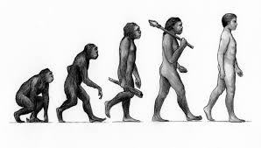
- Man has being evolving. Identify the modern man:

A B C D
- Social studies can provide learners with entrepreneurial opportunities. Which one of the following is an entrepreneurial oppotunity related to social studies? A. teaching B. flying aeroplane C. swimming D. basketry.
- Basic weather instruments are used to measure elements of weather. Which instrument is used to measure the amount of rainfall? A. Wind vane B. Anemometer C. Thermometer D. Rain gauge

- Map reading skills are important in Social Studies. Which of the following is used on a map to show the relationship between the distance on the map and the actual distance on the ground? A. Legend B. North arrow C. Title D. Scale
- Grade 7 learners studied different types of trades. The type of trade demonstrated below is likely to be?

A. barter trade B. currency trade C. international trade D. money-market trade
- Population refers to the total number of people living in a particular area. Which of the following factors would discourage people from settling in an area? A. Availability of water sources. B. Presence of fertile soil. C. Harsh climatic conditions. D. Availability of social amenities.
- Which one of the following was not an early visitor to the east coast of Africa?
- Persians B. Portuguese C. Arabs D. Americans
- Different sources help us learn about the past. Which of the following is an example of an oral source of history? A. A photograph B. A traditional song C. An ancient building D. A historical document
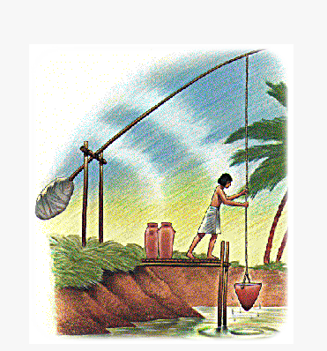
- Grade 9 learners were shown the following type of irrigation used in ancient Egypt.

The irrigation method shown above was known as? A. Canal irrigation B. Basin irrigation C. Shadoof irrigation D. Overead irrigation
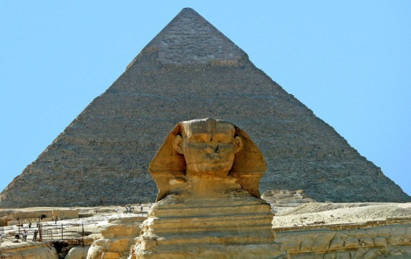
- Which one of the following early African kingdom is associated with the building and and construction of the following structure?

A. Mali empire B. Egyptian kingdom. C. Kongo kingdom. D. Zimbabwe kingdom.
- Values guide our actions and choices. Which of the following is a positive value that helps in building trust with others? A. Cheating B. Loyalty C. Greed D. Laziness
- Every child has rights. Which of the following is a right of a child? A. Right to work for long hours. B. Right to be denied education. C. Right to protection from harm. D. Right to make all their own decisions.

- Citizenship means belonging to a country. Which of the following is a responsibility of a good citizen in school? A. Disobeying school rules. B. Littering the school compound. C. Participating in school activities. D. Damaging school property.

- Conflicts can happen at home or in school. Which of the following is a common cause of conflict among learners in school? A. Sharing of resources. B. Respecting each other's opinions. C. Misunderstanding communication. D. Helping each other with school work.

- Ancient communities developed different technologies. The knowledge of hieroglyphics helped the modern world in?
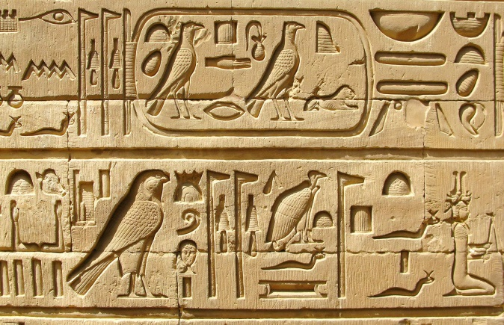
A. hunting. B. Building. C. writing . D. Preserve food more.
- Traditional methods of interaction between African communities included trade and cultural exchange. Which of the following is a benefit of cultural exchange? A. Communities become identical. B. People learn new ways of doing things. C. It always leads to conflicts. D. Traditional practices are completely abandoned.
- Our moods can affect how we relate with others. Which one of the following shows a angry mood?


A B C D

SECTION B (80 marks)
Answer ALL questions in this section.
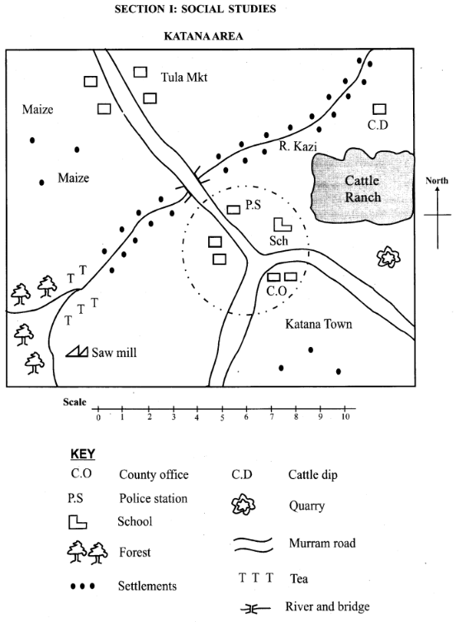
- A Social Studies teacher used the sketch map provided to facilitate a lesson on map reading.

Katana hill

In km

Hill
  - The teacher asked the learners to give the direction of Tula market from the School. The direction is (1 mark)
_____________________________________________________________________________
b) During the lesson, the teacher asked the learners to measure the straight-line distance between the Katana hill and the School using the provided scale. G i v e t h e d i s t a n c e in kilometres metres. (Show your working) (2 marks)
_____________________________________________________________________________
_____________________________________________________________________________c) Learners observed that most people had settled along river kazi. State the settlement pattern along River Kazi( 1 mark)
_____________________________________________________________________________
d) The learners observed different features shown on the map. Name four features shown on the map. (2 marks)
_____________________________________________________________________________

_____________________________________________________________________________

_____________________________________________________________________________
_____________________________________________________________________________
e) A crime happens In katana town, where will the people report the crime to?
__________________________________________________ ( 1mark)
f) The learners were asked to discuss why people might choose to live in the area shown on the map. Identify three possible reasons based on the features shown. (3 marks)
_____________________________________________________________________________

_____________________________________________________________________________
_____________________________________________________________________________
- Human rights are important for everyone. Identify five basic rights that you enjoy as a child at home and in school. (5 marks)
______________________________________________________________________

______________________________________________________________________

______________________________________________________________________

______________________________________________________________________
______________________________________________________________________
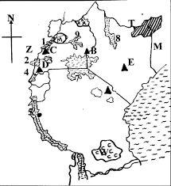
- Grade 7 learners were learning about physical features on a map.
M

N

O

a) Identify mountains marked BEC. (3 marks)
B________________________E________________________ C_______________________
b) Identify the water body marked MNO. (3 marks)
M __________________________________________________________________________

N __________________________________________________________________________
0___________________________________________________________________________

- Grade 7 learners discussed the characteristics of early human beings.
a) Identify two uses of fire during the early man’s stage. (2 marks)
____________________________________________________________________________
_____________________________________________________________________________
b) Give three Characteristics of zinjenthropus. (3 marks)
_____________________________________________________________________________

_____________________________________________________________________________
_____________________________________________________________________________
- Conflicts can occur in the school environment.
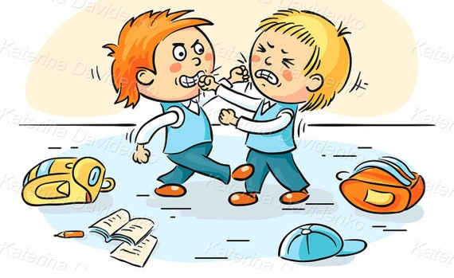
Outline two simple methods that learners can use to resolve disagreements among themselves peacefully. (2 marks)
_____________________________________________________________________________
_____________________________________________________________________________
- African communities have diverse cultures. State three aspects that make up the culture of a community. (3 marks)
_____________________________________________________________________________

_____________________________________________________________________________
_____________________________________________________________________________
- Learners discussed the importance of various resources found in their environment.
  - Outline two natural resources found in Kenya. (2 marks)
_____________________________________________________________________________

____________________________________________________________________________

____________________________________________________________________________

Use the map of Kenya blow to answer the following questions
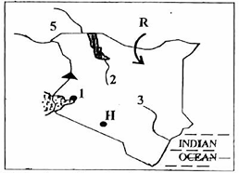
    - Which mineral is mined in the area marked H (1 mark)
_________________________________________________________.
    - Identify the city marked 1. (1 mark)
_________________________________________________________.
    - River 3 is called? (1 mark)

________________________________________________________.
    - The country marked 5 is called? (1 mark)
_______________________________________________________.
- Learners discussed positive values that help people live well together. Highlight five values that promote good relationships within a family. (5 marks)
_____________________________________________________________________________

_____________________________________________________________________________

_____________________________________________________________________________

_____________________________________________________________________________
_____________________________________________________________________________
- Grade 7 learners were taught about sources of historical information.
a) Identify four examples of sources of historical information. (4 marks)
_____________________________________________________________________________

_____________________________________________________________________________

_____________________________________________________________________________
_____________________________________________________________________________

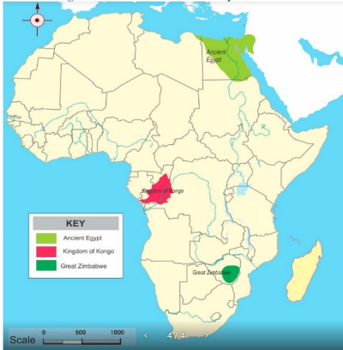
b) Using the map below, mention the early African kingdoms labeled QRS. ( 3 marks)
R
Q
S

Q: ___________________________________.
R: ___________________________________.
S: ___________________________________.

  - Explain three ways in which the Arabs influenced the culture at the coast in kenya.( 2 marks)
_____________________________________________________________________________

_____________________________________________________________________________

_____________________________________________________________________________

_____________________________________________________________________________
- Members of the Social Studies club discussed factors that influence the growth of the Egyptian kingdom. Mention any two factors. (2 marks)
_____________________________________________________________________________

_____________________________________________________________________________

_____________________________________________________________________________

_____________________________________________________________________________
  - Name the following Egyptian technologies. ( 3 marks)

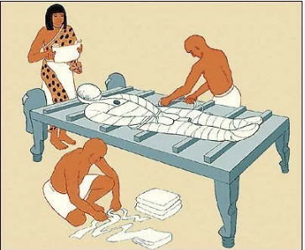 | 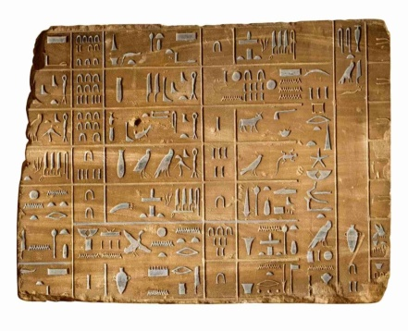 | 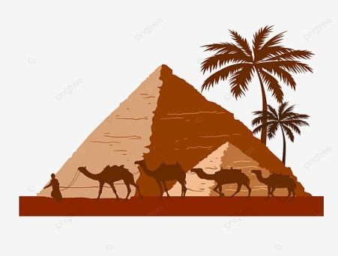
- Different economic activities are carried out in Africa. Discuss two benefits of practicing agriculture to a community. (4 marks)
_____________________________________________________________________________

_____________________________________________________________________________

_____________________________________________________________________________

_____________________________________________________________________________

_____________________________________________________________________________

- Grade 7 learners discussed about money
- Highlight three functions of money. (3 marks)

_____________________________________________________________________________

_____________________________________________________________________________

_____________________________________________________________________________

- State three characteristics of barter trade. (3 marks)

_____________________________________________________________________________

_____________________________________________________________________________

_____________________________________________________________________________

- Buruburu has a total population of 50,000 people with an area of 10km². Calculate its population density.( 2 marks)

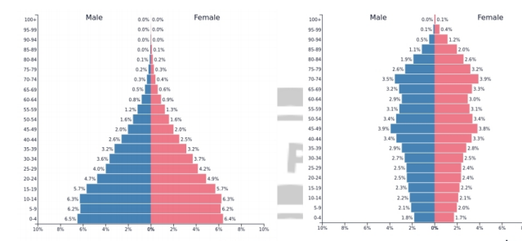
- From the diagram below. Identify the population pyramid of Kenya. (1 mark)

A B

- Being a good citizen involves fulfilling certain duties. State three responsibilities that you have as a learner in contributing to the cleanliness of your school environment. (3 marks)
________________________________________________________________________

________________________________________________________________________

________________________________________________________________________

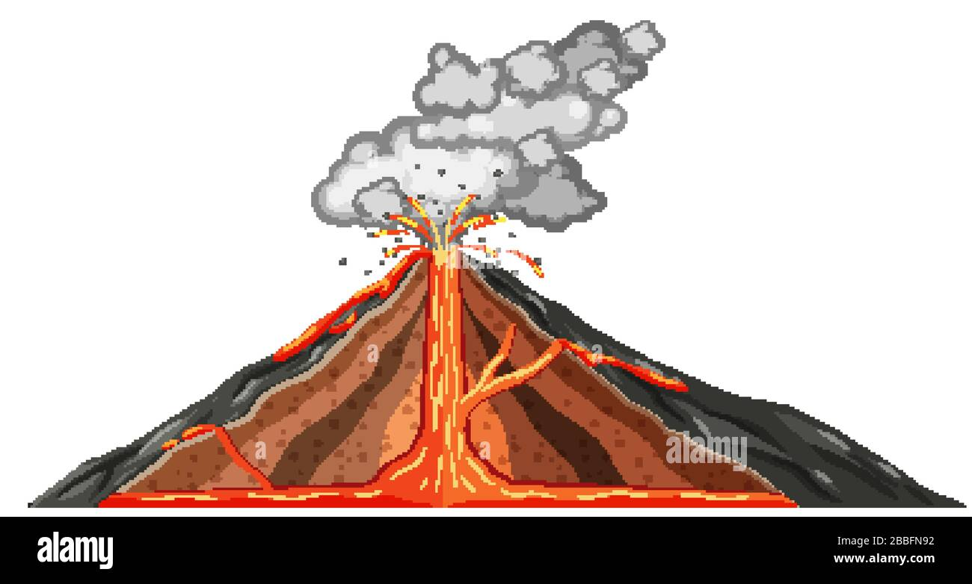
- A Grade 7 teacher used a simple diagram to illustrate a basic concept in Social Studies. Use it to answer questions a and b.

U

V

a) (i) Identify the feature shown in the diagram.
__________________________________________________________________ (1 mark)
ii) Name one mountain in Kenya formed through the process above.
___________________________________________________________________ (1 mark)
b) Name the parts labelled.
U: _________________________________________.

V: _________________________________________.

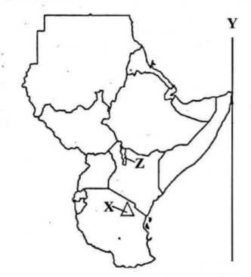
  - Use the map of eastern Africa below to answer the following questions

Name the feature marked.
Z: ________________________________.
X: ________________________________.

THIS IS THE LAST PRINTED PAGE

MARKING SCHEME
SECTION A (20 marks)
- C.
- B.
- D.
- D
- D.
- D.
- D.
- A.
- C.
- D.
- B.
- C.
- B.
- B.
- C.
- C.
- C.
- C.
- B.
- C
SECTION B (80 marks)
- a) North- East b) Working:
  - Measure the distance on the map using a ruler (e.g., it might be 12 cm).
  - Use the scale to convert this to actual distance (e.g., if 1 cm = 1km then 4 cm = 12 * 1 = 12km
  - Answer: The straight-line distance is 12km​ c) Linear settlement d) - Market
    - School
    - River
    - Village
    - Road
e) Katana Police station f) - Availability of water: People settle near rivers for water supply for domestic use and agriculture.
    - Presence of fertile soil: Areas near rivers often have fertile land due to silt deposits, which is good for farming.
    - Accessibility: The presence of a road suggests easier transportation and communication, attracting settlement.
    - Road network
    - Availability of school
    - Presence of employment opportunities like in the sawmill ,market, ranch, quarry
    - Presence of Security

  - The right to education.
  - The right to shelter.
  - The right to food and nutrition.
  - The right to health care.
  - The right to protection from abuse and neglect.
- a) B - Mount Elgon E – Mount Kenya C - Ruwenzori mount b) M - Lake Turkana N - Lake Turkana O - Indian Ocean
- a) - Providing warmth and light.
  - Cooking food.
  - Protection from wild animals.
  - Hunting
  - Lighting at night b) - Had a heavy jaw and large teeth.
  - Was quadrupedal walked on four legs.
  - Ate fruits
  - Lived on trees
  - Hairs covered entire body
  - Had a sagittal crest (a bony ridge on the top of the skull).
  - Had a small brain size compared to modern humans.

  - Talking and listening: Learners can sit down and talk about their disagreements, actively listening to each other's perspectives to find a solution.
  - Seeking help from a neutral person: If they cannot resolve it themselves, they can ask a teacher or a trusted classmate to help mediate the conflict.

  - Language: The way people communicate within the community.
  - Customs and traditions: The shared practices, rituals, and beliefs of the community.
  - Arts and crafts: The forms of creative expression, such as music, dance, and visual arts.
  - etc
- a) - Water
  - Forests
  - Minerals (e.g., gold, soda ash)
  - Wildlife
  - Soil
  - Water
  - Wind
  - Solar/sunlight
b) Soda ash c) Kisumu city d) Tana River e) South Sudan

  - Respect
  - Love and care
  - Honesty
  - Patience
  - Forgiveness
- a) - Oral traditions (stories, myths, legends, songs)
  - Written records (books, letters, diaries, official documents)
  - Archaeological evidence (artifacts, tools, pottery, ruins)
  - Audio-visual materials (photographs, films, recordings) b) Q: Ancient Egyptian Kingdom R: Kongo Kingdom S: Great Zimbabwe Kingdom c) - Language: The Kiswahili language at the coast has many Arabic loanwords.
  - Religion: Islam became a significant religion along the Kenyan coast.
  - Architecture: The construction of mosques and buildings with Arabic architectural styles.
  - Dressing: males wore kanzus and females wore hijabs
  - Foods: began cooking mahamri,pilau etc

  - Fertile Nile River Valley: The Nile provided water for irrigation and fertile soil for agriculture, leading to food surplus and population growth.
  - Strong Centralized Government: A well-organized government could manage resources, organize labor for large projects (like pyramids and irrigation), and maintain stability.
  - Strong military
  - Strong kings
  - Better irrigation and farming methods.
  - Better writing methods and calendars c)
  - (i) mummification
  - (ii) Hieroglyphics
  - (iii) Pyramid

  - Food security: Agriculture provides food for the community, reducing dependence on external sources and ensuring sustenance.
  - Employment and income: It creates jobs for farmers and others involved in the agricultural sector, contributing to the local economy.
  - Economic development: Surplus agricultural produce can be sold, generating income and contributing to the overall economic growth of the community.
  - Raw materials for industries: Agriculture can provide raw materials for processing industries, further boosting the economy.
- a) - Medium of exchange: Money is used to buy and sell goods and services.
  - Store of value: Money can be saved and retain its value over time.
  - Unit of account: Money provides a common way to measure the value of goods and services. b) - Direct exchange of goods and services.
  - No common measure of value.
  - Difficulty in finding someone with what you want and wanting what you have (double coincidence of wants). c) Population density = Total population / Area Population density = 50,000 people / 10 km² Population density = 5000 people/km2​ d) A (Kenya has a relatively high birth rate and a decreasing death rate, resulting in a pyramid shape with a broad base and a narrower top.)

  - Participating in clean-up exercises organized by the school.
  - Properly disposing of litter in designated bins.
  - Reporting any instances of littering or damage to school property to the relevant authorities.
- a) (i) Volcanic Mountain (ii) Mount Kenya, Aberdare Ranges, menengai crator, (any one) b) U: Crater V: Magma Chamber d) Z: Lake Turkana X: Mount Kilimanjaro

