Candidate’s Name: ………………………………………………………… Assessment Number: …………………………………………
School Name: ……………………………………………………………………. School Code: …………………………………………………………
Candidate’s Signature: ………………………………..…………….Date: …………………………………………………….…………….
COMPETENCE BASED EDUCATION
KENYA JUNIOR SCHOOL EDUCATION ASSESSMENT
712/1 PRE-TECHNICAL STUDIES (Theory)
JUNE, 2025
Time: 1 hour 40 minutes
INSTRUCTIONS TO CANDIDATES
- Write your name and assessment number in the spaces provided above.
- Write the name and code of your school in the spaces provided above.
- Sign and write the date of the assessment in the spaces provided above.
- This paper consists of two sections: A and B.
- Section A comprises Multiple Choice Questions.
- Section B comprises Short Structured questions.
- Answer ALL the questions in section A on the separate ANSWER SHEET provided.
- Answer ALL the questions in section B in the spaces provided in this question paper.
- Do not remove any page from this question paper.
- Answer all questions in English.
For official use only
SECTION B
Task | Question | Max Score per Task | Candidate’s Score per Question | Candidate’s Score per Task
Task 1 | 31–38 | 20
Task 2 | 39–45 | 15
Task 3 | 46–50 | 15
 | Total | 50
This paper consists of 10 printed pages. Candidates should check the question paper to ascertain that all the pages are printed as indicated and that no questions are missing.

© 2025, The Competence Based Curriculum Turn over

SECTION A (30 marks) Read the instructions carefully.
- You have been given this question paper and a separate answer sheet.
- Answer ALL questions in this section on the ANSWER SHEET provided, NOT in the question paper.
- Do all the necessary rough work in the question paper.
HOW TO USE THE ANSWER SHEET 4. Use an ordinary HB pencil. 5. Confirm that the answer sheet you have been provided with has the following:
YOUR ASSESSMENT NUMBER
YOUR NAME
NAME OF YOUR SCHOOL
NAME OF THE SUBJECT
- Keep the answer sheet clean, dry and DO NOT fold it.
- For each of the questions 1 – 30, four options are given. The options are lettered A, B, C and D. In each case, only ONE of the four options is correct. Choose the correct answer from the options.
- On the answer sheet, the correct answer is to be shown by drawing a dark line inside the box in which the letter you have chosen is written.
Example In the Question Booklet:
  - Which one of the following is a drawing tool?
A. Hammer B. Pencil C. Saw D. Nail
The correct answer is ‘B’.
On the answer sheet, in the set of boxes given for number 12, draw a dark line inside the box with the letter B printed in it as indicated below.
12) [A] [B] [C] [D]
- Your dark line MUST be inside the box.
- For each question, ONLY ONE box is to be marked in each set of four boxes.

SECTION A (30 marks)
Answer All questions in this section on the answer sheets provided.

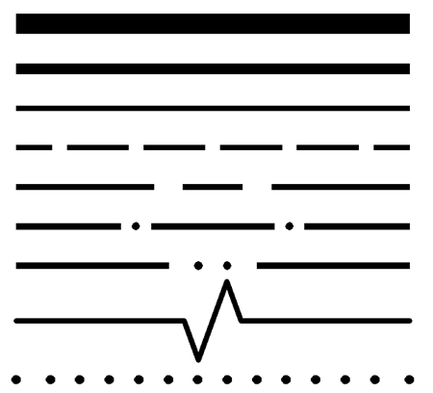
- Wambui drew a technical drawing line as shown below. What is its name?

A. Drawing line B. Phantom line C. Break line D. Centre line
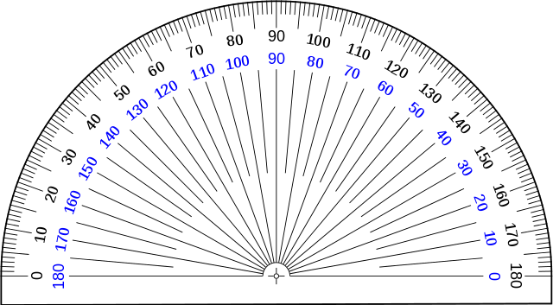
- The measuring instrument below is a:

A. Ruler B. Protractor C. Compass D. Set square
- Which one of the following is a type of natural material? A. Plastic B. Wood C. Rubber D. Concrete
- Which one of the following is a not a component of pretechnical studies? A. Physics studies B. computer studies C. business studies D. Technical studies
- A tool used for cutting pieces of wood is a: A. Hammer B. Saw C. Chisel D. File
- Which one of the following is a safety precaution in a workshop? A. Running in the workshop B. Keeping the work area clean C. Playing with tools D. Using damaged tools
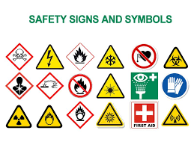
- Which one of the following is a common hazard in a workshop showing high voltage?

A. B.

C. D.

A. First aid kit B. Untidy floor C. Safety goggles D. Fire extinguisher
- A tool used for driving screws is a: A. Wrench B. Pliers C. Screwdriver D. Mallet
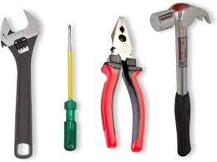
- A tool was used to tighten and cut wires, which tool was used for that purpose?

A B C D
- What is a need? A. Something you want but don't need B. Something essential for survival C. Something expensive D. Something you buy for fun

- Which one of the following is a basic human need? A. A car B. Food C. A smartphone D. Sweets
- What is a want? A. Something essential for survival B. Something you desire but can live without C. Something free D. Something you must have
- Which one of the following is a way to earn money? A. Playing all day B. Doing chores for payment C. Wasting resources D. Sleeping
- Which one of the following is not a component of communication? A. sender B.channel C. Money D. Receiver
- Which one of the following is not a good? A. car B. teaching C. bread D. cloths
- Mwangi had the following coins.Which one of the following is a not a Kenyan currency?
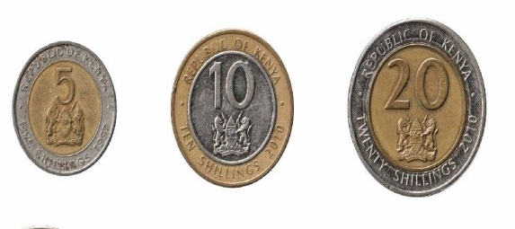
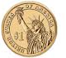

A B C D

- Which one of the following is a physical resource needed for a simple business like selling vegetables? A. Skills B. Money C. A stall or table D. Customers

- What is the main purpose of a computer? A. To draw pictures only B. To process information C. To play games only D. To make phone calls
- Which one of the following is a part of a computer? A. Table B. Chair C. Keyboard D. Wall
- Which computer part is a display component?
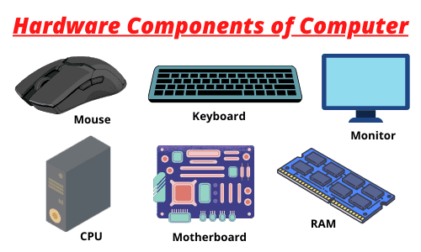

A B

C D
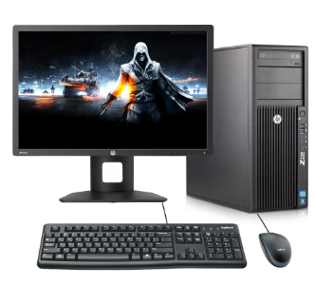
- Wambugu has a desktop computer at home.she wants to turn it on.What should she press to turn on desktop computer?

A. A key on the keyboard B. The power button on the monitor C. The power button on the system unit D. The mouse
- Which device is used to move a pointer on the computer screen and click on items? A. Keyboard B. Monitor C. Mouse D. Printer
- Which one of the following is a common use of computers? A. Cooking food B. Building houses C. Sending emails D. Planting trees
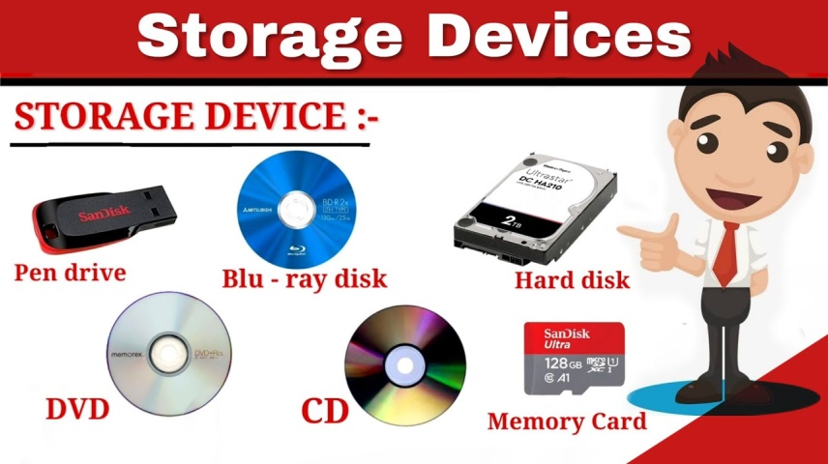
- Grade 7 learners brought the following storage devices for learning.Which one is called Universal serial Bus?

A B C D
- What is the main risk of talking to strangers online? A. They might become your friends B. They might be dangerous people C. They might share interesting pictures D. They might teach you new things
- Which one of the following is safe practice when using the internet? A. Giving your home address to someone you just met online B. Clicking on pop-up ads that offer free prizes C. Asking an adult for help if you see something strange online D. Sharing your password with your friends

- Davis created a website for his business company so that he could reach his online customers better. What is a website? A. A type of computer B. A collection of related web pages on the internet C. A computer program D. A keyboard shortcut
- Grade 7 learners handled some metals.Which one of the following is not a metallic material? A. Plastic B. copper C. alluminium D. Steel
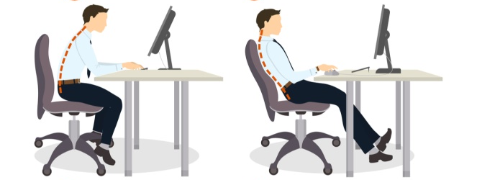
- Kurao has been using a computer. Which one of the following is the right posture while using the computer?

A B
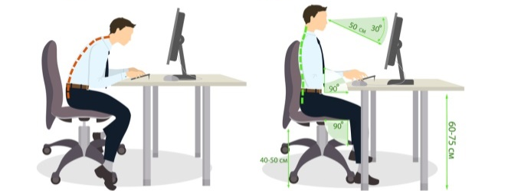

C D

- During a 3-D drawing competition, learners drew different 3-D shapes, which shape is called tetrahedron?
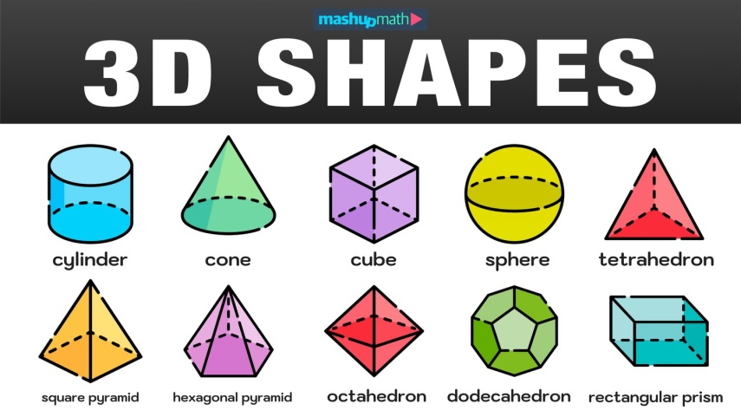

A B C D

SECTION B (50 marks)
Answer ALL the questions in this section in the spaces provided.
Task 1 (20 Marks)
- State two different types of lines used in technical drawing. (2 marks)
________________________________________________________________________
________________________________________________________________________

- Name the following drawing tools: (2 marks) (a) A tool used to draw circles:
____________________________________________________________ (b) A tool used to draw straight lines:
_____________________________________________________________
- State two methods of freehand sketching. (2 marks)
_______________________________________________________________________
_______________________________________________________________________
- Make a freehand sketch of a rectangular box. (3 marks)

- State two differences between natural materials and synthetic materials, giving one example of each. (3 marks)
________________________________________________________________________
________________________________________________________________________
________________________________________________________________________
- Name the material commonly used to make the following items: (3 marks) (a) A wooden chair: ____________________________________________________________ (b) A plastic bottle: ____________________________________________________________ (c) A metal spoon: _____________________________________________________________
- State two basic workshop safety rules in the workshop. (2 marks)
________________________________________________________________________
_______________________________________________________________________
- State one injury that can occur in a workshop if tools are left lying on the floor. (1 mark)
_______________________________________________________________________
- Name two measuring tools used in a workshop. (2 marks)
________________________________________________________________________
________________________________________________________________________
Task 2 (15 Marks)
- Differentiate between a need and a want, giving one example of each. (3 marks)
________________________________________________________________________
________________________________________________________________________

- Communication in business is very important. Define the term communication. (1 mark)
________________________________________________________________________
_______________________________________________________________________
- Name one Social media where one can use to advertise business goods and services. (1 mark)
________________________________________________________________________
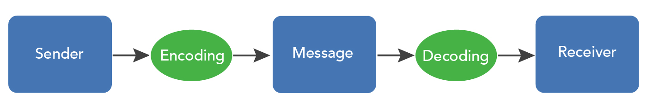
- Fill in the gaps below on the process of communication. (2 marks)

- Name two simple ways a junior school learner can earn some money. (2 marks)
________________________________________________________________________
________________________________________________________________________
- Mr. Mushene displayed the following . from the choices select 2 needs or a want. (3 marks)
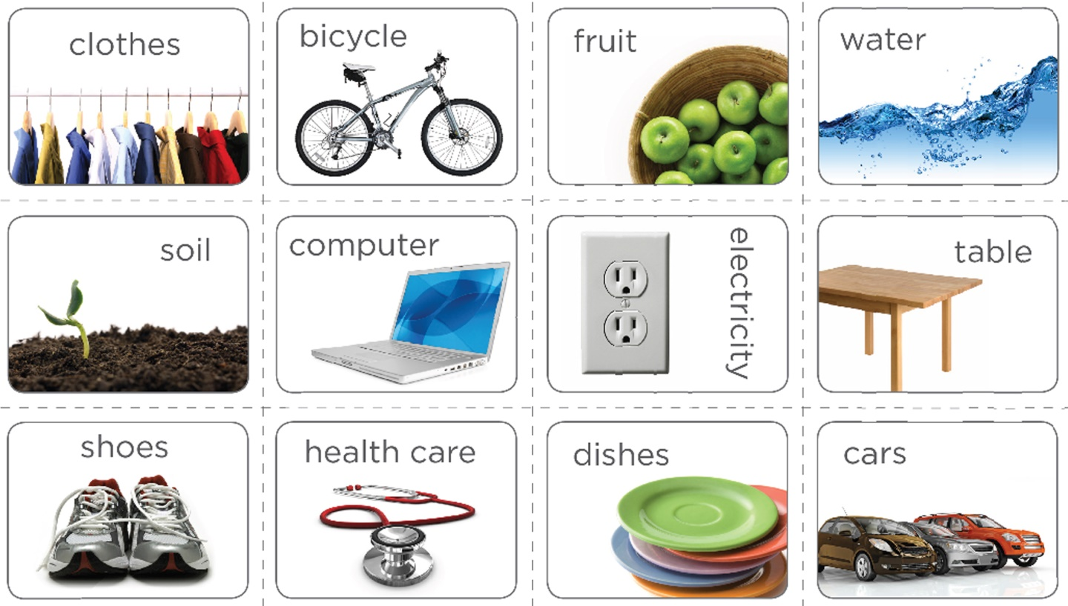
Human Needs | Human want
- Name two types of resources needed to start a very simple business like selling pencils and rulers to classmates. (2 marks)
________________________________________________________________________
_______________________________________________________________________
- State one benefit of saving money regularly. (1 mark)
___________________________________________________________________
Task 3 (15 Marks)
- Mr. Parsaloi asked his learners to mention some uses of the computer.State two basic uses of a computer likely mentioned. (2 marks)
________________________________________________________________________
_______________________________________________________________________
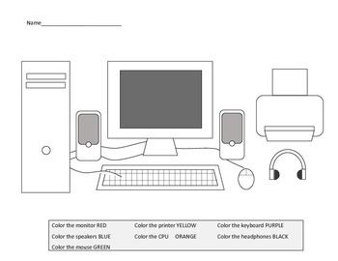
- Name the following computer parts: (3 marks) (a) The part with keys for typing: _______________________________________________ (b) The part that looks like a screen: ____________________________________________ (c) The main box of the computer: _______________________________________________
- Explain one basic step you should follow to turn on a desktop computer. (1 mark)
________________________________________________________________________
________________________________________________________________________
- Explain what you should do if you encounter something online that makes you feel uncomfortable or unsafe. (1 mark)
________________________________________________________________________
________________________________________________________________________
- State two things you should NOT share with strangers online. (2 marks)
_______________________________________________________________________
_______________________________________________________________________
- Name one online platform where people can communicate with each other. (1 mark)
_______________________________________________________________________
- Oscar has been using cmputers to do his daily tasks.Explain why it is important to take breaks when using a computer for a long time. (1 mark)
________________________________________________________________________
________________________________________________________________________
- Learners visited different places where computers were used.Mention one place where compouters are used today. (1 mark)
________________________________________________________________________
- What is the purpose of the spacebar key on a keyboard? (1 mark)
________________________________________________________________________
- Explain why it is important to shut down a computer properly before turning off the power switch. (2 marks)
________________________________________________________________________
_______________________________________________________________________
THIS IS THE LAST PRINTED PAGE.

SECTION A (30 marks)
- C
- A
- B
- A
- B
- B
- D
- C
- B
- B
- B
- B
- B
- C
- B
- D
- C
- C
- B
- C
- D
- B
- C
- B
- A
- A
- B
- A
- C
- A
SECTION B (50 marks)
Task 1 (20 Marks)

  - Centre line
  - Hidden line
  - Outline/Visible line
  - Dimension line
  - Extension line
  - Cutting plane line
  - Short break line
  - Phantom line
  - Cutting plane
  - Drawing line
  - Leader line
  - Straight line
  - Curved line
  - Spiral line
  - Zigzag line
  - Vertical line
  - Horizontal line
  - Perpendicular line
  - Diagonal line
  - Long break line (Any two) (2 marks)
- (a) Compass (1 mark) (b) Ruler/Straight edge (1 mark)

  - Sketching using points/dots
  - Sketching using light lines/construction lines
  - Sketching using overall dimensions/blocking-in (Any two) (2 marks)
- (A freehand sketch of a rectangular box) (3 marks)
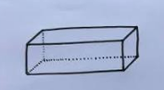

Feature | Natural Materials | Synthetic Materials | Example
Origin | Found in nature | Man-made / Artificially produced | Wood, Cotton
Processing | Usually require minimal processing | Require chemical reactions and industrial processes | Plastic, Nylon

(3 marks)
- (a) Wood (1 mark) (b) Plastic (1 mark) (c) Metal (e.g., stainless steel, aluminum) (1 mark)

  - Wear appropriate Personal Protective Equipment (PPE).
  - Keep the work area clean and tidy.
  - Use the right tool for the job.
  - Report any faulty tools or equipment.
  - Do not run in the workshop.
  - Pay attention to what you are doing. (Any two) (2 marks)

  - Tripping
  - Falling
  - Injury from stepping on the tool (Any one) (1 mark)

  - Ruler
  - Measuring tape
  - Vernier caliper
  - Micrometer screw gauge (Any two) (2 marks)
Task 2 (15 Marks)
- A need is something essential for survival, such as food, water, shelter, and clothing. For example, food is a basic need because humans cannot survive without it. (1.5 marks) A want is something that a person desires but can live without. For example, a smartphone is a want because while it can be useful, it is not essential for basic survival. (1.5 marks)
- Communication is the process of conveying information, ideas, or feelings from one person or group to another through the use of words, symbols, or actions. (1 mark)

  - Facebook
  - Instagram
  - Twitter/X
  - WhatsApp (for business)
  - TikTok (Any one) (1 mark)
- Sender → Message → Channel → Receiver → Feedback (2 marks)

  - Doing chores for neighbours for payment.
  - Selling small handmade items.
  - Helping with tasks like gardening or car washing for a small fee.
  - Tutoring younger learners. (Any two) (2 marks)
- (From the choices provided, select two that are clearly needs or a want) (3 marks)
  - Human Needs: i. Food, ii. Shelter (Examples)
  - Human Want: i. A new toy, ii. A video game (Examples)

  - Pencils and rulers (physical resources/inventory)
  - Money (financial resource/capital)
  - A bag or container to carry the items (physical resource)
  - A place to sell (physical resource - even if it's just their desk) (Any two) (2 marks)

  - It helps in achieving financial goals.
  - It provides security for unexpected expenses.
  - It can lead to investment opportunities.
  - It can reduce reliance on borrowing. (Any one) (1 mark)
Task 3 (15 Marks)

  - For typing and creating documents.
  - For browsing the internet and accessing information.
  - For communication (e.g., email, video calls).
  - For entertainment (e.g., playing games, watching videos). (Any two) (2 marks)
- (a) Keyboard (1 mark) (b) Monitor/Screen (1 mark) (c) System unit/CPU (Central Processing Unit) (1 mark)
- Press the power button on the system unit. (1 mark)
- Tell a trusted adult (e.g., parent, teacher) immediately about what you saw and stop interacting with it. (1 mark)

  - Your full name
  - Your home address
  - Your school name
  - Your phone number
  - Your passwords
  - Personal pictures (Any two) (2 marks)

  - WhatsApp
  - Facebook
  - Instagram
  - Twitter/X
  - Telegram
  - Skype (Any one) (1 mark)
- Taking breaks helps to prevent eye strain, fatigue, and other physical discomforts associated with prolonged computer use. (1 mark)

  - Schools
  - Offices
  - Hospitals
  - Banks
  - Libraries
  - Airports
  - Shops (Any one) (1 mark)
- The spacebar key is used to insert a blank space between words or characters when typing. (1 mark)

  - To prevent loss of unsaved data.
  - To allow the operating system and applications to close down properly, which can prevent errors and corruption of files.
  - To ensure that the computer is ready for the next use. (Any two) (2 marks)
THIS IS THE LAST PAGE OF THE MARKING SCHEME

