Candidate’s Name: ………………………………………………………… Assessment Number: …………………………………………
School Name: ……………………………………………………………………. School Code: …………………………………………………………
Candidate’s Signature: ………………………………..…………….Date: …………………………………………………….…………….
COMPETENCE BASED EDUCATION
KENYA JUNIOR SCHOOL EDUCATION ASSESSMENT
705/1 INTEGRATED SCIENCE (Theory)
JUNE 2025 PAPER 1 TIME: 1 hour 40 minutes
INSTRUCTIONS TO CANDIDATES
- Fill in all proper details above
- This paper consists of two sections: A and B.
- Section A comprises Multiple Choice Questions numbered 1 to 30.
- Section B comprises short, structured questions number 31 to 40.
- Answer ALL the questions in section A on the separate ANSWER SHEET provided.
- Answer ALL the questions in section B in the spaces provided in this QUESTION PAPER.
- Do NOT remove any page from this question paper.
- Answer ALL the questions in English.
For official use only
SECTION B | Maximum Score | Candidate’s Score
Question
Question 31 | 04
Question 32 | 05
Question 33 | 06
Question 34 | 04
Question 35 | 05
Question 36 | 04
Question 37 | 06
Question 38 | 06
Question 39 | 05
Question 40 | 05
Total | 40
Candidate’s score per task
This paper consists of 14 printed pages. Candidates should check the question paper to ascertain that all the pages are printed as indicated and that no questions are missing.

© 2025 The Dynasty Assessment Council Turn over

SECTION A (30 marks)
Answer ALL the questions in this section.
- You have been given this question paper and a separate answer sheet. This section consists of 30 multiple choice questions.
- Answer ALL questions on the ANSWER SHEET provided, NOT on the question paper.
- Do all the necessary rough work on the question paper.
HOW TO USE THE ANSWER SHEET
- Use an ordinary HB pencil.
- Confirm that the answer sheet you have been provided with has the following:
YOUR ASSESSMENT NUMBER YOUR NAME
NAME OF YOUR SCHOOL NAME OF THE SUBJECT
- Keep the answer sheet clean and dry. DO NOT fold it.
- For each of the questions 1 – 30, four options are given. The options are lettered A, B, C and D. In each case, only ONE of the four options is correct. Choose the correct option.
- On the answer sheet, the correct answer is to be shown by drawing a DARK LINE inside the box in which the letter you have chosen is written.
Example:
In the Question Paper:
  - Which one of the following is a characteristic of all living things? A. Movement B. Photosynthesis C. Reproduction D. Having a backbone
The correct answer is C.
On the answer sheet, in the set of boxes given for number 12, draw a DARK LINE inside the box with the letter C printed in it as marked below.
12 [A] [B] [C] [D]
- Your dark line MUST be within the box. DO NOT make any marks outside the boxes.
- For each question, ONLY ONE box is to be marked.

SECTION A (30 marks)
Answer ALL the questions in this section.

- Which one of the following is a basic science skill? A. Singing B. Measuring C. Drawing comics D. Running
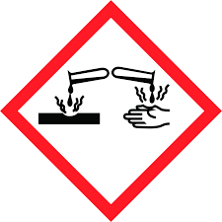
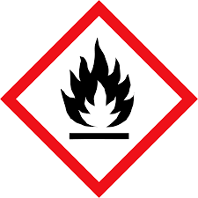
- Which one of the following symbols represents a substance that can cause burns if it touches the skin?
A. B.

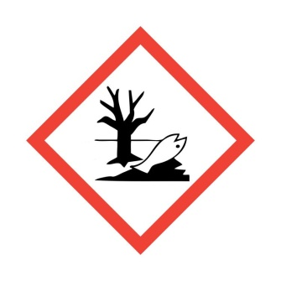

- D.

- Which one of the following is a characteristic of all living things? A. Flying B. Growth C. Having fur D. Living in water
- During one of the science lessons, a teacher projected some examples of living things. Which component of integrated science deals with the study of living things? A. Chemistry B. Physics C. computer studies D. Biology
- Which one of the following is not found in a first aid kit? A. Adhesive bandages B. Sterile gauze pads C. Disposable gloves D.wire gauze

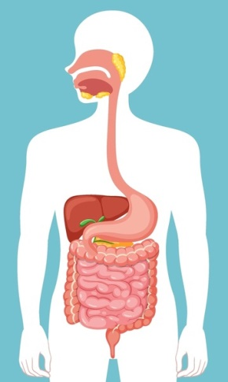
- In the human digestive system, digestion starts in the place marked?
A
B
C
D

A. A B. B C.C D.D
- Akinyi is in the science laboratory for the first time. Her teacher is explaining the rules. Akinyi notices a broken beaker on the floor near her desk.According to laboratory safety rules, what should Akinyi do immediately?
A) Pick up the broken pieces carefully with her bare hands.
B) Alert the teacher about the broken beaker.
C) Sweep the pieces under the bench quickly.
D) Ignore it as it's not her mess.

- Oscar is measuring the volume of milk for an experiment. He needs to use a piece of laboratory apparatus that gives an accurate measurement of liquid volume.
Which apparatus is most suitable for accurately measuring a specific volume of liquid?
A) Beaker
B) Conical flask
C) Measuring cylinder
D) Test tube

- Mrs. Wambua asks her learners to observe how quickly sugar dissolves in hot water versus cold water. They record the time taken in each case.
Which basic science skill are the learners primarily using in this experiment?
A) Classifying
B) Predicting
C) Measuring
D) Hypothesising

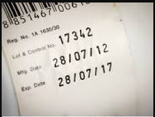
- David buys a new bottle of juice from the shop.

Before opening it, he looks at the label to find out the ingredients, expiry date, and nutritional information.Which part of the packaging is David examining to get this information?
A) The bottle cap
B) The price tag
C) The barcode
D) The packaging label

- Sarah is comparing the amount of maize flour in two different bags. One bag is labelled "2 kg" and the other "5000 g". She wants to know which one has more flour.Kilogram (kg) and gram (g) are units for which basic quantity?
A) Length
B) Mass
C) Volume
D) Time

- Mr. Kimani is teaching his class about the standard international units used globally in science. He asks a learner for the S.I. unit for length.What is the basic S.I. unit for length?
A) Kilogram (kg)
B) Second (s)
C) Metre (m)
D) Litre (L)

- Amina is setting up an experiment to heat a liquid over a Bunsen burner. She used the apparatus below.
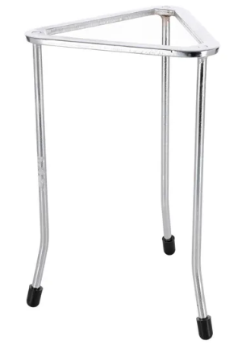

What is the name of the apparatus used?
A) Tripod stand
B) Test tube rack
C) Filter funnel
D) Mortar and pestle

- A learner wants to know which part of the breathing system has C- shaped rings of cartilage.
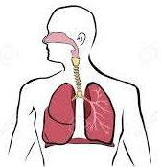

W

X

Y

Z

Which one is the right part?
A) W
B) X
C) Y
D) Z

- John is preparing to use a Bunsen burner to heat a substance. He needs to get a hot, non-luminous flame. To obtain a hot, non-luminous flame from a Bunsen burner, what adjustment should John make?
A) Close the air hole completely.
B) Open the air hole completely.
C) Adjust the gas tap only.
D) Point the chimney downwards.

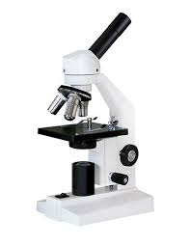
- Mwangi is using a microscope to observe plant cells. He adjusts the knob that significantly changes the distance between the objective lens and the specimen to get a rough focus. Which part of the microscope is Mwangi using for coarse focusing?
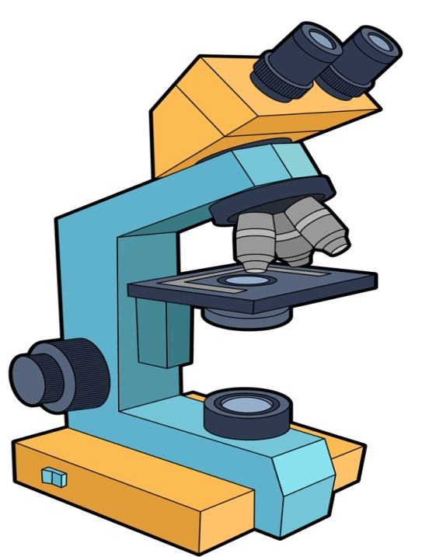

A) Fine adjustment knob
B) Revolving nosepiece
C) Coarse adjustment knob
D) Eyepiece

- Grade 7 is learning about different types of mixtures. Their teacher shows them a sample of sand mixed with water, where the sand settles at the bottom after some time.
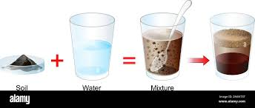

This type of mixture, where solid particles settle in a liquid, is called a:
A) Solution
B) Colloid
C) Suspension
D) Alloy

- Sarah has a mixture of iron fillings mixed in rice. She wants to separate the iron fillings from the rice.
Which method of separating mixtures is best suited for separating dissolved salt from water?
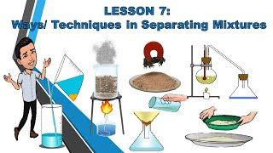

A B

C D

- Jane was asked to separate a certain mixture using the method shoen below.
This type of method is known as a:

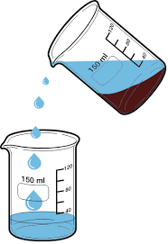

A) Chromatography
B) Fractional distillation
C) Winnowing
D) Decantation

- A career teacher displayed various career pathways. Which one of the following is not a career related to the study of Integrated Science?




A B




C D

- While learning about acids and bases, learners were asked to mention laboratory acid-base indicators, which one was not?
A) Methyl orange
B) Hydrochloric acid
C) Litmus solution
D) Phenolphalein

- Akinyi crushes some purple cabbage leaves and adds a little water to make a juice. She plans to use this juice to test if different household substances are acidic or basic. What is Akinyi using the purple cabbage extract as?
A) A solvent B) A solute
C) A catalyst D) A pH indicator

- A science learner is given an unknown liquid and a strip of red litmus paper and a strip of blue litmus paper to identify if the liquid is acidic, basic, or neutral.If the liquid turns the red litmus paper blue but the blue litmus paper remains blue, what can the learner conclude about the liquid?
A) It is acidic.
B) It is basic.
C) It is neutral.
D) It is pure water.

- The teacher explains that the pH scale is used to measure the acidity or basicity of a substance.
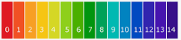

A substance with a pH of 2 is considered:
A) Strongly basic B) Weakly basic
C) Strongly acidic D) Neutral

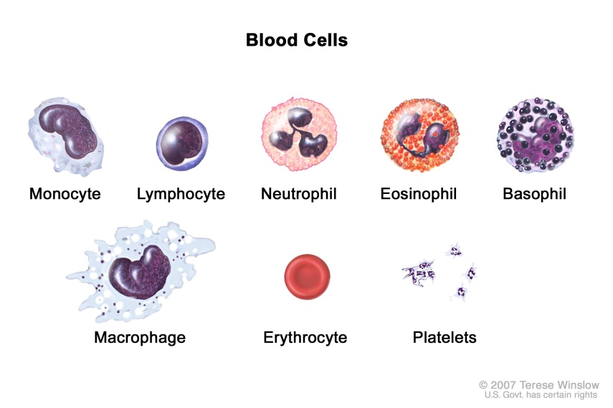
- Identify the Red Blood cell?

A. B.

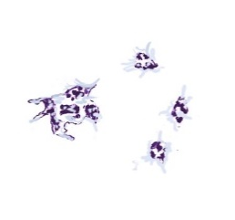
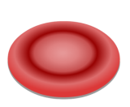
C. D.

- In many parts of Kenya, farmers add lime (calcium oxide or calcium hydroxide, which are basic) to their soil to improve crop yield.

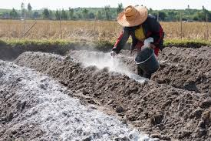

Which common use of a base in Kenya is being described here?
A) As a food preservative
B) In manufacturing fertilisers
C) To neutralise acidic soil
D) For making soft drinks

- What is a common use of acids in either industry or households in Kenya?
A) Making soap
B) Neutralising bases
C) Sweetening food
D) Cleaning greasy surfaces
- Which of the following is the BEST reason for tying back long hair in a science laboratory?
A. To look neat
B. To prevent it from catching fire or getting caught in apparatus
C. To see the experiments clearly
D. To avoid disturbing others

- Which laboratory apparatus is used to measure a specific volume of a liquid accurately?
A. Beaker
B. Measuring cylinder
C. Conical flask
D. Test tube
- The process by which plants make their own food is called:
A. Respiration
B. Transpiration
C. Photosynthesis
D. Germination

SECTION B (40 marks)
Answer ALL the questions in this section in the spaces provided.
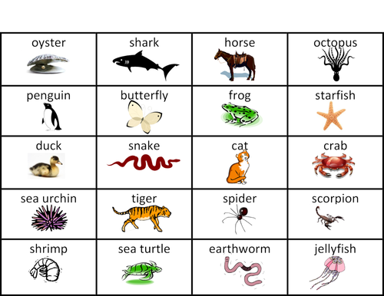
- Study the picture below and use it to answer question 31.

  - Animals without a backbone are called ______________________.
  - From the photograph Identify

Mammal | Reptile | Amphibian | Crustacean

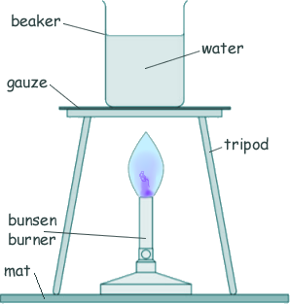
- Study the diagram below showing a science experiment setup and answer the questions.

  - Identify two pieces of apparatus shown in the diagram used to support the beaker during heating. (2 marks)
____________________________________________________________________.
____________________________________________________________________.

  - Describe the type of flame shown in the Bunsen burner diagram. (1 mark)

____________________________________________________________________.

(c) State one safety precaution that should be observed when using a Bunsen burner in the laboratory. (2 marks)

____________________________________________________________________.
____________________________________________________________________.

- Study the diagram of the measuring cylinder above and answer the questions.
Learners wanted to measure the volume of irregular objects. They immersed a stone as shown below.
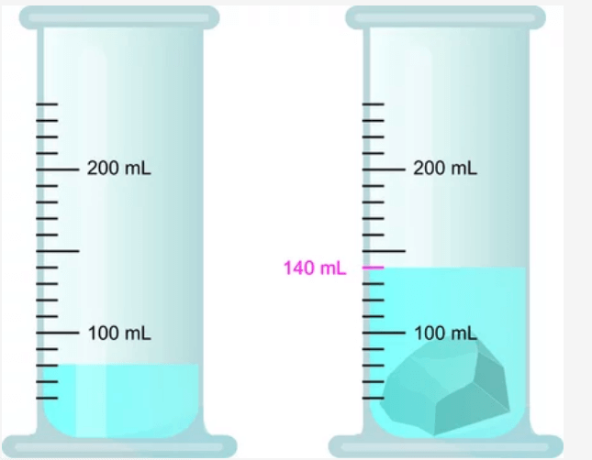

(a) Name the apparatus shown in the diagram. (1 mark)
____________________________________________________________________.
____________________________________________________________________.
(b) Calculate the volume of the liquid displaced by the stone (2 marks)

____________________________________________________________________.
____________________________________________________________________.

(c) State one reason why a measuring cylinder is preferred over a beaker for measuring the volume of liquids in an experiment. (2 marks)

____________________________________________________________________.
____________________________________________________________________.

- Study the diagram of the microscope above and answer the questions.

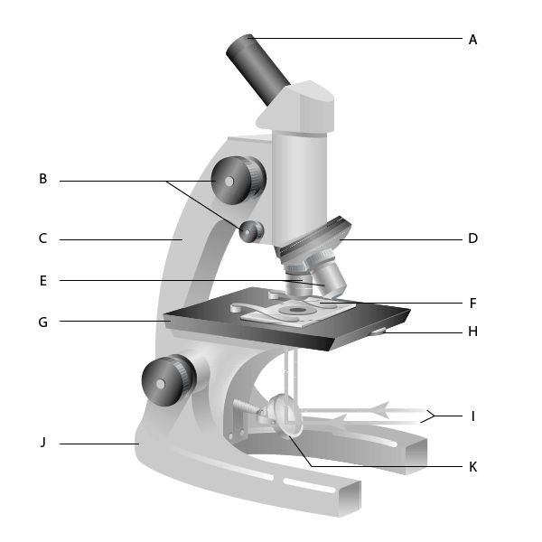
(a) Identify the parts labelled: (2 marks)

G _______________________________________________________________.
J ________________________________________________________________.

(i) The part you look through at the top.
____________________________________________________________________.
____________________________________________________________________.
(ii) The part used for making small, clear adjustments to the focus.
____________________________________________________________________.
____________________________________________________________________.
(b) State the function of the revolving nosepiece. (1 mark)
____________________________________________________________________.
____________________________________________________________________.
(c) If the eyepiece has a magnification of 10x and the objective lens being used has a magnification of 40x, calculate the total magnification of the specimen being viewed. Show your working. (2 marks)

____________________________________________________________________.
____________________________________________________________________.

____________________________________________________________________.
____________________________________________________________________.

____________________________________________________________________.
____________________________________________________________________.

- Study the diagram showing the results of testing three substances with litmus paper and answer the questions.

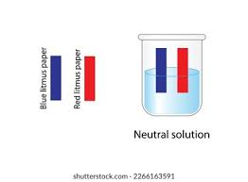
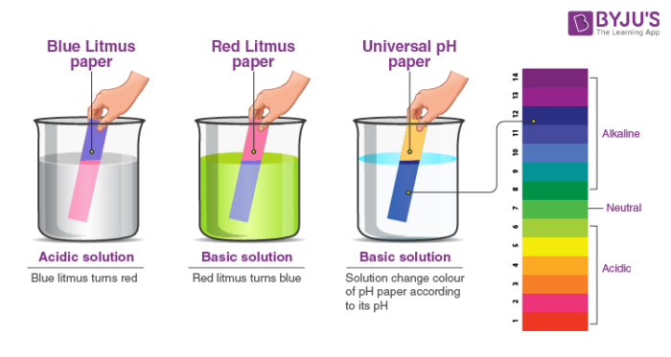

A B C

(a) Classify the substance in Test tube A as acidic, basic, or neutral. (3 marks)

NEUTRAL SUBSTANCE | BASIC SUBSTANCE | ACIDIC SUBSTANCE

(c) Name one type of substance likely to as the one in Test tube C. (1 mark)

_______________________________________________________________.

(d) Name a common household substance that could be in Test tube B. (1 mark)

_______________________________________________________________.

- Study the picture showing various measuring tools and answer the questions.

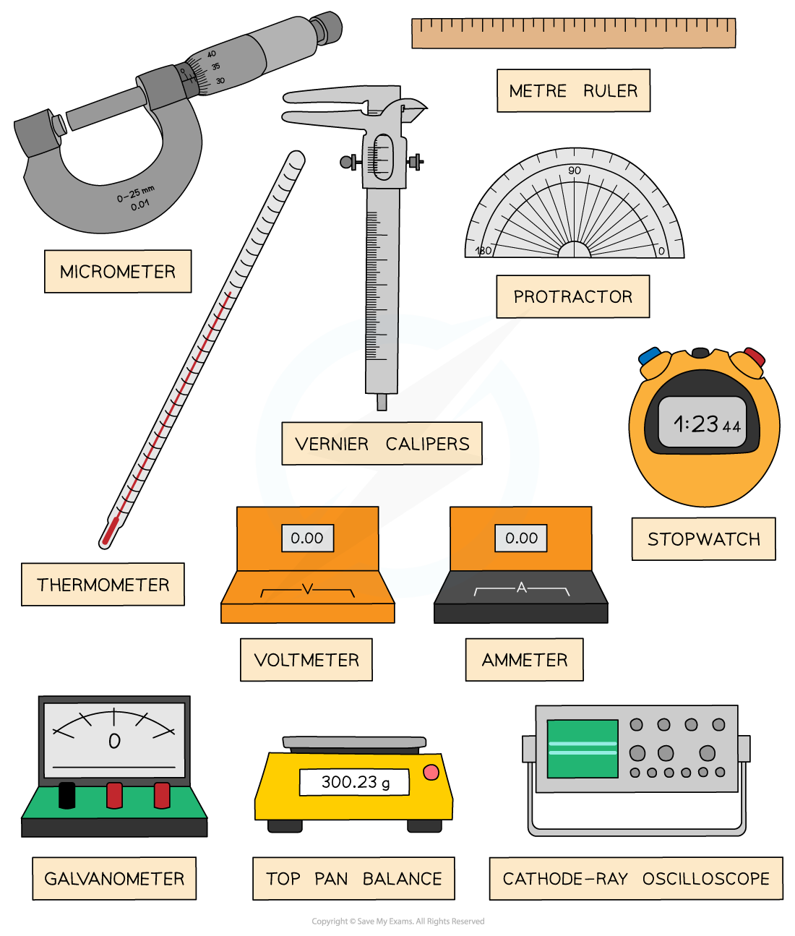

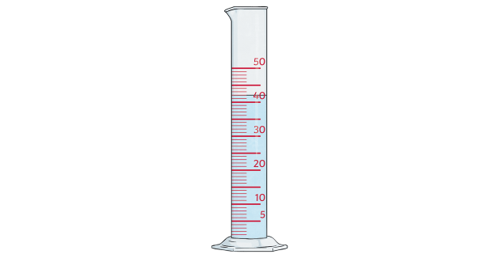

MEASURING CYLINDER

(a) From the picture, identify the apparatus used to measure: (2 marks)
(i) Time ____________________________________________.
(ii) Length__________________________________________.
  - Which apparatus in the picture is used to measure a derived quantity? Name the quantity. (2 marks)

Apparatus
Derived quantity

(c) Name the basic S.I. unit for the quantity measured by the measuring cylinder. (1 mark)
_____________________________________________________________________.
- Study the diagram showing the pH scale and the corresponding colours of Universal Indicator and answer the questions.
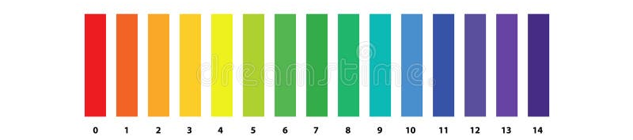
(a) According to the diagram, what colour does Universal Indicator show when a substance has a pH of exactly 7? (1 mark)
_______________________________________________________________________.
(b) A science learner tests a sample of liquid soap using Universal Indicator, and the indicator turns deep blue. Using the information from the diagram, what can the learner conclude about the nature of liquid soap (acidic, basic, or neutral)? Explain your reasoning. (2 marks)
_______________________________________________________________________. _______________________________________________________________________. (c) Another learner tests a sample of fruit juice and the Universal Indicator turns orange. Estimate the likely pH range of this fruit juice based on the diagram. (2 marks)
_______________________________________________________________________._____
__________________________________________________________________.
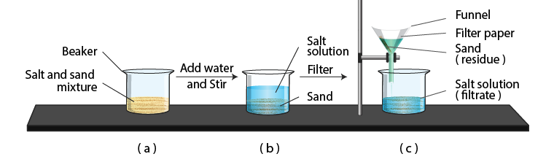
- Study the diagram above showing a method used to separate a mixture and answer the questions.

(a) Name the method of separating mixtures illustrated in the diagram. (1 mark)
_______________________________________________________________________.
(b) Based on its appearance before separation, what type of mixture is being separated in the diagram? (1 mark)
_______________________________________________________________________.
(c) Explain why this method is suitable for separating this particular type of mixture. (1 mark)
_______________________________________________________________________.
_______________________________________________________________________.
(d) Describe one practical situation in a Kenyan household or community where this method of separation might be used. (2 marks)
_______________________________________________________________________.
_______________________________________________________________________.
THIS IS THE LAST PRINTED PAGE

MARKING SCHEME
  - B.
  - A.
  - B.
  - D.
  - D.
  - A.
  - B
  - C
  - C
  - D
  - B
  - C
  - A
  - B
  - B
  - C
  - C
  - A.
  - D
  - C.
  - B
  - D
  - B
  - C
  - D
  - C
  - B
  - B.
  - B
  - C.
SECTION B (40 marks)
31. Study the picture below and use it to answer question
(a) Animals without a backbone are called invertebrates. (1 mark)
(b) From the photograph, identify (3 marks):
- Mammal: Tiger, cat, horse
- Reptile: Snake
- Amphibian: Frog
- Crustacean: Crab
32. Study the diagram below showing a science experiment setup and answer the questions.
(a) Identify two pieces of apparatus shown in the diagram used to support the beaker during heating. (2 marks)
- Tripod stand
- Wire gauze
(b) Describe the type of flame shown in the Bunsen burner diagram. (1 mark)
- Non-luminous flame (or blue flame)
(c) State one safety precaution that should be observed when using a Bunsen burner in the laboratory. (2 marks)
- Keep flammable materials away from the flame. (Other valid answers include: Never leave a lit Bunsen burner unattended; Use heat-resistant gloves when handling hot objects; Ensure the Bunsen burner is placed on a stable surface; Tie back long hair and loose clothing.)
33. Study the diagram of the measuring cylinder above and answer the questions.
(a) Name the apparatus shown in the diagram. (1 mark)
- Measuring cylinder
(b) Calculate the volume of the liquid displaced by the stone (2 marks)
- Volume of liquid before stone = 50 ml
- Volume of liquid after stone = 75 ml
- Volume of liquid displaced = 75 ml−50 ml=25 ml
(c) State one reason why a measuring cylinder is preferred over a beaker for measuring the volume of liquids in an experiment. (2 marks)
- A measuring cylinder has more precise graduations/markings than a beaker, allowing for more accurate volume measurements. (Another valid reason: Measuring cylinders are designed specifically for measuring volumes, while beakers are more general-purpose containers.)
34. Study the diagram of the microscope above and answer the questions.
(a) Identify the parts labelled: (2 marks)
- G: Eyepiece
- J: Coarse adjustment knob
(i) The part you look through at the top. (1 mark)
- Eyepiece
(ii) The part used for making small, clear adjustments to the focus. (1 mark)
- Fine adjustment knob
(b) State the function of the revolving nosepiece. (1 mark)
- It holds the objective lenses and allows the user to switch between different magnifications.
(c) If the eyepiece has a magnification of 10x and the objective lens being used has a magnification of 40x, calculate the total magnification of the specimen being viewed. Show your working. (2 marks)
- Total magnification = Magnification of eyepiece × Magnification of objective lens
- Total magnification = 10×40=400×
35. Study the diagram showing the results of testing three substances with litmus paper and answer the questions.
(a) Classify the substance in Test tube A as acidic, basic, or neutral. (3 marks)
- NEUTRAL SUBSTANCE: ​
(c) Name one type of substance likely to be the one in Test tube C. (1 mark)
- Acid (e.g., lemon juice, vinegar, hydrochloric acid)
(d) Name a common household substance that could be in Test tube B. (1 mark)
- Base/Alkali (e.g., soap solution, baking soda solution, toothpaste)
36. Study the picture showing various measuring tools and answer the questions.
(a) From the picture, identify the apparatus used to measure: (2 marks)
- (i) Time: Stopwatch
- (ii) Length: Ruler/Metre rule
(b) Which apparatus in the picture is used to measure a derived quantity? Name the quantity. (2 marks)
- Apparatus: Measuring cylinder
- Derived quantity: Volume
(c) Name the basic S.I. unit for the quantity measured by the measuring cylinder. (1 mark)
- Cubic metre (m³) (While millilitre (ml) or litre (L) are commonly used with measuring cylinders, the basic SI unit for volume is the cubic metre.)
37. Study the diagram showing the pH scale and the corresponding colours of Universal Indicator and answer the questions.
(a) According to the diagram, what colour does Universal Indicator show when a substance has a pH of exactly 7? (1 mark)
- Green
(b) A science learner tests a sample of liquid soap using Universal Indicator, and the indicator turns deep blue. Using the information from the diagram, what can the learner conclude about the nature of liquid soap (acidic, basic, or neutral)? Explain your reasoning. (2 marks)
- The liquid soap is basic. The diagram shows that Universal Indicator turns blue or deep blue at pH values above 7, indicating a basic substance.
(c) Another learner tests a sample of fruit juice and the Universal Indicator turns orange. Estimate the likely pH range of this fruit juice based on the diagram. (2 marks)
- The likely pH range of this fruit juice is approximately pH 3 to pH 4. The diagram shows that Universal Indicator turns orange in this pH range, indicating an acidic substance.
38. Study the diagram above showing a method used to separate a mixture and answer the questions.
(a) Name the method of separating mixtures illustrated in the diagram. (1 mark)
- Filtration
(b) Based on its appearance before separation, what type of mixture is being separated in the diagram? (1 mark)
- Suspension (a mixture where solid particles are dispersed in a liquid but will eventually settle) or Insoluble solid in a liquid
(c) Explain why this method is suitable for separating this particular type of mixture. (1 mark)
- Filtration works by passing the mixture through a filter paper, which has small pores that allow the liquid to pass through but trap the larger solid particles.
(d) Describe one practical situation in a Kenyan household or community where this method of separation might be used. (2 marks)
- Separating sand or soil from water collected from a river or well. (Other valid examples include: Straining tea leaves after brewing tea; Filtering out impurities from traditional brews.)
THIS IS THE LAST PRINTED PAGE

