Candidate’s Name: ………………………………………………………… Assessment Number: …………………………………………
School Name: ……………………………………………………………………. School Code: …………………………………………………………
Candidate’s Signature: ………………………………..…………….Date: …………………………………………………….…………….
COMPETENCE BASED EDUCATION
KENYA JUNIOR SCHOOL EDUCATION ASSESSMENT
706/1 AGRICULTURE AND NUTRITION (Theory)
PAPER 1 JUNE 2025 Time: 1 hour 40 minutes
INSTRUCTIONS TO CANDIDATES
- Fill in all the required details above.
- This paper consists of two sections: A and B.
- Section A comprises Multiple Choice Questions numbered 1 to 30.
- Section B comprises short, structured questions number 31 to 42.
- Answer ALL the questions in section A on the separate ANSWER SHEET provided.
- Answer ALL the questions in section B in the spaces provided in this QUESTION PAPER.
- Do NOT remove any page from this question paper.
- Answer ALL the questions in English.
For official use only SECTION B
Task | Question | Maximum score | Candidate’s score | Total per task
Task 1: Agriculture | 31 | 3
 | 32 | 3
 | 33 | 3
 | 34 | 3
 | 35 | 4
 | 36 | 4
 | 37 | 4
Task 2: Nutrition | 38 | 2
 | 39 | 2
 | 40 | 5
 | 41 | 2
 | 42 | 5

This paper consists of 8 printed pages. Candidates should check the question paper to ascertain that all the pages are printed as indicated and that no questions are missing.

© 2025 The Kenya National Examinations Council Turn over
SECTION A (30 marks)
Answer ALL the questions in this section.
Please read these instructions carefully
- You have been given this question paper and a separate answer sheet. This section consists of 30 multiple choice questions.
- Answer ALL questions in this section on the ANSWER SHEET provided, NOT on the question paper.
- Do all the necessary rough work on the question paper.
HOW TO USE THE ANSWER SHEET
- Use an ordinary HB pencil.
- Confirm that the answer sheet you have been provided with has the following: YOUR ASSESSMENT NUMBER YOUR NAME NAME OF YOUR SCHOOL NAME OF THE SUBJECT
- Keep the answer sheet clean and dry. DO NOT fold it.
- For each of the questions 1 – 30, four answers are given. The answers are lettered A, B, C and D. In each case, only ONE of the four choices is correct. Choose the correct answer.
- On the answer sheet, the correct answer is to be shown by drawing a DARK LINE inside the box in which the letter you have chosen is written.
Example
In the Question Paper:
- Nairobi City dwellers put garbage at designated areas. The huge amounts of garbage are collected by trucks and deposited at the Dandora dumpsite. This pollutes soil mainly by
A. agricultural chemical wastes. B. artificial fertilizer application. C. plastic wastes. D. waste water.
The correct answer is ‘C’.
On the answer sheet, In the set of boxes numbered 17, draw a DARK LINE inside the box with the letter C printed in it as marked below.
- [A] [B] [C] [D]
- Your dark line MUST be inside the box. DO NOT make any marks outside the boxes.
- For each question, ONLY ONE box is to be marked.

SECTION A (30 marks)
Answer ALL the questions in this section.

- Which one of the following is NOT a component of soil? A. Air. B. Water. C. Rocks. D. Organic matter.
- Which type of soil feels smooth and sticky when wet? A. Sandy soil. B. Loamy soil. C. Clay soil. D. Silt soil.
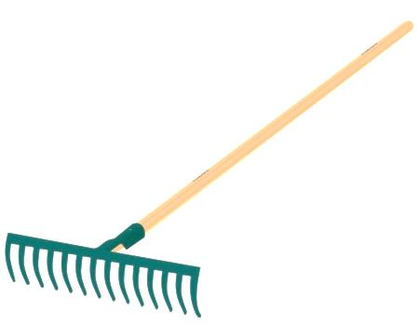
- Which of the following is a hand tool used for digging and breaking up soil?
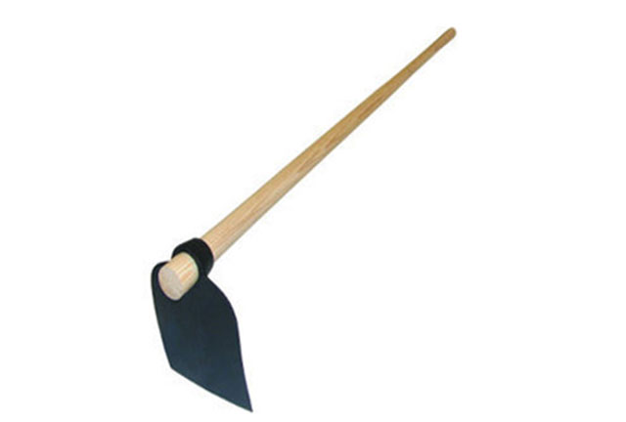
A B

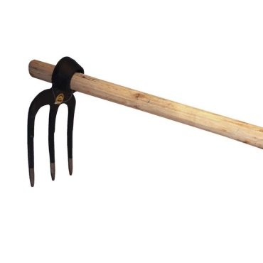
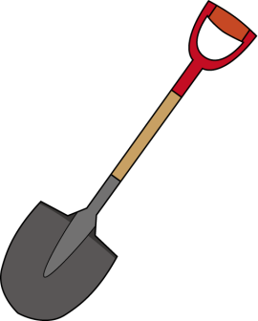
C D

- Which one of the following is a cereal crop? A. Beans. B. Cabbage. C. Wheat. D. Tomato.
- The practice of removing excess seedlings to avoid overcrowding is called: A. Weeding. B. Thinning. C. Transplanting. D. Mulching.
- Which of the following is a pest that attacks crops by sucking sap from leaves? A. Termite. B. Aphid. C. Cutworm. D. Weaver bird.
- Which one of the following is a method of soil conservation? A. Burning bushes. B. Removing crop residues. C. Planting trees. D. Grazing animals on bare ground.
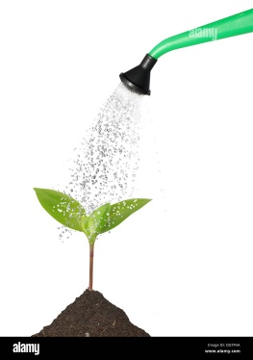
- Ole mashati was observed irrigating his crops.

Water is important for plants because it is needed for: A. Photosynthesis. B. Pollination. C. Germination. D. Pest control.
- Which one of the following is a common type of livestock kept in Kenyan homes? A. Zebras. B. Chickens. C. Lions. D. Snakes.
- Which feed is given to young animals to help them grow quickly? A. Roughage. B. Concentrates. C. Fodder. D. Hay.
- Which part of a chicken is used for laying eggs? A. Beak. B. Comb. C. Vent. D. Wattle.
- Which one of the following is a sign of a sick animal? A. Eating well. B. Active and playful. C. Keeps away from others. D. Shiny coat.
- Why is it important to provide clean water to livestock? A. To make them produce more meat. B. To keep them cool. C. To prevent diseases. D. To make them look attractive.

- Which one of the following is a product obtained from cattle? A. Eggs. B. Milk. C. Wool. D. Honey.
- What is the main source of vitamin C in our diet? A. Cereals. B. Meat. C. Fruits and vegetables. D. Dairy products.
- Which food group provides the body with energy? A. Proteins. B. Vitamins. C. Carbohydrates. D. Minerals.
- Lack of iron in the diet can cause a condition called: A. Goitre. B. Rickets. C. Anaemia. D. Scurvy.
- Which one of the following foods is a good source of protein? A. Rice. B. Sukuma wiki. C. Beans. D. Margarine.
- Which cooking method involves heating food in water at 100 degrees Celsius? A. Frying. B. Steaming. C. Roasting. D. Boiling.
- Which kitchen tool is used for peeling vegetables and fruits? A. Knife. B. Spoon. C. Peeler. D. Fork.
- Why is it important to wash hands before handling food? A. To make the food taste better. B. To prevent the spread of germs. C. To cool down the hands. D. To remove water from hands.

- Which one of the following is a correct way to store cooked food? A. Leave it on the table uncovered. B. Cover it and keep it warm. C. Store in a clean, covered container in the refrigerator. D. Leave it in the cooking pot on the stove.
- Which of the following is a staple food in many parts of Kenya? A. Bread. B. Rice. C. Maize. D. Chips.
- What is the main purpose of a balanced diet? A. To make food expensive. B. To provide all necessary nutrients for the body. C. To make you feel full quickly. D. To reduce the amount of food you eat.
- Which one of the following is a basic sewing stitch? A. Knitting. B. Crocheting. C. Running stitch. D. Weaving.
- Which sewing tool is used to measure body parts or fabric? A. Scissors. B. Thimble. C. Tape measure. D. Pins.
- Which one of the following is NOT a reason for keeping clothes clean? A. To look smart. B. To prevent skin diseases. C. To make them last longer. D. To make them feel heavy.


- Martha was using a certain cleaning equipment while at home.

Which cleaning tool did she use for removing dust from furniture surfaces? A. Broom. B. Mop. C. Dustpan. D. Duster.
- Why should broken glasses or sharp objects be disposed of carefully? A. To avoid littering. B. To prevent injuries. C. To save space in the dustbin. D. To recycle them easily.
- Which one of the following is a hygiene practice in the home? A. Leaving dirty dishes in the sink. B. Sweeping floors regularly. C. Wearing dirty clothes. D. Not washing hands after using the toilet.

SECTION B (40 marks)
Answer ALL the questions in this section.
- Soil is important for growing plants. (a) Name two types of soil. (2 marks)
________________________________________________________________________
________________________________________________________________________
(b) State one way in which soil helps plants. (1 mark)
________________________________________________________________________
________________________________________________________________________
- Garden tools help in preparing land and taking care of crops. (a) Name two hand tools used in the school garden. (2 marks)
________________________________________________________________________
________________________________________________________________________
(b) State one safety rule to follow when using garden tools. (1 mark)
________________________________________________________________________
________________________________________________________________________
- Learners planted maize in their school garden. (a) Is maize a cereal, legume, or vegetable? (1 mark)
________________________________________________________________________
(b) Name two pests that commonly attack maize in the field. (2 marks)
________________________________________________________________________
________________________________________________________________________
- Water is a very important resource. (a) Give two ways in which water is used in agriculture. (2 marks)
________________________________________________________________________

________________________________________________________________________
(b) State one simple way of conserving water on the farm. (1 mark)
________________________________________________________________________
________________________________________________________________________

- Keeping livestock requires proper care. (a) Name two types of livestock that can be kept for meat. (2 marks)
________________________________________________________________________

________________________________________________________________________
(b) State two reasons why farmers provide shelter for their livestock. (2 marks)
________________________________________________________________________
________________________________________________________________________
- Animal feeds are divided into different types. (a) Name two main types of animal feeds. (2 marks)
________________________________________________________________________
________________________________________________________________________
(b) Give two examples of home-made animal feeds. (2 marks)
________________________________________________________________________
________________________________________________________________________
- Hygiene is important when handling livestock. (a) Give two hygiene practices a farmer should observe when milking a cow. (2 marks)
________________________________________________________________________
________________________________________________________________________
(b) State two signs of a healthy chicken. (2 marks)
________________________________________________________________________
________________________________________________________________________
- Outline two food groups that are important for energy. (2 marks)
________________________________________________________________________
________________________________________________________________________
- Name two common cooking methods used in Kenyan homes. (2 marks)
________________________________________________________________________
________________________________________________________________________
- You are preparing tea for your family. (a) Name two main ingredients you will need besides water. (2 marks)
________________________________________________________________________

________________________________________________________________________
(b) Outline three steps involved in preparing a cup of tea. (3 marks)
________________________________________________________________________
________________________________________________________________________
________________________________________________________________________
- State two reasons why we should keep our clothes clean. (2 marks)
________________________________________________________________________
________________________________________________________________________
- Simple stitches are used in sewing. (a) Name two basic hand sewing stitches you have learnt. (2 marks)
______________________________________________________________________

________________________________________________________________________
(b) Outline three tools you would need for simple hand sewing. (3 marks)
________________________________________________________________________
________________________________________________________________________
________________________________________________________________________

THIS IS THE LAST PRINTED PAGE.

MARKING SHEME
- C
- C
- A
- C
- B
- B
- C
- A
- B
- B
- C
- C
- C
- B
- C
- C
- C
- C
- D
- C
- B
- C
- C
- B
- C
- C
- D
- D
- B
- B

SECTION B (40 marks) Answer ALL the questions in this section.
- Soil is important for growing plants. (a) Name two types of soil. (2 marks) * Sandy soil * Clay soil * Loamy soil * Silt soil (Any two)
(b) State one way in which soil helps plants. (1 mark) * Provides anchorage/support for the roots. * Supplies water to the plants. * Supplies nutrients/minerals to the plants. * Provides air for root respiration. * Provides a habitat for soil organisms. (Any one)
- Garden tools help in preparing land and taking care of crops. (a) Name two hand tools used in the school garden. (2 marks) * Jembe/Hoe * Panga/Machete * Rake * Trowel * Fork jembe/Digging fork * Watering can * Shovel/Spade (Any two)
(b) State one safety rule to follow when using garden tools. (1 mark) * Use the right tool for the right job. * Carry tools with the sharp end pointing downwards. * Store tools in a safe place after use. * Keep cutting edges sharp. * Wear appropriate protective gear (e.g., gloves, boots). * Ensure there is enough space between users when working. (Any one)
- Learners planted maize in their school garden. (a) Is maize a cereal, legume, or vegetable? (1 mark) * Cereal
(b) Name two pests that commonly attack maize in the field. (2 marks) * Maize stalk borer * Armyworm * Maize weevil (in storage and field) * Cutworm * Aphids (Any two)
- Water is a very important resource. (a) Give two ways in which water is used in agriculture. (2 marks) * Irrigation of crops. * Watering livestock. * Mixing farm chemicals (e.g., pesticides, fertilizers). * Cleaning farm equipment and structures. * Processing agricultural products. (Any two)
(b) State one simple way of conserving water on the farm. (1 mark) * Mulching. * Water harvesting (e.g., rainwater harvesting). * Using efficient irrigation methods (e.g., drip irrigation). * Repairing water leaks promptly. * Avoiding over-watering. (Any one)
- Keeping livestock requires proper care. (a) Name two types of livestock that can be kept for meat. (2 marks) * Cattle (beef) * Goats * Sheep * Pigs * Rabbits * Poultry (chickens, turkeys, ducks, geese, pigeons) (Any two)
(b) State two reasons why farmers provide shelter for their livestock. (2 marks) * To protect them from harsh weather conditions (e.g., rain, sun, wind, cold). * To provide security from predators and thieves. * To provide a clean and comfortable resting place. * To facilitate management and handling. * To prevent the spread of diseases. (Any two)
- Animal feeds are divided into different types. (a) Name two main types of animal feeds. (2 marks) * Roughages * Concentrates
(b) Give two examples of home-made animal feeds. (2 marks) * Cut grass/hay * Crop residues (e.g., maize stoker, bean haulms) * Kitchen waste (vegetable peelings, etc.) (if suitable for the animal) * Brewers’ waste * Poultry droppings (as a feed ingredient for other animals, if processed) (Any two)
- Hygiene is important when handling livestock. (a) Give two hygiene practices a farmer should observe when milking a cow. (2 marks) * Wash hands thoroughly with soap and water before milking. * Ensure the udder and teats of the cow are clean (wash and dry). * Use clean milking equipment (e.g., buckets, milk cans). * Wear clean clothing. * Milk healthy animals separately from sick ones. (Any two)
(b) State two signs of a healthy chicken. (2 marks) * Bright and clear eyes. *Good product quality (egg/meat) quality. * Smooth and well-kept feathers. * Alert and active. * Good appetite (eats well). * Normal droppings. * No signs of external parasites. (Any two)
- Outline two food groups that are important for energy. (2 marks)
  - Carbohydrates (e.g., maize, rice, potatoes, bread)
  - Fats and oils (e.g., cooking oil, butter, avocado)
- Name two common cooking methods used in Kenyan homes. (2 marks)
  - Boiling
  - Frying
  - Roasting
  - Stewing
  - Grilling
  - Steaming (Any two)
- You are preparing tea for your family. (a) Name two main ingredients you will need besides water. (2 marks) * Tea leaves/Tea bags * Milk * Sugar (Acceptable as a main ingredient)
(b) Outline three steps involved in preparing a cup of tea. (3 marks) 1. Boil water. 2. Put tea leaves/tea bag in a cup. 3. Pour the hot water into the cup. 4. Allow it to brew for a few minutes. 5. Add milk and/or sugar to taste. 6. Stir and serve. (Any three logical steps that lead to a cup of tea)
- State two reasons why we should keep our clothes clean. (2 marks)
  - To prevent the spread of germs and diseases.
  - To avoid bad body odour.
  - To look smart and presentable.
  - To make clothes last longer. (Any two)
- Simple stitches are used in sewing. (a) Name two basic hand sewing stitches you have learnt. (2 marks) * Running stitch * Back stitch * Hemming stitch * Overcasting stitch * Slip stitch (Any two)
(b) Outline three tools you would need for simple hand sewing. (3 marks) * Needle * Thread * Scissors * Thimble * Tape measure/Ruler * Pins (Any three)
THIS IS THE LAST PRINTED PAGE.

