MARKING SCHEME GRADE 7 PRE – TECHNICAL STUDIES

- Sharp edged tools that can cause cuts

Naked wires that can cause electric shock

Poorly lit rooms where one can knock against objects Poorly stored items on shelves that can fall on people Working without protective gears.
(4x1= 4 marks)

(Mark any relevant answer)

- Wear protective clothing

Avoid operating using tools he is not skilled to use
Observe the floor keenly whenever working in the workshop Be aware of the slippery floors caused by spilt oils

Avoid corrosive substances (4 x 1= 4 marks)

(Mark any relevant answer)

- Install strong metallic doors

Install thick metallic grills on the windows
Install C.C.Tv cameras
Ensure the padlocks installed are not easy to break

(3 x 1= 3 marks)

(Mark any relevant answer)

- Create story passwords

Use free wi fi with caution
Watch out for links with attachments Check to see if the site is secure Do not overshare on social media

(4 x 1 = 4 marks)

- Switch on the electric sockets

Switch on the ups
Switch on the C.P.U (Central Processing Unit)
Switch on the monitor

(4 x 1 = 4 marks)

- Super computers

Main frame computers Mini computers Micro computers

(4 x 1= 4 marks)

- Traffic control system

Weather forecasting Robotic systems

Satellites
(4x1= 4 marks)
(Mark any other relevant answer)

- It ensures the employees have the information they need

It builds positive work environment
It eliminates inefficiencies
It promotes healthy work relationships
(4 x 1 = 4 marks)
(Mark any relevant other)

9. (a) Still life drawing of a plant, drawing an animal from imagination (2 marks)

- House plan Mathematics shapes
(2x1 = 2 marks)

(Mark any relevant answer)

- A drawing of a circle with the middle point indicated. It can also be any circular diagram and labelled

(3 x 1 = 3 marks)

- Scarcity

They have cost price
Have alternative uses and different productivity (2 x 1 = 2 marks)

SECTION B 30 MARKS

- (a) Wind

Water
Sun/Solar energy
Vegetation
Biogas
(5 x 1= 5 marks)
(b) These are economic resources that replenish naturally after use. They do not get extinct or exhausted.

- Investing in renewable energy sources Deducing waste through re-use and recycling
Proper disposal of waste products
(2 x 1 = 2 marks)

(Mark any relevant other)

(3 x 1= 3 marks)
(Mark any relevant answer)

- (a) Soil

Wood
Water
Stone
Rubber
(5 x 1 = 5 marks)

- Tape measure Steel rule Calipers

Weighing balances

Stop watch
(5 x 1 = 5 marks)
(Mark any relevant answer)

- Creation of employment opportunities

Improvement of living standards to the locals
Access roads constructed are also used by the local people Creation of market to the agricultural products (wheat)

Establishment of other related industries e.g packaging materials industries
(5 x 1= 5 marks)
(Mark any relevant answer)

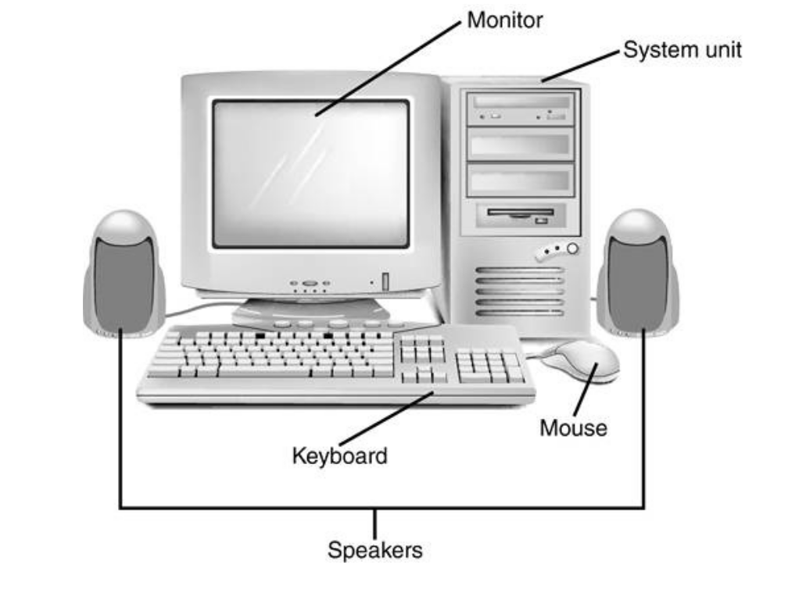
15. Award makes according to accuracy, diagram clarity and labelling (5 marks)

