MARKING SCHEME GRADE 7 CREATIVE ARTS AND SPORTS

1.

Visual art

music

sports
(3 × 1 = 3 marks)

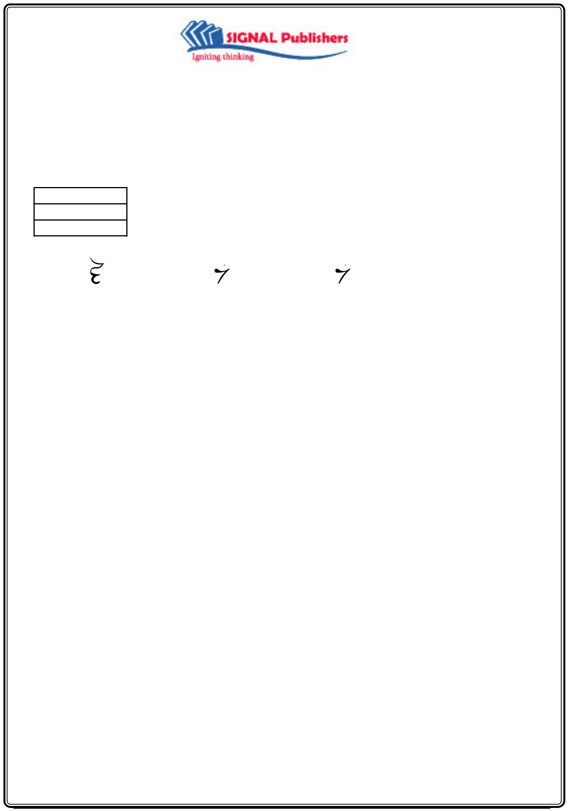
2. | 1st asteric | 2nd asteric | 3rd asteric
3. | (a) carry |  | (1 × 3 = 3 marks)
 | (b) approach run | (c) cross over | (d) release
4. | (a) variation of notes |  | (3 × 1 = 3 marks)

- use of rests
- use of time signature
5. A – very low (4 × 1 = 4 marks)
B – high
C – low
D – very high
6. | (a) Throw the javelin when only instructed to do |  | so | (4 × 1 = 4 marks)
 | (b) Do not throw the javelin when returning it
 | (c) Always carry the javelin vertically with the |  | point down
 | (d) Throw the javelin in the defined area when it is clear
7. | (a) Old magazines | (any other correct source is acceptable 3 × 1 = 3 marks)
  - Old newspapers
  - Old calendars
- (a) Wall toss activity
  - (i) Coordination
      - Upper body strength
    - Endurance
- (a) Balance
  - Rhythm
(c) movement (any other correct answer is acceptable 3 × 1 = 3 marks)
10. (a) Time signature means the number of beats in a bar (2 × 1 = 2 marks)
(b) 34 – means three crotchets in a bar

- (a) Panga
  - wood carving knife
  - chisel
12. (a) clapping | (any two correct answers 2 × 1 = 2 marks)
12. (a) clapping | (4 × 1 = 4 marks)
- tapping
- marching to rhythm
- swaying
- swinging

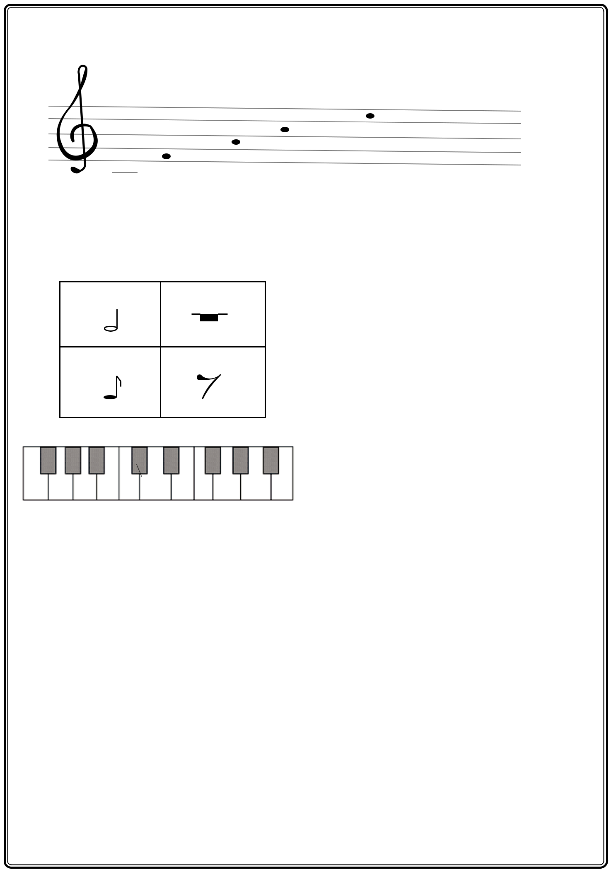
13. (a)

_{C} C

A
F

C

Treble staff = 1mark
Notes in spaces = 4 marks
Ledger line C = 1 mark

(b)
NOTE REST

(c)

C

D E

- (a) – sports help in physical fitness
– Sports are a source of income
– Sports are a source of entertainment
– Sports help in character moulding

(Any 3 well explained points × 2 = 6 marks)

- – music is used in cheering to give players moral support

– music is used when performing physical activities that enhance physical fitness

(Any 2 correct answers × 2 = 4 marks)

- (a) it refers to the types of art that can be appreciated by sight.
  - – painting
– sculpture
– pottery
– basketry (1 × 3 = 3 marks)

- – source of income: visual artworks can be sold to get money
– Tourism attraction: tourists come to our country and visit museums to see traditional visual artwork bringing foreign exchange to our country.

– Visual arts items are exported to other countries earning our country foreign
 | exchange |  | (Any 3 well explained points × 2 = 6 marks)

