GRADE SIX (6)
Time: 1 HOUR 40 MIN.

CREATIVE ARTS & SOCIAL STUDIES

M.E. ASSESSMENT TERM TWO
M TWO

ART AND CRAFT
- Grade four learners of Emakhwale Comprehensive School were seen drawing different Shapes and shading them as shown below

Which technique of shading did they use?
- Twining
- Stippling
- Smudging
- Cross hatching
- During a practical lesson, Grade five learners of Mukambi Comprehensive School were asked to draw a still life composition. Which of the following diagrams shows the correct overlapping of forms they drew?
B. .
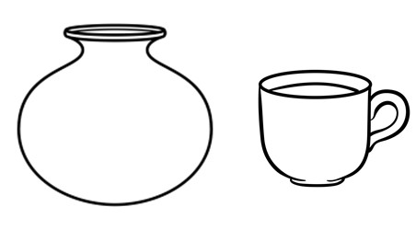
- .
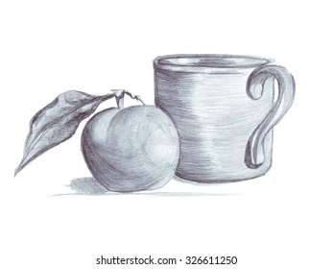

- .

D. .
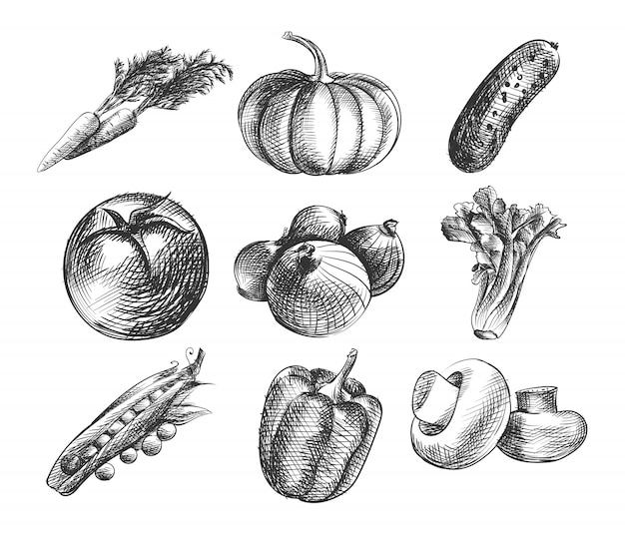

- During a group activity, Grade 6 learners mixed different Primary colours in equal amounts to obtain Secondary colours they were using
- Green, violet, blue
- Orange, red, purple
- Violet, green, purple
- Red, yellow, blue
- Mr. Chora a teacher of Art and Craft asked learners to bring weaving materials to be used during a practical lesson to weave a circular mat. Which of the following materials did they not need to carry?
- Sisal, banana, fibres, old fabrics
- Clay, sisal, leather
- Reeds, palm, leaves, raffia
- Elephant grass, bamboo stem, wattle sticks
- The statements below describe the steps to be followed when carving a wooden cooking stick
- Rub the stick with sand paper
- Curve off the unwanted parts.
- Cut the piece of wood to desired length.
- Mark the position where the handle will be
- Refine the shape of the cooking stick
Which of the following shows the correct order to follow?
- iii, iv, ii, v, i
- i, ii, iv, v, iii
- ii, iv, iii, i, v
- v. iii, iv, i, iv
- Grade 6 learners were decorating a pot. Which of the following methods did they not use?
- Stamping B. Scratching
C. Stitching D. incising
- Which of the following is not a type of puppet?
- Glove puppet
- Nail puppet
- Stick puppet
- Marrionates
- Jane, a Grade 6 learner was decorating her name written in block lettering. Which of the following was not used as a way of decorating it?
- Colouring
- Cross-hatching
- Shading
- Thonging
- Grade 5 learners mounted their artwork as shown below.

. 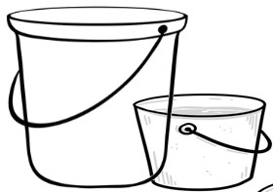
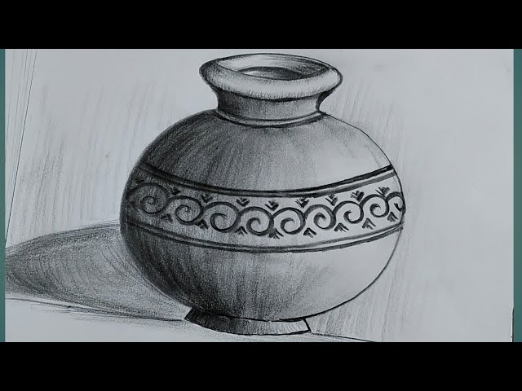

Which one of the following could be the main reason why they mounted and displayed their work?
- to make others envious.
- To be sold easily.
- To make them look big
- To make them last longer.
- Which one of the following is not a device for taking photographs?
- Tablets B. Mirror
C. Mobile phones D. Camera

MUSIC

- Religious songs are also called _______________________ songs

- Art B. Topical C. Sacred D. Arrangement

- _________ songs talk about issues affecting the society.

- Patriotic B. Folk songs C. Entertainment D. Topical

- A _______ is a two part song performed by two people each singing a different voice part.
- Solo B. Duet
C. Trio D. Quartet
- A …………….is an indigenious string instrument with one or two strings.
- Bow B. Fiddle
C. Beats D. Soft
- Below is a diagram of a Kenyan Indigenious instrument. Use it to answer question 5.
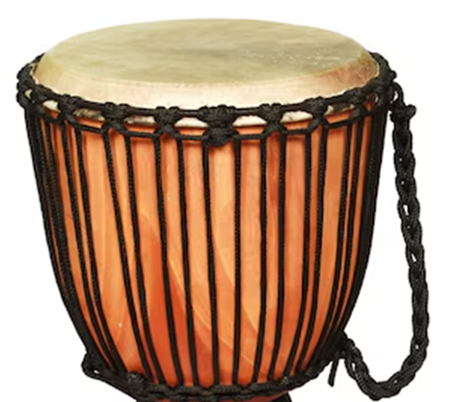

The instrument above is tuned by ____
- Tightening the strappings B. Hitting the membrane
C. Burning D. Boiling
- A descant recorder is a ________ instrument.

- String B. Drum C. Whistle D. Wind

- ________ are items used during the performance of a folk dance such as pots, cooking sticks, stools, balls and baskets.
- Ornaments B. Costumes
C. Props D. Message
- Write the French rhythm names for the notes below: -


- Ta tafa ta
- Taa tate taa
- Taa aa taa
D. Tafa taa te
- Name the parts of the note below.
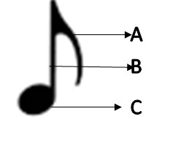
- Tail, head, stem
B. Stem, tail, head
C. Tail, stem, head
D. Tail, head, flag

- Which of the following Solfa syllables are written in descending order?
- d' t l s f m r d,
B. d r m f s l t d
C. d’ t m r s’ l s m
D. d s f m s l t d
SOCIAL STUDIES

- Imaginary lines drawn on a map running from West to East are called.
- Longitudes B. Altitude
C. Climate D. Latitude
- Grade 6 pupils of Bora school had a field trip. On their way, the observed some physical features. Which one was a drainage feature?
- Valley B. Mountain
C. Lake D. Plain
- During a social studies lesson, the teacher asked Grade 6 learners to name historic built environment found in Kenya. Who gave the correct answer.
- Joy : Vasco Da Gamma Pillar
- John : Askari Monument
- Mary : John Garang Mausoleum
- Magi : Namugongo Shrine.
- Given below are characteristics of a type of climate
i). Receives high rainfall throughout the year.
ii). Receives convectional rainfall
iii). It has high temperature throughout the year.
The above description is likely to be
- Semi-Arid climate
- Mountain climate
- Tropical climate
- Equatorial climate
- A grade 5 teacher asked learners to make a poster showing how to care for historic built environment. Which one is the correct answer.
- Destroy historic built environment.
- Educate people on importance of historic built environment.
- Break items in the historic built environment.
- Not dusting items in the historic built environment
- Which one of the following is a role of a headteacher in a school?
- Is the chief disciplinarian
- Prepares and maintains class register
- Prepares school timetable.
- Secretary to the Board.
- Grade 5 learners of Makutano primary listed the importance of fishing in Kenya.
Who gave the wrong response.
- Hassan : Source of employment
- Issa : Earns foreign exchange
- Amina : Destruction of the environment
- Zawadi : Source of food.
- Grade 5 learners used digital devices to look for cushites found in Kenya. Which combination of communities did they get?
- El-molo and Maasai B. Nubians and Agikuyu
C. Rendile and Borana D. Nandi and Mijikenda

- Maria is walking from the market to her home. She saw a road sign indicating no entry. Which one of the given sign did she see?
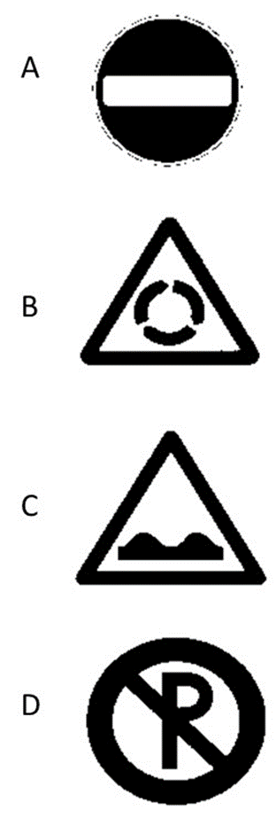

- Learners from Mara school visited a nearby river and saw people fishing as indicated in the diagram below.

Which method of fishing is it?
- Spearing B. Use of baskets C. Hook and line D. Net drifting
- What are the qualities of a good leader
A. Cruel B. Dishonest C. Unjust D. Kind
- Grade 5 Social studies teacher asked learners to name a mineral at Kariandusi in Kenya. Which is the right response.
A. Salt B. Soda ash C. Diatomite D. Flouspar.
- Grade 5 learners are planning to start an enterprise project in the school. What is the activity they should do?
- Discuss where to sell their products
- Discuss the type of project to start.
- Share out the profits
- Agree on the roles during the project
- Mr. Omollo asked learners to name elective positions in Kenya. Which elective position is in charge of a constituency?
- Member of Parliament B. President
C. Governor D. Member of County Assembly
- A child born of Kenyan parents in Kenya becomes a Kenyan by
- Registration B. Dual citizenship C. Naturalization D. Birth

CRE

- The following are gifts given to baby Jesus by the wisemen. Which one was not?
A. Myrrh B. Frankincense C. Silver D. Gold
- The grade 6 pupils of Ebulechia primary school were asked to state appropriate activities on how they can engage in during their leisure time.
Ann: Attending disco parties
David: Sitting by the road side
Doreen: Doing physical exercises
Onesmus: Participating in beting games.

Who among the following pupils gave the correct answer?
- Ann B. David C. Doreen D. Onesmus

- According to the Bible, God gave human beings the responsibility to take care of His creation. Which one is not a way of caring for God’s creation?
- Feeding animals
- Cleaning the environment
- Planting trees
- Polluting the environment
- Learners of grade 4 were asked to state ways in which members of a family can promote unity at home.
Silvia: Reporting those who do not work
Blessed: Sharing duties among themselves
Morice : Inviting their friends to help them do the work
Dicalaus : Giving gifts to those who work hard.

Who among the following pupils gave the correct answer?
- Silvia B. Blessed C. Maurice D. Dicalaus
- A Grade four CRE teacher at Mabanga primary school asked pupils to group the books of the Bible according to the old and New Testament- select the group that contains only the books of the new testament.
- HEBREWS, JUDE, ROMANS
- HOSEA, LUKE, MARK
- HAGGAI, ESTHER, DANIEL
- AMOS, TITUS,ACTS
- Why is the Bible considered to be the inspired word of God?
- It is a beautiful book B. Encourages wrong doing
C. Praises evils D. Rebukes evil
- After reading the miracle of the healing of the woman who had flow of blood. Your teacher asks you to give a reason why the woman touched the edge of the garment of Jesus. Select the correct answer from the choices given.
- She loved the garment of Jesus
- She was told by the disciple to do so
- She touched it by mistake
- She had faith that she would be healed.
- Jesus was baptized by John the Baptist in River Jordan. Which of the following did not happen during the events?
- Heaven opened
- Jesus cried in a loud voice
- The Holy spirit in form of a dove came down from.
- A voice was heard saying “You are my own dear son. I am pleased with you”
- Jesus was led by the Holy spirit into the desert to be tempted by the devil. How many times was He tempted.
- Two B. One C. Three D. Five
- The following are events that took place during the call of Moses
i). God called Moses
ii). Moses was taking care of his father-in-law’s sheep and goats.
iii). God told Moses to remove his sandals’
- Grade 6 learners from Mukambi primary school discussed ways of taking care of the environment. They came up with the following ways except?
- Swimming in a nearby river
- Cleaning rivers
- Educating people on the importance of environment
- Planting trees
- Genesis 2:12 says “ I will bless who bless you. But I will curse those who curse you. And through you I will bless all the Nations” These words were said by God to?
A. Adam B. David C. Abraham D. Noah
- In Mark 1:16-20, What were the disciples doing before they were called by Jesus.
A. Praying B. Fishing C. Walking D. Ploughing
- Which one among the following children has been denied their rights.
- Peace – Arranging the books on the shelve
- Mary – Playing with her friends
- John – Helping with chores around the house
- Moses – Working in a school plantation during school hours
- Grade 6 class teacher has realized that most of the learners use their parent’s mobile phones while at home. The correct advice for the teachers to give to learners on how to use the mobile phones is?
- Carry the phones to school and watch videos with friends.
- Look for relevant information for your class work
- Exchanging text messages about their friends
D. Make calls to their friends of their parents.

