NYAMIRA NORTH SUB COUNTY
NAME….…………………………………………………..ADM NO………….
SCHOOL………………………………………………..… CLASS…………………...
231/1/2/3
BIOLOGY PAPER (HYBRID)
CONTEST 1, 2025
TIME: 2 HOURS
INSTRUCTIONS TO CANDIDATE:
- Write your name and index number in the spaces provided above.
- Answer ALL the questions in the spaces provided.

For Examiner’s use only

QUESTIONS | MAXIMUM SCORE | CANDIDATES SCORE
1-19 | 58
20 | 12
21 | 10

- State two characteristics of organisms that are easily observed in both animals and plants. (2marks)-growth and development
-reproduction
-nutrition
-irritability
2. (a) Terrestrial insects such as locusts were captured and their blood was analysed. It was found that the blood does not have blood pigments such as haemoglobin. Explain. (2 marks)
In insects oxygen is not transported in blood but circulates in tubes and airsacs.
Haemocoel only transports nutrients
(b) State how the tracheal system in insects is adapted to gaseous exchange. (3 marks)
Trachea-has rings of cartilage to prevent it from collapsing/ensure is open all through
Hairs around spiracles conserve water
Tracheoles are numerous to increase surface area for gaseous exchange
3. State two functions of a diastema in herbivores. (2 marks)
Provide space to turn food in mouth
Enable separation of newly cut vegetation and regurgitated food
4. State three biotic factors that could affect an antelope living in Masai Mara. (3 marks
Predation
Competition
Parasitism
symbiosis
5. Describe how the leaves of submerged plants are adapted to gaseous exchange. (3 marks)
Stomata on upper surface for efficient gaseoius exchange
Have aerenchyma tissue for gaseous exchange
Lack cuticle for easier gaseous exchange
Deeply dissected to create large surface area for gaseous exchange
6. Name the part of the seed whose growth brings about epigeal germination. (1 mark)
hypocotyl
7. State three aspects of light that affect the rate of photosynthesis. (3 marks)
Light intensity
Light duration
Light wavelength
8. (a) Identify the class with organisms that have three body parts and three pairs of legs. (1 mark)insecta
(b) Suggest three reasons why members of the class named in (a) above are adapted to all types of habitats. p (3 marks)
Presence of exoskeleton
Excrete uric acid that needs less water to eliminate
Ability to fly
Small size consume less food
Diverse mouth parts suited for feeding
9. (a) List three types of chromosomal mutation. (3 marks)
Deletion
Translocation
Duplication
Inversion
(b) (i)a What are sex-linked genes? (1 mark)
Genes carried on sex chromosomes and inherited with them
(ii) Name two conditions that are sex-linked. (2 marks)
Haemophilia,colourblindness,hairy pinna,hairy nose,duchene muscle dystrophy
10. (a) Name two digestive enzymes produced in their inactive form. (2 marks)
Pepsin
Trypsin
Rennin
11. Name the organelles that carry out the following functions (2mks)
- Destroy old and worn-out organelles lysosome
- Formation of spindle fibres centriole
12. (a) Why would you give an athlete glucose and not sucrose after a race? (1mk)
Simple sugar-easily broken down to produce energy
Easily absorbed in blood Acc highly soluble..provide instant energy (b)What happens to lactic acid after oxygen debt recovery? (2mks)
Oxidized to CO₂ and water.
Converted to glucose then glycogen stored in the liver
13.The diagram below represents a plant cell that was subjected to a certain treatment.

At the start At the end of the experiment

a) Account for the shape of the cell at the end of the experiment. (2 marks)

plant cell in hypertonic solution, water drawn out by osmosis it become flaccid, cell membrane pulls away from the cell wall and it becomes plasmolysed

b) Draw a diagram to illustrate how an animal cell would appear if subjected to the same treatment. (1mk)

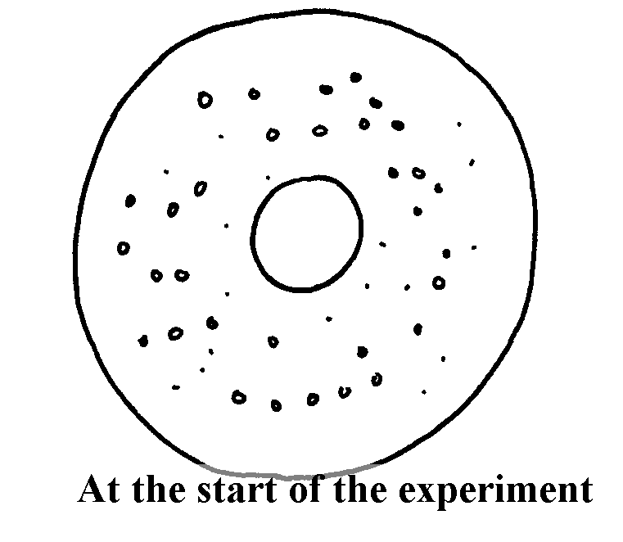
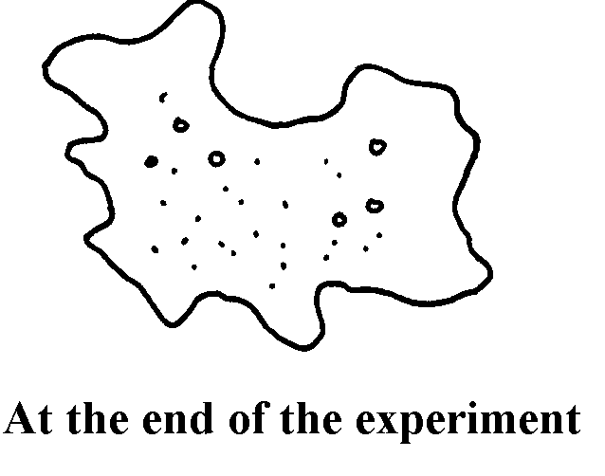

14. Name two types of valves in the heart. (2 marks)
Tricuspid valves
Bicuspid valves acc semilunar valves
15.a) Name the hormones that controls metamorphosis in insects (2marks)
Juvenile hormones
Ecdysone hormone
b) Give one advantage of metamorphosis in insects (1mark)
reduced competition for resources
exploitation of different habitats
16a Name the physiological process by which water molecules move from one cell to the other (1mark)osmosis
b) State 3 significance of the process in a) above 3marks
maintains turgidity of cells
offers support to herbaceous plants
transport of water and mineral salts in the plant
absorption of water from the soil

17. The graph below represents growth pattern in a group of organisms
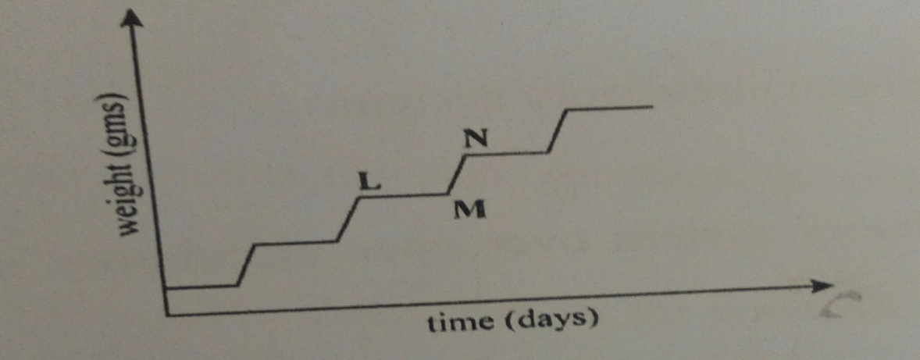
( a)Name the type of growth curve (1 mark)
Intermittent growth curve
(b) Name the phylum that shows this type of pattern (1 mark)
Arthropoda
18. The diagram below shows some processes that take place in the ovary and oviduct around the time of fertilization.
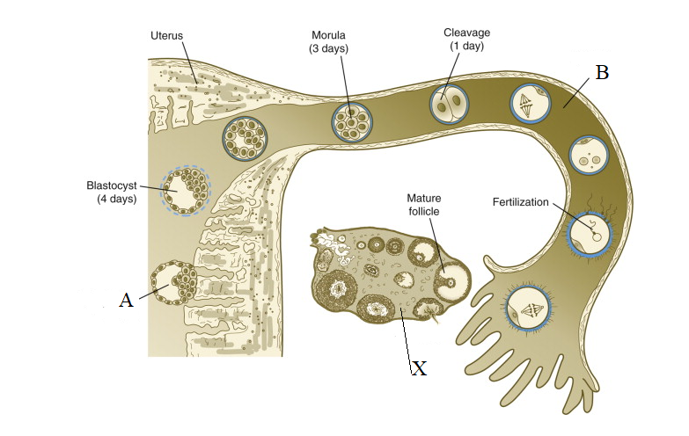
Name
- The process labeled A implantation (1mark)

- Structure X and B (2marks)
X ovary
B fallopian tube
- The hormone produced by structure labeled X ( 1mark)
oestrogen
19a). State two theories that explains origin of life (2marks)
Creation theory
Chemical evolution theory
Organic evolution theory
b) State three evidences of organic evolution (3marks)
geographical distribution
fossil records
comparative serology
comparative embryology
comparative anatomy
20. An experiment was carried out to investigate transpiration and absorption of water in a certain plant species. The plants were potted and supplied with adequate water. The amount of water lost and absorbed was determined. The results are shown in the table below;

Time of the day | Amount of water in grams
 | Transpiration | Absorption
0700-0900 | 30 | 15
0900-1100 | 40 | 25
1100-1300 | 48 | 34
1300-1500 | 56 | 45
1500-1700 | 40 | 50
1700-1900 | 25 | 40
1900-2100 | 15 | 28
2100-2300 | 10 | 21

- Using the same axes, plot graphs to show transpiration and absorption of water in grams against time of the day. (7mks)
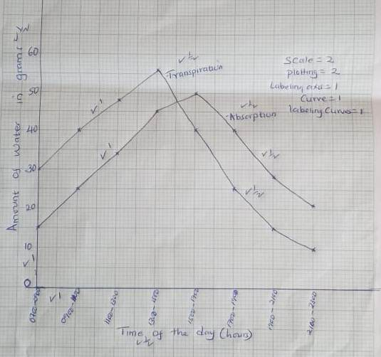

b) 1500-1700hrs

(C) - Wind – rate of transpiration is faster when it is windy due to blowing away of layers of water vapour (accept the converse)
- Humidity – when humidity is low the rate of transpiration is faster due to steep water vapour diffusion gradient (accept the converse)
- Atmospheric pressure – rate of transpiration is high at low atmospheric pressure (accept the converse)
- Light - At high light intensity; stomata open increasing the rate of transpiration (Accept the converse)
- Temperature – At high temperature the rate of evaporation increases thus increasing the rate of transpiration; (Accept the converse)
(

- At what time of the day was the amount of water the same for transpiration and absorption;(1mk)

- Name two factors and explain how they would affect transpiration and absorption at any given time. (4mks)

21.Below are photographs of certain in organisms marked M₁, M₂, M₃, and M₄ a partial identification key.
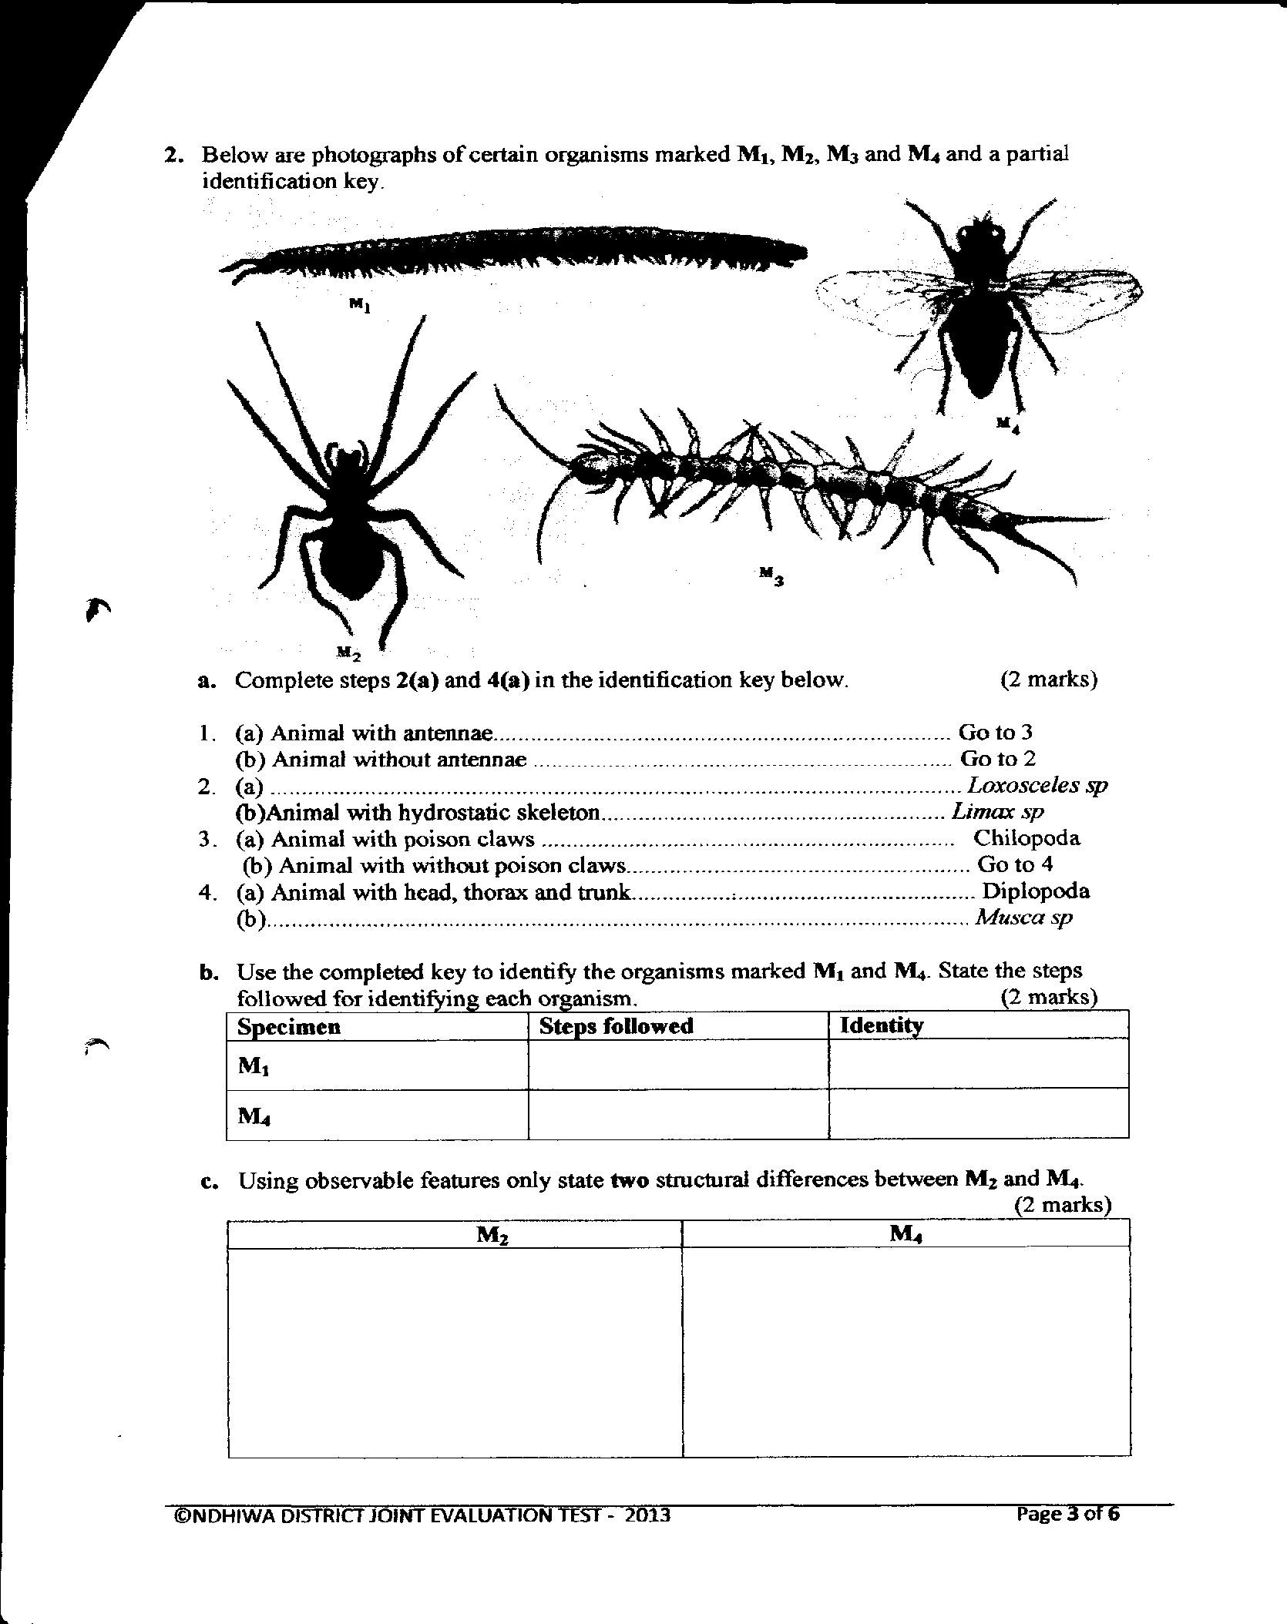

a)Complete steps 2(a) and 4(a) in the identification key below. (2mks)
1. (a) Animal with antennae……………………………………Go to 3
(b) Animals without antennae……………………………….Go to 2
2. (a) ……Animals with exoskeleton……………………Loxosceles sp
(b) Animals with hydrostatic skeleton……………………….Limax sp
3. (a) Animals with poison claws………………………………Chilipoda
(b) Animals with without poison claws ……………………..Go to 4
4. (a) Animals with head, thorax and trunk …………………….Diplopoda.
(b) …Animals with head, thorax and abdomen…………….Musca sp

(b)Use the completed key to identify the organisms marked M₁ and M₄. State the steps followed for identifying each organism.
(4mks)
Specimen | Steps followed | Identity
M₁ | 1a,3b,4a | Diplopoda
M2 | 1b;2a | Lexosceles
M3 | 1a,3a | Chilopoda
M₄ | 1a,3b,4b | Musca sp
(c)Using observable features only, state two structural differences between M₂ and M₄. then M₁ and M₃ (4mks)
M₂ | M₄
Lack antennae | Have antennae
2 body parts | 3body parts

M₁ | M₃
Cylindrical body | Dorsal-ventrally flattened body
A pair of legs per segment  Short antennae | 2 pairs of legs per segment  Long antennae

END
SUCCESS

