

T3-2024
MATHEMATICS
POST MOCK, 2024
PAPER 121/1
MARKING SCHEME

1 | $\frac{28+18}{-2}- \frac{15-(2 ×6)}{3}$  = $\frac{46}{-2}- \frac{(15-12)}{3}$  -23 – 1 = -24 | M1  M1  A1
 |  | 3
2. | . P²⁻pq-pq+q²  p (p-q)p(q-q)  (P-q)²  2p²-2pq-pq=q²  (2p-q) (p-q)  (p-q) ² p-q  (2p-q)(P-q) = 2p-q | M1  M1  A1
 |  | 3
3. | 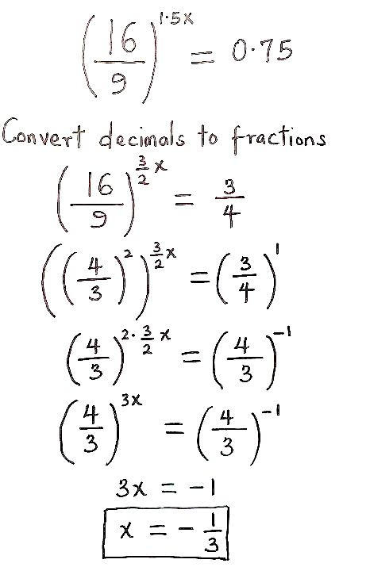 | M1  M1  A1
 |  | 3
4. | a).4²=9²+6²-2 x 6 x 9 cosQ  108cosQ=101  Q = cos 10.9352  Q =20.74⁰  b) .area of PQS  = ½ x 9 x 10 sin 20.74⁰  = 15.94cm² | M1  A1  M1  A1
 |  | 4
5. | Cos (3x-180⁰)= √3/2  3x -180 = 30  3x = 210  X= 70⁰ | M1  M1  A1
 |  | 3
6. | 840=2³x 3 x 5 x 7  396=2² x 3² x 11  GCD=2² x 3=12  Area =12 x 12  = 144cm² | M1  M1 for both prime factors  A1
 |  | 3
7. | Mass of spray = 384  Intense radius =3.2  Density of = 0.6g/lcm²  V= M/D= 384g/0.6glc= 640cm³  Volume of the cylinder= π²h  π²h= 640  3.142x 3.22 h= 640  h₂= 640 = 640  3.142x 3.22 3.142 x 10.24  = 640/32.17408  19.891789  = 19.89cm | M1  M1  M1  A1
 |  | 4
8. | a. pet= 20-9=11  inverse = 1 5 -3  11 -3 4  5 /11 -3/11  -3/11 4/11 B₁  5/11 -3/11 4 3 x 5/11 -3/11 6  3/11 4/11 3 5 y -3/11 4/11 5  1 0 = 15/11  0 1 2/11  x=15/11  y=2/11 | M1  A1
 |  | 3
9. | 1/9 +1/5 -1/4 = 20+12-18  60  = 17/60  17/60=1hr  1= 1 x 60/17  60/17 = 3.5294118  = 3.529 hrs | M1  M1  A1
 |  | 3
10. | 4680 x 123140  = Ksh 577512  Remaining  557512-51790  Kshs 525,722  = 525,722  69.10  = US£ 608.13 | M1  M1  M1  A1
 |  | 4
11. | 4-6 = -3/2 and b+1 = 2/3  3-9 2 a-2  3a +2b=17  -2a+3b=-7  6a+4b=34  -6a+9b=-21  13b=13  b=1  a=5 | M1  M1  A1
 |  | 3
12. | x/5x  bx=180⁰  x=30⁰  no of sides =180/30  = 12sides | M1  M1  A1
 |  | 3
13. | a. OB= 1/3 2 + 5  3 -3  9 + 4  2/3 + 10/3  1 -2  3 -8/3  = 4  -1  17/3  B .0B = √4²+ (-1)²+ (17/3)²  √ 1b +1+32.11  = √49.11  =7.007 square units | M1  A1  B1
 |  | 3
14 | Let 10th digit be x  0 x =y  X+y=1b(i)  10y +a –(10x +y) =18  10y+x-10x-y=18  9y-9x=18  y-x=2(ii)  y+x=18  y+x=16  2y 0=18  Y=9  X=7  Number  79 | M1  M1  A1
 |  | 3
15 | m/F= 2/3  m=2/3p  M-10 = 1/3  f+6  3m-30=F+6  M=f/3+12  = f/3+12= 2/3 f  F+36=2f  F=36  M=2/3 x36  = 24  Total 36+24=60 | M1  M1  A1
 |  | 3
16 | 120% =Ksh 36,000  100% = 100 x 3600  120  Kshs 36,000  Profit = 76,000  % profit = 36000 x 100  30,000  = 12% | M1  M1  A1

17 | Let the number of sh.100 tickets be x  Let the number of sh. 50 tickets be y  Total amount collected = 100x + 50y = 100,000  If 30% more of y were sold, the amount = $\frac{130}{100}$ x 50y  If 40% less of x were sold, the amount = $\frac{60}{100}$ x 100x  (65y + 60x = 112500) x 10……….(i)  (50y + 100x = 100,000) x 13……..(ii)  650y + 600x = 1125000…………(iii)  650y + 1300x = 1300000………..(iv)  Subtract eqn (iv) from eqn (ii)  700x = 175000  x = 250  $∴$ 50y + 100 x 250 = 100,000  50y $÷$ 25000 = 100,000  50y = 100000 – 2500  50y = 75000  y = 1500  Number of tickets costing sh.50= 1500  Number of tickets costing sh.100 = 250 | M1  M1  M1  M1  A1  M1  M1  A1  B1  B1 | For both expansions
 |  | 10
18. a)
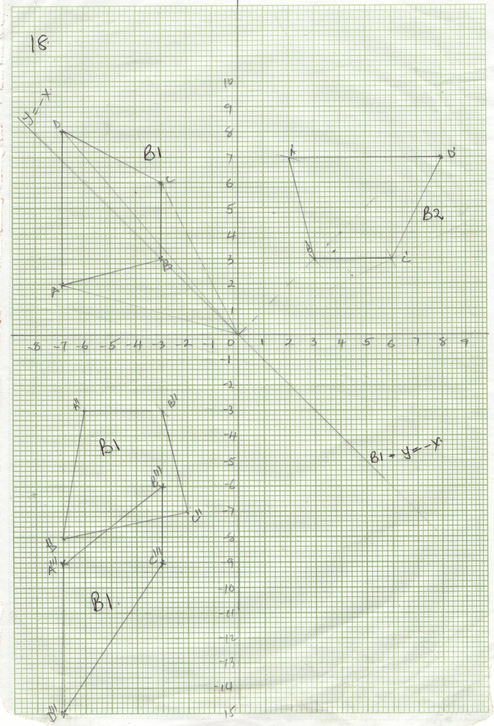
 | d) ii) Let the matrix be $\left(\begin{matrix}a & b \\ c & d\end{matrix}\right)$  $\left(\begin{matrix}a & b \\ c & d\end{matrix}\right) \left(\begin{matrix}-7 & -3 \\ -2 & -3\end{matrix} \begin{matrix}-3 & -7 \\ -6 & -8\end{matrix}\right)$ = $\left(\begin{matrix}-7 & -3 \\ -9 & -6\end{matrix} \begin{matrix}-3 & -7 \\ -9 & -15\end{matrix}\right)$  → $\left(\begin{matrix}-7a-2b & -3a-3b \\ -7c-2d & -3c-3d\end{matrix} \begin{matrix}-3a+6b & -7a-8b \\ -3c-6d & -7c-8d\end{matrix}\right)$  =$\left(\begin{matrix}-7 & -3 \\ -9 & -6\end{matrix} \begin{matrix}-3 & -7 \\ -9 & -15\end{matrix}\right)$  = -7a – 2b = -7 ……..(i) x 3  -3a – 3b = -3 …….(ii) x 2  -21a – 6b = -21…..(iii)  -6a – 6b = -6…….(iv) −  -15a = -15  a = -1  from (i) → -7(1) – 2b = -7  -2b = 0  b = 0  -7c – 2d = -a ……………(i) x 3  -3c – 3d = -6…………….(ii) x 2  -21c – 6d = -27  -6c – 6d = -12 −  -15c = -15  c = 1  -3(1) – 3d = -6  -3d = -3  d = 1  Matrix = $\left(\begin{matrix}a & b \\ c & d\end{matrix}\right) \left(\begin{matrix}1 & 0 \\ 1 & 1\end{matrix}\right)$  Shear: Shear factor 1  Y –axis invariant  iii)Area = $\frac{1}{2}\left(3+6\right)4=18 square units$ | M1  M1  B1  A1
 |  | 10

19 | a)  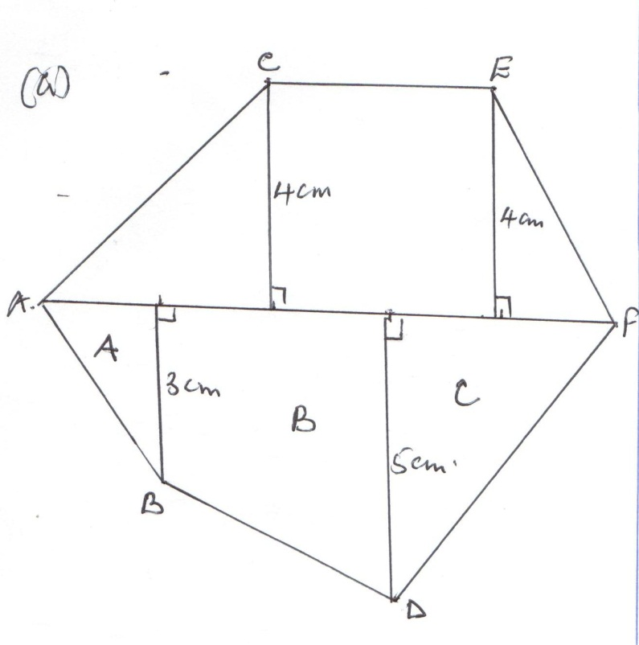  b) i) Area of ΔA = ½ x 20 x 30  = 300m²  Area of trapezium B = ½ (30 + 50)40  = 1600m²  Area of ΔC = ½ x 40 x 50  = 100m²  Area of trapezium ACEF  ½ x (100 + 40)40  = 2800 m²  Total area = (300 + 1600 + 1000 + 2800)  = 5700 m²  ii) Area in hectares = $\frac{5700}{1000 }=0.57 ha$ | B1  B1  B1  B1  M1  M1  M1  M1  A1  B1 | Location of B  Location of C  Location of D  Location of E
 |  | 10
20 | 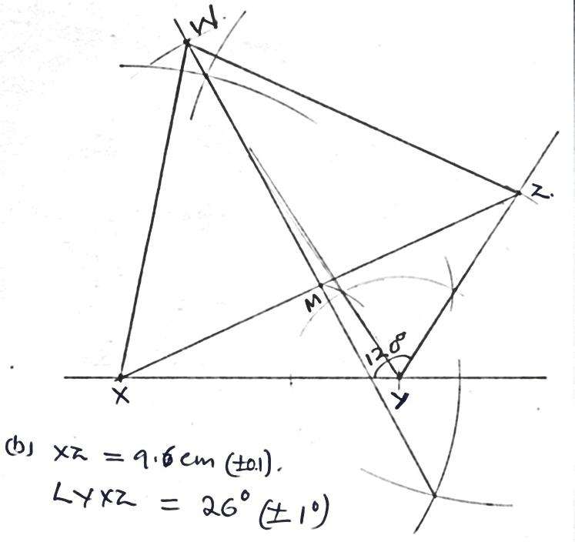  c) WM = 6.4 cm ($±$0.1)  Area of ΔXZW  ½ b x h = ½ x 96 x 6.4  = 30.72 cm² | B1  B1  B1  B1  B1  B1  B1  B1  M1  A1 | For 120º construction  Complete construction of ΔXYZ  Length  Angle YXZ  Perp bisec of XZ to M  Correct location of W  Complete ΔXZW  Length WM  ½ x 6.4 x 9.6  For 30.72 cm²
 |  | 10
21 | a)  b) i) Mean = 3.7 + $\frac{-22.5}{100}$ = 3.475  = 3.48  ii) Standard deviation  $\frac{45.25}{100}- {\left(\frac{-22.5}{100}\right)}^{2}$ = 0.3819  $s.d= \sqrt{0.3819}$ = 0.617980  $=0.62$ | M1  M1  M1  M1  M1  M1  M1  A1  M1  A1 | d = X – A  fd  d²  d²f  $\sum{fd}$  $\sum{d^{2}f}$
  x | f | d = X - A | fd | d² | d²f
  2.2  2.7  3.2  3.7  4.2  4.7  5.2 | 5  15  24  40  10  4  2 | -1.5  -1.0  -0.5  0  0.5  1.0  1.5 | -7.5  -15  -12  0  5  4  3 | 2.25  1  0.25  0  0.25  1  2.25 | 11.25  15  6  0  2.5  4  4.5
   | $\sum{f=100}$ |  | $\sum{fd=-22.5}$ |  | $\sum{d^{2}f=45.25}$
 |  | 10
22. | a) Function y = 2x² + 4x − 3  b) -2.5, 0.6  c) y = 2x² + 4x – 3  0 = 2x² + x – 5  y = 3x + 2  y 0 1  y 2 5  -1.8, 1.6 | B2 | For correct table
  x | -4 | -3 | -2 | -1 | 0 | 1 | 2
  2x² | 32 | 18 |  |  |  |  | 8
  4x-3 | -19 | -15 |  | -7
  y | 13 | 3 |  | -5 | -3
 |  | 10

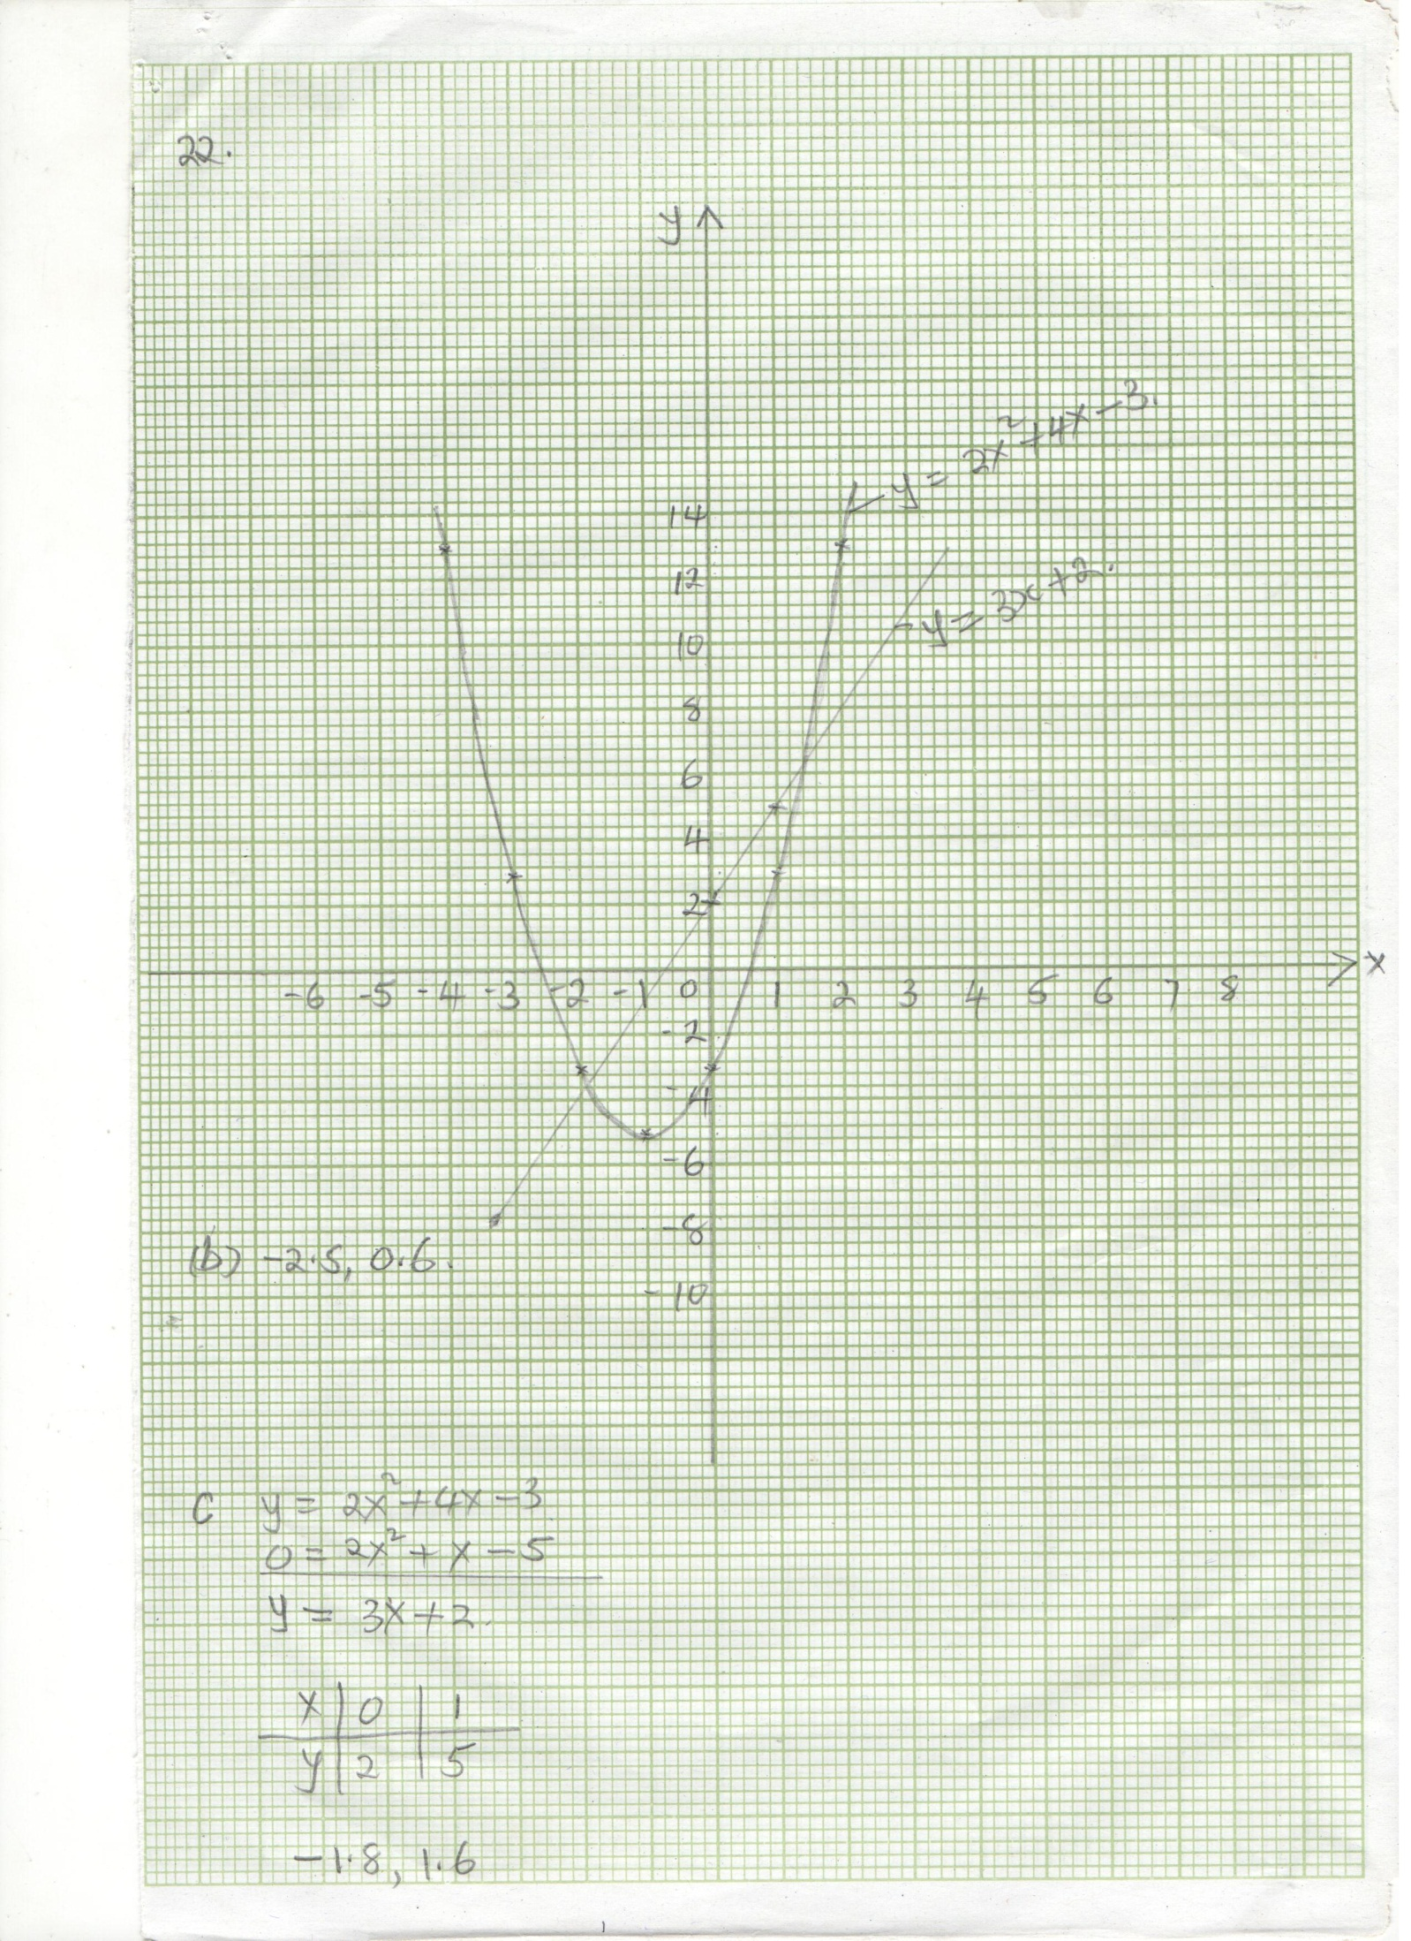
 |  | 10
23 | a) Area of the carpet (x + 4) (x – 1)  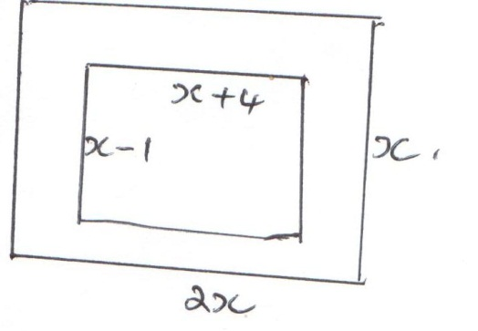  (x + 4) (x – 1) = 36  x² – x + 4x – 4 = 36  x² + 3x – 40 = 0  x² + 8x – 5x – 40 = 0  x(x + 8) – 5(x + 8) = 0  (x + 8) (x – 5) = 0  x = 5 or x = 8  x = 5m  Area of uncarpeted floor  2x² – {(x + 4) (x – 1)  2 x 25 – (9 x 4)  50 – 36 = 14m²  b) No. of tiles = $\frac{14 ×100 ×100}{20 ×20}$  = 350 tiles  Cost: (350 x 100) + (36 x 300)  = sh.45,800 | M1  M1  M1  A1  M1  A1  M1  A1  M1  A1
 |  | 10
24 | 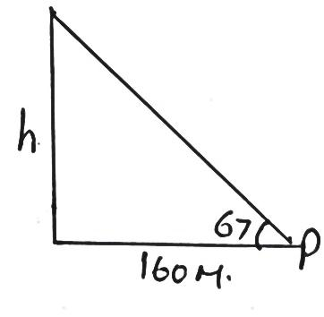  tan 67 = $\frac{h}{160}$  h = 160 tan 67  = 376.94m  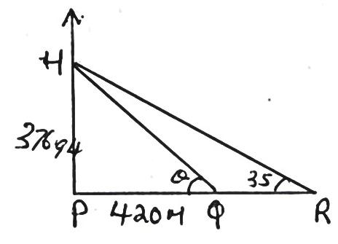  $\tan{θ}= \frac{376.94}{420}$  = 0.8974761  = 0.8975  $θ$ = 41.91º  $\tan{35= }\frac{376.94}{QR+420}$  QR tan 35 + 420 tan 35 = 376.94  QR = $\frac{376.94-420\tan{35}}{\tan{35}}$  = $\frac{376.94-420 ×0.7002}{0.7002}$  = 118.3376  PR = QR + 420 = 538.34 m | B1  M1  A1  B1  M1  A1  M1  M1  A1 | Sketch  Diagram
 |  | 10

