
Kenya Certificate of Secondary Education
443/ 3 Biology - Paper 3
POST MOCK, 2024
(Practical )
T2- 2024 – Time 2 hours

Name …………………………………………….……… Adm Number…………………………..
Candidate’s Signature ………………….…...……….. Date ……………………………………

INSTRUCTIONS TO CANDIDATES
- Write your name, class and admission number in the spaces provided above.
- Sign and write the date of the examination in the spaces provided.
- Answer all questions in the spaces provided.
- You are required to spend the first 15 minutes of the 1 ¾ hours allowed for this paper reading the whole paper carefully before commencing your work.
- Additional pages must not be inserted.
- Candidates should check the question paper to ascertain that all the pages are printed as indicated and that no questions are missing
FOR EXAMINERS USE ONLY
Section | Maximum Marks | Candidate Score
1 | 13
2 | 16
3 | 11
TOTAL SCORE | 40

T3BIO2024

TURN OVER


- You are provided with three sets of seedlings labelled A, B and C.
Examine them and answer the questions that follow:
- State the conditions under which seedling A and B were grown. (2marks)
A ………………………………………………………………………………………
B……………………………………………………………………………………
- (i) Name the type of germination exhibited by the seedlings. (1mark)
………………………………………………………………………………………
(ii) Give a reason for your answer in b (i) above. (1mark)
………………………………………………………………………………………
………………………………………………………………………………………
………………………………………………………………………………………
- List two observable differences between seedlings A and B. (2marks)
A | B

- Name the term used to describe the phenomenon exhibited by specimen B(1mark)
………………………………………………………………………………………
- (i) Name the response exhibited by the seedlings labelled C. (1mark)
………………………………………………………………………………………
(ii)Explain how the response named in (e) (i) above occurred. (2marks)
………………………………………………………………………………………
………………………………………………………………………………………
- Separately, pluck, cut and crush the leaves from seedling A and B.
Place the crushed extract into separate test-tubes labelled A₁ and B₂.
Add 2ml of water to form solutions A₁ and B₁ respectively.

- Using the reagent provided, carry out food test on A₁ and B₁. (4 marks)
Test for | Procedure | Observation | Conclusion

- Account for the results obtained (f) (i) above. (2marks) ……………………………………………………………………………………………………………………………………………………………………………………………………………………………………………………………………………………………………………………………………………………………………………………
2. Below are photographs of animals labeled R and T. Study them carefully and answer the questions that follow.

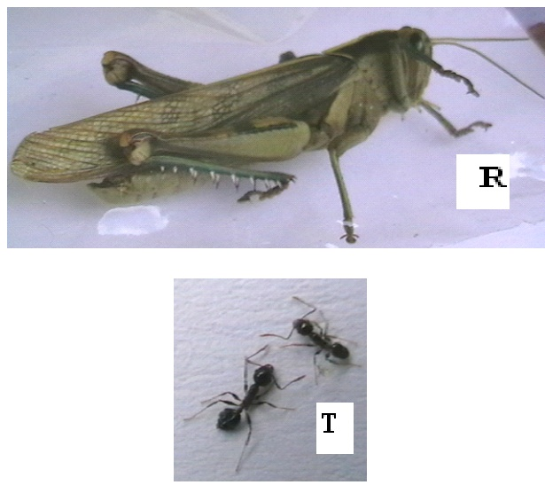

a)
i) Name the phylum to which the animal in photograph R belongs. (1 mark)
……………………………………………………………………..………….…………………………………………………………………………….……………………………….……………………………………………………………………………………………………………………
ii). List three characteristics found in members belonging to the phylum of specimen R only. (3 marks)
…………………………………………………………………………….……………………………….………………………………………………………………………………………………….……………………………………………………………………………………………
iii). Which class does the animal in photograph R belong. (1mark)
………………………………………………………………………………..………….…………………………………………………………………………………………………………………

b). Using observable features only, state three differences between animals in photograph R and T (3marks)
………………………………………………………………………………..………….…………………………………………………………………………….……………………………….………………………………………………………………………………………………….……
c). On the photograph T name the parts labeled 2 and 3. (2 marks)
…………………………………………………………………………….……………………………….………………………………………………………………………………………………….……………………………………………………………………………………………….
3. Study the photographs below and use them to answer the questions that follow;
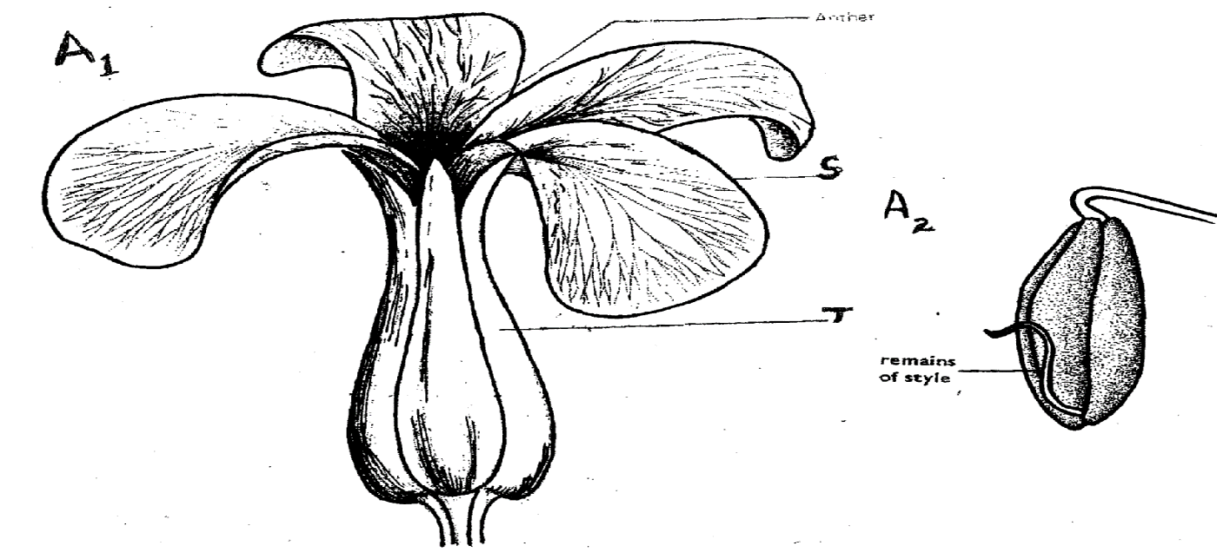
A₁
A₂
S

T
Remains of style

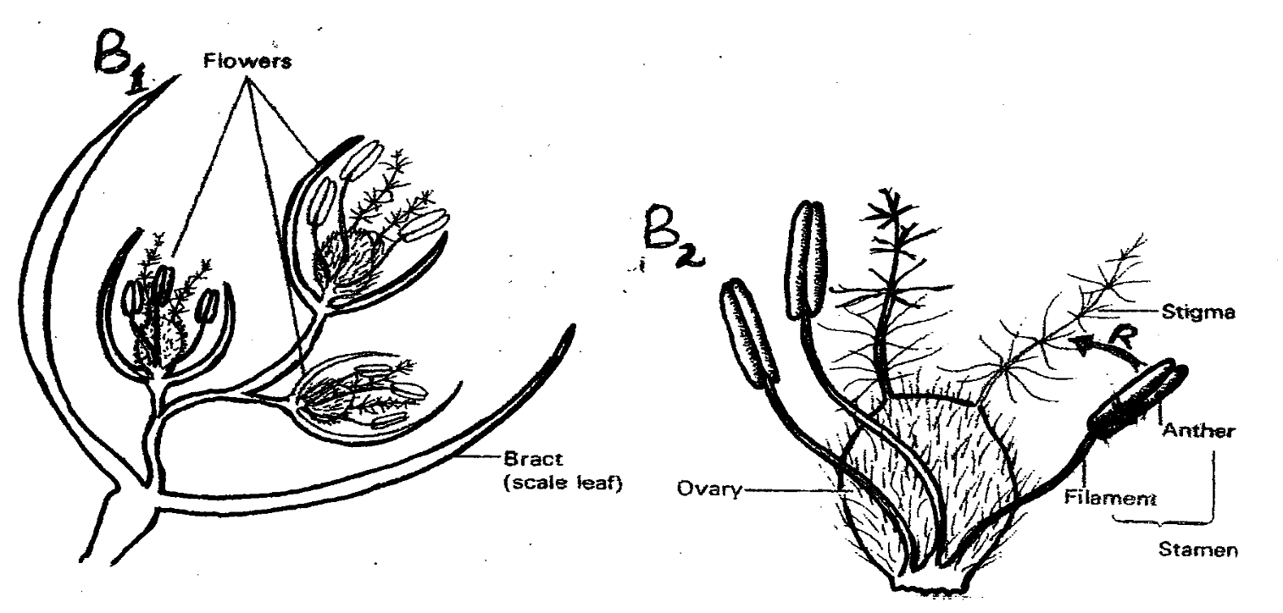
B₂
B₁

a) Using the number of flowers arising from the shoot of each plant, state the flowers labelled A₁ and B₁ (2 marks)

……………………………………………………………………………………………………………………………………………………………………………………………………………………………………………………………………………………………………………………………………………………………………………………………………………………………………………………………………………..
b) Name the class of the plant from which each of the flowers was obtained. Give a reason for your answer in each case (2 marks)

Flower | Class | Reason
A1
B1

c) Name the parts labelled S and T (2 marks)
S……………………………………………………………………………………
T ……………………………………………………………………………………
d) What type of ovary is shown in flower B₁? Give a reason for your answer. (2 marks)

……………………………………………………………………………………………………………………………………………………………………………………………………………………………………………………………………...……………………………………………..
e) i) Name the agent responsible for the process represented by the arrow labelled R in B₂ (1 mark)
……………………………………………………………………………………………………………………………………………………………………………………………………………..
ii) Give a reason for your answer in e (i) above (1 mark)
………………………………………………………………………………………………………………………………………………………………………………………………………….

iii) List two other features (not shown in the photograph) expected of such flowers as B₁ (2 marks)
………………………………………………………………………………………………………………………………………………………………………………………………………………………………………………………………………………………………………………………
f) (i) Name an agent that brings about a similar process as the one shown by the arrow in B₂ for A₁ (1 mark)
……………………………………………………………………………………………………………………………………………………………………………………………………………
ii) Give a reason for your answer in f(i) above (1 mark)
…………………………………………………………………………………………………………………………………………………………………………………………………………………………………………………………………………………………………………………….
g) What is the likely agent of dispersal of the specimen labelled B₂? (1 mark)
……………………………………………………………………......................................………………………………………………………………………………………………………………

THIS IS THE LAST PRINTED PAGE

